
Republic of Iraq
Ministry of Higher Education & Scientific Research
University of Kerbala
College of Engineering
Civil Engineering Department

Modeling the Maintenance Costs of Road Projects in Karbala Governorate Using Fuzzy Neural Network
A Thesis Submitted to the Council of the Faculty of the College of the Engineering/University of Kerbala in Partial Fulfillment of the Requirements for the Master Degree in Infrastructure Engineering

By:
Ali Saad Ahmed
Supervisors
Asst. Prof. Gafel Kareem Aswed

Safar1448
July 2026


Republic of Iraq
Ministry of Higher Education & Scientific Research
University of Kerbala
College of Engineering
Civil Engineering Department

Modeling the Maintenance Costs of Road Projects in Karbala Governorate Using Fuzzy Neural Network
A Thesis Submitted to the Council of the Faculty of the College of the Engineering/University of Kerbala in Partial Fulfillment of the Requirements for the Master Degree in Infrastructure Engineering

By:
Ali Saad Ahmed
Supervisors
Asst. Prof. Gafel Kareem Aswed
Safar 1448
July 2026

بسم الله الرحمن الرحيم

شَهِدَ اللَّهُ أَنَّهُ لَا إِلَٰهَ إِلَّا هُوَ وَالْمَلَائِكَةُ وَأُولُو الْعِلْمِ قَائِمًا بِالْقِسْطِ ۚ لَا إِلَٰهَ إِلَّا هُوَ الْعَزِيزُ الْحَكِيمُ
صدق الله العلي العظيم
( آل عمران: من الآية 18)

Examination committee certification
We certify that we have read the thesis entitled "Modeling the Maintenance Costs of Road Projects in Karbala Governorate Using Fuzzy Neural Network " and as an examining committee, we examined the student " Ali Saad Ahmed" in its content and in what is connected with it and that, in our opinion, it is adequate as a thesis for the degree of Master of Science in Civil Engineering.
Supervisor
Signature:
Name :. Asst. Prof. Gafel Kareem Aswed

Date: / / 2026
Supervisor
Signature:
Name :.
Date: / / 2026

Member
Signature:
Name :.
Date: / / 2026
Member
Signature:
Name :.
Date: / / 2026

Chairman
Signature:
Name :.
Date: / / 2026

Signature:
Name :
Dean of the Engineering College
Date: / / 2026
Signature:
Name :
Head of the Department of Civil Engineering
Date: / / 2026

Supervisor certificate
I certify that the thesis entitled "Modeling the Maintenance Costs of Road Projects in Karbala Governorate Using Fuzzy Neural Network " was prepared by Ali Saad Ahmed under our supervision at the Department of Civil Engineering, Faculty of Engineering, University of Kerbala as a partial of fulfilment of the requirements for the Degree of Master of Science in Civil Engineering.

Signature:
Assist. Prof. Gafel Kareem Aswed
Date: / / 2026

Linguistic certificate
I certify that the thesis entitled "Modeling the Maintenance Costs of Road Projects in Karbala Governorate Using Fuzzy Neural Network," which has been submitted by Ali Saad Ahmed, has been proofread, and its language has been amended to meet the English style.

Signature:

Date: / / 2026

Undertaking
I certify that research work titled "Modeling the Maintenance Costs of Road Projects in Karbala Governorate Using Fuzzy Neural Network" is my own work. The work has not been presented elsewhere for assessment. Where material has been used from other sources, it has been properly acknowledged / referred.

Signature:
Ali Saad Ahmed
Date: / / 2026

Dedication
To my homeland, the great Iraq, and its righteous martyrs who granted us peace and the opportunity to learn.
To my beloved parents, the source of my strength, whose prayers and sacrifices have lighted my path.
To my wonderful wife, for her endless patience and support throughout this journey; and to my dear son, the joy of my life.
I proudly dedicate this thesis to you all.

Acknowledgments
First and foremost, I praise Almighty Allah for granting me the strength to complete this study.

I express my deepest gratitude to my supervisor, Assist. Prof. Gafel Kareem Aswed, for his invaluable guidance, insightful critiques, and continuous support throughout this research. Special thanks also go to the examining committee, and to the Civil Engineering Department at the University of Kerbala for providing a supportive academic environment.

I am deeply grateful to the Engineering Projects Department of the Al-Abbas's Holy Shrine for their exceptional cooperation. I would like to express my special and profound gratitude to Eng. Fallah Hasan Hussein for his outstanding efforts, dedication, and the invaluable assistance he so generously provided. My thanks also extend to the Roads and Bridges Directorate and the Karbala Municipalities for providing critical project data. I also thank the experts and survey participants for their valuable contributions.

Finally, a heartfelt thanks to my friends, and to my beloved family, for their endless patience, sacrifices, and unwavering support.

Abstract
Road maintenance plays a key role in infrastructure management, and accurate estimation of maintenance costs remains a challenge due to the interaction of traffic, structural, and environmental factors. This study aims to develop a reliable model for predicting road maintenance cost in Karbala Governorate, taking into account the local conditions that influence pavement performance and maintenance requirements.
The study is based on a dataset of 248 completed maintenance projects covering the period 2010–2025. A total of 13 input variables were identified through literature review, expert consultation, and Relative Importance Index analysis. These variables represent the main factors affecting maintenance cost under local conditions, including traffic characteristics, pavement condition, and environmental effects. In this study, the Fuzzy Neural Network (FNN) concept is treated as the general intelligent framework, while the Adaptive Neuro-Fuzzy Inference System (ANFIS) is adopted as the practical model implemented for maintenance cost prediction. After data preprocessing, the ANFIS model was developed, and its performance was compared with Artificial Neural Network (ANN) and Multiple Linear Regression (MLR) models.
The results show that the ANFIS model based on Subtractive Clustering achieved the best predictive performance, with a coefficient of determination of R² = 0.95 and a mean absolute percentage error of MAPE = 8.19%, indicating good accuracy. The model also shows a clear ability to represent nonlinear relationships between the input variables and maintenance cost.
The study concludes that the developed ANFIS model can support maintenance cost estimation and help improve planning and decision-making in Karbala Governorate under practical conditions.

list of Contents
Examination committee certification 4
Supervisor certificate 5
Linguistic certificate 6
Undertaking i
Dedication i
Acknowledgments ii
Abstract iii
list of Contents iv
List of Tables xi
List of Figures xii
List of Abbreviations xiii
List of Symbols xvi
Chapter One: Introduction 1
1.1 Background 1
1.2 Problem Statement 1
1.3 Research Justification 2
1.4 Aim of the Study 2
1.5 Objectives of the Study 2
1.6 Research Questions 3
1.7 Hypotheses 3
1.8 Limitations 4
1.9 Methodology Overview 4
1.10 Significance of the Study 5
1.11 Previous Studies on ANFIS Applications 5
1.11.1 Prediction of Maintenance Cost under Uncertainty 6
1.11.2 Application of ANFIS in Cost Prediction 6
1.11.3 Decision Support in Maintenance Planning 6
1.11.4 Pavement Deterioration Prediction 7
1.12 Previous Studies on Road Maintenance Costs 7
Chapter Two: Literature Review 15
2.1 Introduction 15
2.2 Road Maintenance 17
2.2.1 Factors Affecting the Cost of Road Maintenance 17
2.3 Pavement Management Systems (PMS) 19
2.3.1 Structure and Main Functions of PMS 20
2.3.2 Role of PMS in Cost Optimization and Strategic Planning 20
2.4 Traditional Estimation Methodologies 20
2.4.1 Statistical Models for Maintenance Cost Estimation 21
2.4.2 Life-Cycle Cost Analysis (LCCA) 21
2.5 Artificial Neural Networks (ANN) 22
2.5.1 Basic architecture and components 22
2.5.2 Training Algorithms Backpropagation 23
2.5.3 Applications of ANN in Road Engineering 23
2.6 Fuzzy Logic and Fuzzy Neural Networks 24
2.6.1 Fuzzy Inference System (FIS) 24
2.6.2 Main Types of Fuzzy Neural Networks 25
2.7 Adaptive Neuro-Fuzzy Inference System 26
2.7.1 ANFIS Structure and Rule Generation 27
2.7.1.1 Grid Partitioning (GP) 27
2.7.1.2 Fuzzy C-Means Clustering (FCM) 27
2.7.1.3 Subtractive Clustering (SC) 27
2.7.2 Architecture and Layer Structure 28
2.7.3 Hybrid Learning Mechanism of ANFIS 30
2.8 Performance Evaluation Metrics 31
2.8.1 Root Mean Square Error (RMSE) 31
2.8.2 Mean Absolute Error (MAE) 31
2.8.3 Mean Absolute Percentage Error (MAPE) 32
2.8.4 Coefficient of Determination ($R2$) 32
2.9 Chapter Summary 32
Chapter Three: Methodology and Data Analysis 33
3.1 Introduction 33
3.2 Case Study 33
3.3 Open Survey 34
3.3.1 Open Survey Stage 34
3.3.2 Sample Selection Criteria 34
3.3.3 Sample Characteristics 35
3.3.4 Personal Information 36
3.3.5 Results of Open Questionnaire 38
3.4 Closed Survey 38
3.4.1 Sample Size of Closed Survey 38
3.4.2 Reliability of the Questionnaire 39
3.4.3 Relative Importance Index (RII) 40
3.4.4 Analysis of Closed Survey Results 40
3.4.5 Closed Survey Form 41
3.4.6 Analysis of Personal Information 41
3.4.7 Analysis of Respondent Consensus 43
3.5 Factor Ranking Based on RII Analysis 44
3.6 Historical Data Collection 45
3.6.1 Dataset Description 46
3.7 Model Variables Definition and Fuzzification Strategy 46
3.7.1 Fuzzy Variables 46
3.7.2 Numerical Variables 48
3.7.3 Binary Variables 49
3.7.4 Selection of Model Input Variables 50
3.8 Data Preprocessing 51
3.8.1 Data Cleaning 51
3.8.2 Descriptive Statistics 52
3.8.3 Data Normalization 53
3.8.4 Training, Checking, and Testing Sets 53
3.8.5 Different Data Split Ratios 53
3.8.6 Statistical Homogeneity Test (ANOVA) 54
3.9 Fuzzy Rule Generation Methods 55
3.9.1 Subtractive Clustering (SC) Approach 55
3.9.2 Fuzzy C-Means (FCM) Approach 56
3.10 Model Parameter Optimization 56
3.10.1 Membership Functions Evaluation 56
3.10.2 Hybrid Training and Epoch Selection 57
3.10.3 Grid Search Procedure for Model Configuration 57
3.10.4 Comparison of SC and FCM Models 57
3.10.5 Sensitivity Analysis Procedure 58
3.11 Comparative Models 58
3.11.1 Artificial Neural Network (ANN) Model 58
3.11.2 Multiple Linear Regression (MLR) Model 59
3.12 Chapter Summary 59
Chapter Four: Results and Discussion 60
4.1 Introduction 60
4.2 Cost Distribution 60
4.3 Performance Evaluation of ANFIS Models 61
4.3.1 Model Performance Based on Subtractive Clustering (SC) 61
4.3.2 Model Performance Based on Fuzzy C-Means (FCM) 63
4.3.3 Selection of the Optimal Model 64
4.4 Analysis of ANFIS Model Structure and Parameters 65
4.4.1 Sugeno Linear Coefficients 67
4.4.2 Rule Importance Analysis 68
4.4.3 Manual Validation of the Selected Model 69
4.5 Comparison with ANN and MLR 73
4.5.1 Performance of ANN Model 74
4.5.2 Performance of MLR Model 75
4.6 Sensitivity and Interaction Analysis 75
4.6.1 Relative Importance of Input Variables 76
4.6.2 Influence of AADT and HTS on Maintenance Cost 77
4.7 Discussion of Results 78
4.8 Chapter Summary 78
Chapter Five: Development of the Web-Based Application 80
5.1 Introduction 80
5.2 Application Overview and Development Framework 80
5.2.1 Application Objectives 80
5.2.2 Development Phases 81
5.2.3 Main Features and Functions of the Application 81
5.2.4 Practical Application 82
5.3 Application Specifications 82
5.3.1 Operating Method of the Application 83
5.4 Running the Application 84
5.4.1 Home Page Interface 84
5.4.2 Project Creation Interface 85
5.4.3 Input Variables Interface 86
5.4.4 Results Interface 86
5.4.5 Impact Analysis and Explanation Interface 87
5.4.6 Final Report Interface 88
5.5 Evaluation of the Developed Application 90
5.5.1 Sample Selection 90
5.5.2 Presentation and Explanation 90
5.5.3 Data Collection 90
5.6 Analysis of the Evaluation Results 92
5.6.1 Objective of the Application 92
5.6.2 Support for Engineering Work: 92
5.6.3 Need for the Application: 92
5.6.4 Ease of Use and Data Entry 93
5.6.5 Clarity of Outputs and Analytical Pages 93
5.7 Chapter Summary 93
Chapter Six: Conclusions and Recommendations 94
6.1 Introduction 94
6.2 Conclusions 94
6.2.1 Conclusions Related to Variables and Data 94
6.2.2 Conclusions Related to Model Performance 95
6.2.3 Conclusions Related to Application Development 95
6.3 Recommendations On the basis of the results of this study, the following recommendations are made: 96
6.4 Suggestions for Future Research 96
References 98
Appendix A: Open Survey 106
Appendix B: Closed Survey 108
Appendix C: Historical Project Data 122
Appendix E: 126
PUBLICATIONS 130

List of Tables
Table ‎1.1 Previous Studies on Road Maintenance Cost Estimation 8
Table ‎2.1 Coding of Factors Affecting Road Maintenance Cost 18
Table ‎2.2 Road Maintenance Cost Factors in Previous Studies 19
Table ‎3.1 Professional Profile of the Surveyed Experts (Researcher) 35
Table ‎3.2 Classification of RII Values and Importance Levels 40
Table ‎3.3 Kruskal-Wallis Test Results 44
Table ‎3.4 RII Results for Factors Affecting Road Maintenance Cost 45
Table ‎3.5 Input Variables for ANFIS Cost Estimation Model 50
Table ‎3.6 Descriptive Statistics for Model Variables 52
Table ‎3.7 Data Splitting Scenarios and Performance Metrics 54
Table ‎3.8 One-Way ANOVA Results for the Data Subsets 55
Table ‎4.1 Performance Assessment of SC-ANFIS Models 61
Table ‎4.2 Performance Assessment of FCM-ANFIS Models 63
Table ‎4.3 Statistical comparison between the optimal SC and FCM models 64
Table ‎4.4 Parameters of the Selected SC-ANFIS Model 66
Table ‎4.5 Sugeno Linear Coefficients of the Optimal ANFIS Model 67
Table ‎4.6 Input preprocessing values 69
Table ‎4.7 Rule firing strengths 70
Table ‎5.1 Users’ Perspectives on the Developed Application (Researcher) 90

List of Figures
Figure ‎1.1: Research Methodology Flowchart (Researcher) 5
Figure ‎2.1 Conceptual Framework of Previous Studies (Researcher) 16
Figure ‎2.2 Adaptive neuro-fuzzy inference system (Jang, 1993) 28
Figure ‎3.1 Academic Achievement of Open Survey Respondents (Researcher) 36
Figure ‎3.2 Respondents Profession (Researcher) 37
Figure ‎3.3 Respondents' Years of Experience (Researcher) 37
Figure ‎3.4 Academic Achievement of Closed Survey Respondents (Researcher) 42
Figure ‎3.5 Scientific Specialization of the Respondents (Researcher) 42
Figure ‎3.6 Responders Years of Experience (Researcher) 43
Figure ‎3.7 Boxplot of Data Subsets 55
Figure ‎4.1 Distribution of Road Maintenance Costs in the Collected Dataset 60
Figure ‎4.2 Actual vs Predicted Values for Testing Dataset 62
Figure ‎4.3 Architecture of the ANFIS Model Used for Cost Estimation 65
Figure ‎4.4 Fuzzy rule importance in the SC-ANFIS model 68
Figure ‎4.5 Comparison Between ANFIS and ANN Model Predictions 74
Figure ‎4.7 Relative Importance of Input Variables for Maintenance Cost 76
Figure ‎4.8 Interaction effect of AADT and HTS on maintenance cost 77
Figure ‎5.1 Home Page Interface of the Developed Web-Based Application 85
Figure ‎5.2 Project Creation Interface (Researcher) 85
Figure ‎5.3 Results Interface of the Developed Application (Researcher) 86
Figure ‎5.4 Input Variables Interface of the Developed Application (Researcher) 87
Figure ‎5.5 Impact Analysis and Explanation (Researcher) 87
Figure ‎5.6 Project Report Interface (Researcher) 89
Figure ‎5.7 Results and Impact Analysis Interface (Researcher) 89

List of Abbreviations

AADT | Annual Average Daily Traffic
AASHTO | American Association of State Highway and Transportation Officials
AI | Artificial Intelligence
ANFIS | Adaptive Neuro-Fuzzy Inference System
ANN | Artificial Neural Networks
AHP | Analytic Hierarchy Process
ANOVA | Analysis of Variance
ASTM | American Society for Testing and Materials
CBR | California Bearing Ratio
CSF | Critical Success Factors
DBST | Double Bituminous Surface Treatment
DF | Degrees of Freedom
DEMATEL | Decision Making Trial and Evaluation Laboratory
EAC | Estimate at Completion
EFHNN | Enhanced Fuzzy Hybrid Neural Networks
ESAL | Equivalent Single Axle Load
FAHP | Fuzzy Analytic Hierarchy Process
FCM | Fuzzy C-Means Clustering
FIS | Fuzzy Inference System
FMEA | Failure Mode and Effects Analysis
FNN | Fuzzy Neural Networks
GA | Genetic Algorithm
GIS | Geographic Information System
GP | Grid Partitioning
HTS | High Temperature Severity
IQD | Iraqi Dinar
IRI | International Roughness Index
LCCA | Life-Cycle Cost Analysis
LOS | Level of Service
LTPP | Long-Term Pavement Performance
LSE | Least Squares Estimation
MAE | Mean Absolute Error
MAPE | Mean Absolute Percentage Error
MATLAB | Matrix Laboratory
MF | Membership Function
MLP | Multilayer Perceptron
MLR | Multiple Linear Regression
MS | Mean Squares
MSE | Mean Squared Error
OAT | One-At-a-Time
OFN | Ordered Fuzzy Numbers
PCI | Pavement Condition Index
PDF | Portable Document Format
PMS | Pavement Management Systems
PSO | Particle Swarm Optimization
PG | Performance Grade
RFNN | Recurrent Fuzzy Neural Networks
RII | Relative Importance Index
RMSE | Root Mean Square Error
SC | Subtractive Clustering
SS | Sum of Squares
SCRB | State Commission for Roads and Bridges
SPSS | Statistical Package for the Social Sciences

List of Symbols

V1 | Pavement Area
V2 | Pavement Age
V3 | Median Islands
V4 | Asphalt Thickness
V5 | High Temperature Severity )HTS)
V6 | Road Classification
V7 | Road Condition (PCI)
V8 | AADT for Heavy-Loaded vehicles
V9 | Drainage System
V | Maintenance Type
V | Soil Strength
V12 | Pavement Type
V13 | Traffic Volume (AADT)
C | Maintenance cost
C_{norm} | Normalized maintenance cost
C_{max} | Maximum maintenance cost value
C_{min}​ | Minimum maintenance cost value
n | Required sample size
N | Total population size
e | Margin of error
K | Number of questionnaire items
Sᵢ | Variance of scores for each individual item
Sₜ | Total variance of all questionnaire scores
W | Weight assigned to each factor by respondents
x | First input variable
y | Second input variable
pᵢ | Linear consequent coefficient of the first input in ANFIS rule i
qᵢ | Linear consequent coefficient of the second input in ANFIS rule i
rᵢ | Constant term in ANFIS rule i
Zᵢ | Consequent output of rule i

Introduction

Background
Road maintenance is an important part of road network management, and it plays a key role in keeping roads in good service condition and reducing pavement deterioration over time. Road condition may be affected by several factors, including traffic loads, weather conditions, construction quality, and maintenance practices. Therefore, it is important to have a clear understanding of the factors that affect road condition and maintenance cost to achieve good maintenance planning.
The cost of road maintenance is not a simple or fixed process, as the cost can vary depending on site conditions, pavement condition, type of maintenance needed, material prices, labor costs and equipment requirements. Some of these factors may also be unclear or uncertain during the estimation stage. For this reason, depending only on traditional methods may not always give accurate results.
Therefore, more advanced methods are needed to improve road maintenance cost estimation, especially methods that can handle the nonlinear relationships between the affecting factors. Also, fuzzy input variables can be used to represent uncertain conditions, such as pavement condition, damage level, and work difficulty, in a way that is closer to practical field conditions.

Problem Statement
Local engineering departments in Karbala Governorate face difficulties in accurately estimating road maintenance costs. This is mainly due to the reliance on unit rates and previous engineering experience, which may not fully reflect the effects of pavement condition, traffic loads, environmental conditions, and maintenance requirements. Therefore, a more reliable and data-driven prediction approach using Artificial Intelligence (AI) techniques is needed under local conditions.

Research Justification
The need to address important issues in pavement maintenance cost prediction in Karbala Governorate justifies this research. There is still a need to enhance cost prediction under local conditions to aid in maintenance planning and decision making. Furthermore, it is recommended for Iraqi road applications that more systematic pavement maintenance management is required (Hasan et al., 2020). Thus, this study will attempt to make a contribution to this area by creating a cost model based on real project data.

Aim of the Study
The main objective of this research is to build a model to predict the cost of maintenance of flexible pavement in Karbala Governorate by the concept of FNN. The model has been developed from past projects to provide a more accurate and useful cost estimation approach in the local context.

Objectives of the Study
To achieve the aim of this study, the following objectives are defined:
- To collect and prepare a database of road maintenance projects in Karbala, including cost and technical information.
- To identify and analyze the factors affecting the maintenance cost under local conditions.
- To develop a predictive model using FNN based on the collected data.
- To evaluate the model performance by comparing the predicted costs with the actual project costs.
- To develop a predictive application based on the model for practical use in estimating flexible pavement maintenance costs.

Research Questions
This research aims to answer the following questions:
- What are the most important factors affecting the cost of flexible pavement maintenance under the conditions of Karbala Governorate?
- How can FNN be applied to handle uncertainty in road maintenance data?
- How much prediction can the developed model improve accuracy compared with traditional estimation methods?
- How well does the proposed model perform when applied to new maintenance cases?

Hypotheses
The research hypotheses are as follows:
H1: Road section area, pavement age, Pavement Condition Index (PCI), pavement thickness, traffic volume, and other related factors have a significant effect on road maintenance costs in Karbala Governorate.

H2: Road maintenance costs in Karbala Governorate are affected by both technical and field-related factors, which makes the cost estimation process complex.
H3: Fuzzy Neural Networks (FNN) can provide more accurate prediction of road maintenance costs than traditional estimation methods.

Limitations
The limitations of this study are as follows:
- Spatial: This study is limited to Karbala Governorate and is focused on maintenance projects of flexible pavements.
- Time and study limitations: The research is based on historical maintenance data from 2010 to 2025. The study does not include full life-cycle cost analysis, macroeconomic factors affecting material price changes, or administrative factors related to project management.

Methodology Overview
The methodology adopted in the research is systematic, using field data, expert opinions and computational modeling. The study began with a literature review, followed by the open and closed surveys to determine and prioritize the factors affecting road maintenance cost as illustrated in Figure 1.1.The data collected were analyzed through SPSS and the selected variables were fed into ANFIS model in MATLAB. The model was then developed, optimized and evaluated for various data-split ratios and performance measures. Finally a web-based application was developed and tested using the best model.
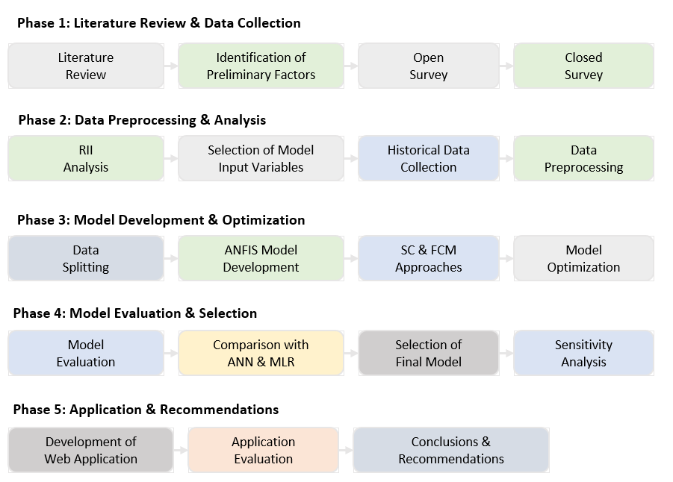
Figure ‎1.1: Research Methodology Flowchart (Researcher)

Significance of the Study
This study is significant because it provides a practical tool for predicting road maintenance costs in Karbala Governorate. The results can help engineers and decision-makers improve cost estimation, support better budget allocation, reduce financial waste, and plan maintenance works more effectively according to local road conditions.

Previous Studies on ANFIS Applications
This subsection reviews selected studies that applied ANFIS in prediction problems related to pavement condition, maintenance needs, and cost-related decision-making.

Prediction of Maintenance Cost under Uncertainty
ANFIS has shown good practical value in predicting costs for construction and highway projects. (Moghayedi and Windapo, 2019) used ANFIS to predict how uncertain events impact highway construction cost and time, and their results showed that the model was more accurate than traditional statistical methods. In a similar case, ANFIS was used to predict estimate-at-completion costs, proving to be a useful forecasting tool under project risks. These findings suggest that ANFIS is not only good for general prediction but also effective for cost-related problems where project outcomes are affected by many uncertain and interacting factors.

Application of ANFIS in Cost Prediction
The model has also been used in highway project management for cost-related prediction. (Moghayedi and Windapo, 2019) applied it to predict the effect of uncertainty events on highway construction cost and reported higher predictive accuracy than the classical statistical method. They also reported lower RMSE and MAPE values, which suggests better performance under uncertain conditions. This makes the model relevant to cost estimation problems influenced by multiple uncertain factors.

Decision Support in Maintenance Planning
ANFIS has been applied in pavement engineering as a practical tool to support maintenance-related decision-making through pavement distress prediction. (Milad et al., 2022) developed ANFIS models for flexible pavement distress in tropical regions using distress characteristics and treatment-related variables, and their results showed that the model can provide accurate predictions for maintenance purposes. In a related application, (Ujong et al., 2025a) also showed that ANFIS can predict pavement deterioration and help transportation agencies prioritize maintenance activities more effectively. These findings suggest that ANFIS can support maintenance planning by linking current pavement condition to future treatment needs in a clear and useful way.

Pavement Deterioration Prediction
The model has also been applied in pavement materials engineering to predict the behavior of asphalt mixtures under different operating conditions. (Nicosia, 2022) developed models to estimate the resilient modulus of asphalt mixtures using laboratory variables and material properties as input data. Their results showed better predictive performance than the corresponding linear regression model. This indicates its ability to represent nonlinear relationships in pavement materials and support engineering evaluation.

Previous Studies on Road Maintenance Costs
ANFIS has been used in a range of engineering applications related to prediction, evaluation, and decision support. Table 1.1 presents selected studies that illustrate these applications across different contexts.

Table ‎1.1 Previous Studies on Road Maintenance Cost Estimation
No | Study | Methodology | Results | Conclusion
1 | (Ujong et al., 2025a) | ANFIS model built from historical and field data for pavement deterioration prediction; subtracted clustering + hybrid optimization reported. | Reported RMSE = 0.85 and R² = 0.9988. | ANFIS showed strong predictive ability for pavement deterioration and can support maintenance planning decisions.
2 | (Sirin et al., 2024) | ANFIS used to identify critical success factors (CSFs) affecting pavement construction project performance. | Validated through robust testing; developed for pavement construction project performance evaluation. | ANFIS is suitable as a decision-support tool for evaluating project performance in pavement construction.
3 | (Abuhishmeh and Hojat Jalali, 2024) | Modified adaptive neurofuzzy system proposed for sewer-main risk assessment and mitigation prioritization. | Framework designed to integrate failure likelihood and consequences for infrastructure risk screening. | ANFIS-based risk assessment can support maintenance prioritization in buried infrastructure management.

Table 1.1 Continued….
No | Study | Methodology | Results | Conclusion
4 | (Mahdi and Erzaij, 2024) | Hybrid ANFIS-FMEA-FAHP model used to assess and prioritize potential trouble factors in troubled building projects. | Hybrid model reported better assessment and prioritization than conventional FMEA-based practice. | ANFIS can strengthen project recovery and prioritization decisions in Iraqi building project management.
5 | (Kiani Mavi et al., 2023) | ANFIS model developed using open construction-cost data and limited early-stage information. | Reported performance was comparable to or better than alternative machine-learning models for conceptual-stage estimation. | ANFIS is applicable to early-stage building cost prediction when detailed design information is unavailable.
6 | (Kaloop et al., 2023) | Machine learning models were used to predict IRI for flexible pavements using LTPP data. | The models predicted pavement roughness accurately, with cracking and rutting being key factors. | Machine learning can support future roughness prediction and road maintenance planning.
7 | (Naji et al., 2022) | ANFIS developed to assess change order management performance; 49 performance parameters grouped into seven categories; k-fold cross-validation used. | Model validated by qualitative structural and behavioral testing. | ANFIS can support systematic evaluation of change order management performance and related cost/time impacts.
Table 1.1 Continued….
No | Study | Methodology | Results | Conclusion
8 | (Dastgheib et al., 2022) | ANFIS used to forecast final project cost while considering qualitative-risk effects; compared with other neural approaches. | Reported MSE ≈ 0.0003; sensitivity analysis identified the most influential factors. | ANFIS improved EAC prediction under uncertain project conditions and supported better cost control.
9 | (Milad et al., 2022) | Three ANFIS models developed using severity, density, road function, and treatment technique as inputs. | Best model achieved R² = 0.934 and RMSE = 0.565 after 30 epochs. | ANFIS can model nonlinear distress behavior and support maintenance-treatment planning in flexible pavements.
10 | (Mehmood and Zhang, 2021) | AHP-DEMATEL was used to analyze factors affecting daily maintenance costs of national and provincial highways. | Highway grade, traffic flow, service life, structure type, topography, pavement thickness, and width were main factors. | Multi-factor analysis can identify important drivers of highway daily maintenance cost.

Table 1.1 Continued….
No | Study | Methodology | Results | Conclusion
11 | (Gaussmann et al., 2020) | ML algorithms, including MLP and K-means, were used with highway maintenance records and price-list data. | K-means gave the best performance for estimating Brazilian highway maintenance costs. | Machine learning can support road maintenance cost estimation when historical maintenance and cost data are available.
12 | (Moghayedi and Windapo, 2019) | ANFIS used to predict the impact size of 76 uncertainty events on highway construction cost and time. | For one reported event, RMSE dropped from 0.213 to 6.05E-08 and MAPE from 0.0484 to 1.35E-08; classical statistics underestimated 62/76 events by an average of −6.5%. | ANFIS provided markedly better support than classical statistics for cost/time prediction under uncertainty.
13 | (Xiaoli et al., 2018) | Historical routine maintenance cost data were analyzed using an improved Bootstrap method. | Cost intervals per lane-kilometer were developed for expressway routine maintenance. | Historical data can be used to estimate expressway routine maintenance cost in real projects.
Table 1.1 Continued….
No | Study | Methodology | Results | Conclusion
14 | (Wang and Wang, 2017) | LCCA model was used to study the optimal timing of pavement preservation. | Traffic loading and initial IRI affected life extension and agency cost benefits. | Life-cycle cost analysis helps select suitable preservation timing and improve maintenance cost planning.
15 | (Teng et al., 2016) | Linear regression models were developed using highway maintenance cost data and road characteristics. | The model included age, pavement surface type, traffic volume, truck flow, area type, and elevation. | Regression models can estimate annual highway maintenance cost and support pavement management systems.

From the previous studies presented in Table 1.1, it can be seen that the cost estimation of road maintenance has been studied in various ways. Most of these studies were conducted under different conditions than those of Karbala Governorate, however. The local conditions in Karbala including the high temperature during summer, heavy-loaded traffic, pavement condition, and the increase in traffic during religious visits may have a direct impact on maintenance cost. Thus, the models created in other environments may not be able to accurately reflect the actual cost behavior in Karbala.

In addition, most of the previous studies were related to pavement deterioration, pavement condition or general construction cost prediction, and fewer studies were directly related to road maintenance cost with actual completed project records. In addition, the application of ANFIS for this purpose is still limited under Iraqi local conditions. To this end, this study attempts to bridge this gap by creating a model based on ANFIS from actual completed road maintenance projects in Karbala Governorate.
Chapter One: Introduction
This chapter introduces the research background, problem statement, previous studies, research gap, aim, objectives, research questions, hypotheses, significance and limitations of the study. It also provides an overview of the research methodology and thesis structure.
Chapter Two: Literature Review
This chapter is a review of the road maintenance cost estimation and its major factors affecting it. It also examines the development of computational cost estimation from traditional to modern approaches, such as artificial intelligence and neuro-fuzzy systems in road management applications.
Chapter Three: Methodology and Data Analysis
This chapter presents the procedures used for data collection and analysis of the costs of road maintenance in Karbala Governorate. It involves factor identification through a two-stage survey, statistical analysis using SPSS and the development of ANFIS, ANN and MLR models. It also describes the data splitting, model training, testing and comparison procedures used for cost prediction.
Chapter Four: Results and Discussion
The results from the model are presented in this chapter. It assesses the accuracy of the prediction and compares the predictions of the ANFIS with the actual cost of the project. It also includes a discussion of the results and model performance under different conditions.
Chapter Five: Development of the Web-Based Application
This chapter presents the web-based predictive application developed in this research as a practical support tool. It describes the application interface, the integration of the developed model and its contribution to support the maintenance cost estimation.
Chapter Six: Conclusions and Recommendations
This chapter provides a summary of the results and conclusions of the research. It also offers some practical recommendations for the stakeholders and points out the future research directions for the field of intelligent road maintenance management.

Literature Review

Introduction
This chapter provides a literature review of road maintenance cost estimation and the factors which affect pavement performance and maintenance needs. It first considers the engineering, traffic and environmental factors which contribute to pavement degradation over time. It then explores the main approaches to maintenance cost estimation, including Life-Cycle Cost Analysis (LCCA), and moves on to data-driven approaches in pavement engineering.
In the chapter, Artificial Neural Networks (ANN) and neuro-fuzzy systems are also discussed, in this case ANFIS. The present study has chosen ANFIS on the basis of this review as it is capable of modelling nonlinear relationships and handling uncertain data. The chapter gives the theoretical background required for developing a predictive model which can represent the local conditions in Iraq. The issues discussed in this chapter are presented in Figure 2.1.

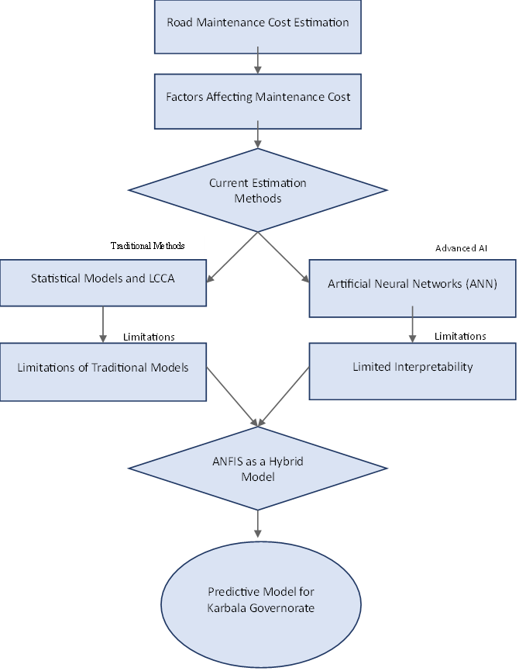
Figure ‎2.1 Conceptual Framework of Previous Studies (Researcher)

Road Maintenance
Road maintenance is important to maintain road pavements in good condition and to ensure safe use over time. Over time, pavement condition deteriorates because of traffic loads and environmental conditions, and is often manifested as cracks, potholes and rutting (Nautiyal and Sharma, 2022). Thus, maintenance decisions should not be made solely based upon the damage that is visible. The PCI is a common method that mainly indicates the surface condition of the pavement but does not necessarily reflect its true performance (Thompson et al., 2026). This may impact the accuracy of the maintenance decision when PCI is used in isolation. Therefore, using PCI in conjunction with other assessment techniques can enhance decision making and help to give a more accurate estimation of maintenance costs.

Factors Affecting the Cost of Road Maintenance
The damage to roads is complicated and makes maintenance cost difficult to estimate. The literature is mainly centered around three aspects: physical properties, traffic volumes and environmental effects. It is important to understand these groups because it demonstrates that maintenance costs result from a combination of operational factors rather than a single cause.
1. Engineering and Physical Characteristics
Engineering and physical characteristics directly impact maintenance cost as they affect pavement performance and type of maintenance needed. Llopis-Castelló et al. (2020) showed that the condition of the pavement is not only affected by the pavement surface performance, but also by the structural and material properties. Their research identified how structural capacity, thickness of the layer, material characteristics and subgrade condition all affect the resistance of the pavement to deterioration over time. This suggests that the physical strength of the pavement system is closely linked to maintenance cost as weaker structural conditions tend to need earlier or more intensive maintenance.
2. Traffic Loads
Damage to pavement and maintenance costs are greatly influenced by traffic levels. It was found that road deterioration is more pronounced in the presence of high traffic volumes and heavy axle loads particularly in weak pavements (Llopis-Castelló et al., 2020). The results corroborate the need to incorporate traffic indicators as part of pavement condition prediction and planning for maintenance.
- Environmental and Climatic Factors
Other factors influencing pavement distress include temperature, moisture, and climate changes, which can cause pavement distress, shorten pavement service life, and increase pavement reconstruction requirements over time. As a result, these conditions should be taken into account in the maintenance evaluation.Table 2.1 is a summary of the major factors that impact road maintenance cost from previous studies, and the code that was given to each of these factors.

Table ‎2.1 Coding of Factors Affecting Road Maintenance Cost
No | Description of Factors | Factor Code
1 | Area of the affected area | F1
2 | Road age after the last paving | F2
3 | PCI (Pavement Condition Index) | F3
4 | Thickness of asphalt layers | F4
5 | Traffic load of the road (AADT) | F5
6 | Percentage of vehicles with heavy loads | F6
7 | Type of road (Main, Secondary) | F7
8 | Type of road layers (Asphalt, Concrete) | F8
9 | Climatic factors (Heat, Humidity) | F9
10 | Type of maintenance (Preventive, Routine, Emergency) | F
After assigning codes to the main factors, Table 2.2 shows the use of these factors in previous studies. This helps to identify the factors that were more frequently considered in the literature on road maintenance cost.
Table ‎2.2 Road Maintenance Cost Factors in Previous Studies
Factors Code | (Ji et al., 2020) | (Pekša and Rubulis, 2019) | (de Bortoli et al., 2022) | (Nautiyal and Sharma, 2022) | (Marović et al., 2018) | (Jung et al., 2020) | (Ujong et al., 2025b) | (Ali and Lafta, 2023) | (Teng et al., 2016) | (Obeti et al., 2024) | (Ferdinand et al., 2024) | (Liu and Cao, 2024) | (Ghadbhan Abed et al., 2022) | (Al-Saady and Rezouki, 2023) | (Kırbaş and Karaşahin, 2016) | (Basnet et al., 2023) | (Cabrera and Silva, 2023) | (Majstorović and Jajac, 2022)
F1
F2
F3
F4
F5
F6
F7
F8
F9
F10

Pavement Management Systems (PMS)
PMS are commonly used to evaluate the condition of a pavement to guide maintenance decisions. It is important to review this framework since it helps to correlate condition evaluation with maintenance planning and budget-related decisions.

Structure and Main Functions of PMS
One of the most popular tools used to assist in road network decision making is a Pavement Management System (PMS). Ali and Lafta (2023) explained that a PMS combines road condition data, performance predictions, and maintenance strategies into one system. This assists road agencies in making the appropriate repairs and in managing their budgets. Elgamal et al. (2025) also noted that these systems are based on the assessment of the road condition using standard measures, including PCI and IRI. These measures assist in prioritizing maintenance, planning projects and allocating budgets. This indicates that a PMS is not only a system to assess road conditions but also a useful tool for road maintenance decision making.

Role of PMS in Cost Optimization and Strategic Planning
This framework also assists in strategic planning in the face of budget constraints. The use of modern tools can enhance the prioritization of maintenance and resource allocation (Al-Mansoori et al., 2020). In a similar finding, Ahmed et al. (2017) reported that predictive and optimization methods aid the decision-maker in addressing funding constraints while considering pavement performance requirements. This approach thus enables long-term maintenance planning and cost optimization.

Traditional Estimation Methodologies
Traditional estimation methods are widely used in pavement maintenance planning because they offer a practical approach to estimating costs and making decisions. These techniques are primarily statistical and engineering based, and are helpful in explaining the general behavior of costs (Basnet et al., 2023). But, when maintenance issues are complicated and interdependent, their forecasting capabilities are constrained. For this reason, they are still a valuable reference but not always sufficiently precise to be used on their own to predict maintenance costs.

Statistical Models for Maintenance Cost Estimation
Some of the oldest tools used in estimating maintenance cost are traditional statistical methods. Pavement maintenance and repair planning has been done using statistical and empirical models for a long time, as they have been used to describe pavement performance trends and facilitate pavement maintenance decisions (Basnet et al., 2023). Recent studies also demonstrated the usefulness of regression-based models to explain the general relationship between the pavement variables and the predicted outcomes, particularly because the results of the regression models can be easily interpreted and assessed by the use of various model assessment measures such as R², RMSE, and MAPE. But, Radwan et al. (2025) concluded that classical regression is not as effective when pavement deterioration is affected by nonlinear and interacting factors. However, regression-based techniques are still valid as baseline tools and more flexible methods may be required for prediction of maintenance costs.

Life-Cycle Cost Analysis (LCCA)
LCCA is commonly employed for comparing pavement options for the life of a project. This method was demonstrated to be useful for evaluation of maintenance strategies, which takes into account the long-term costs rather than just the initial cost (Iskandar et al., 2018). The same study also suggested that maintenance undertaken at the right time could help to lower the overall life-cycle cost, versus waiting for a major reconstruction. LCCA is less effective, however, if the input data is incomplete, or if the road conditions change rapidly over time. For these situations, more flexible and data-driven approaches to cost estimation may be needed.

Artificial Neural Networks (ANN)
ANN is a model which is based on data and can be used to discover patterns and model complex relationships between input and output variables. It was demonstrated that ANN can better simulate the nonlinear behavior of pavement than traditional methods especially in case of deterioration caused by multiple interacting factors (Kuruvachalil et al., 2025). Abd et al. (2024) also used machine-learning models to enhance the prediction of the cost of highway projects by utilizing local project data in the Iraqi context. Although ANN has the ability to predict, it is not always easy to explain the relationship between the input variables and the final output and is often criticized for its low ability to explain the results. Therefore, recent works have been more concerned with models that are predictive and have better explanations, leading to the growing application of ANFIS in maintenance-related applications.

Basic architecture and components
ANN is made up of layers of interconnected neurons that convert input data into predicted output data. According to Yao et al. (2024), ANN consists of an input layer, one or more hidden layers, and an output layer. The hidden layers enable the network to learn complex relationships that are difficult to represent using conventional linear techniques. In addition, it was found that the training process is important for the performance of the ANN, as the connection weights are adjusted during training to enhance the accuracy of predictions (Wan et al., 2025). Moreover, activation functions like Sigmoid and ReLU enable the network to depict nonlinear patterns. The above properties make the ANN a useful tool in pavement engineering applications for prediction, assessment and maintenance.

Training Algorithms Backpropagation
ANN predictive power is largely dependent on the training process. Adounkpe et al. (2025) said that training involves updating the model parameters to minimize the prediction error, and thus the selection of the optimizer is a crucial aspect of model development. Johnson et al. (2023) also demonstrated that the learning rate influences the convergence rate and stability of training. This is the context in which backpropagation is still the default learning method to update weights and biases to minimize the loss function. This implies that the accuracy and reliability of the model is directly affected by the training algorithm.

Applications of ANN in Road Engineering
In road engineering, ANN has been extensively used for the prediction of pavement condition and planning of pavement maintenance. Tamagusko et al. (2024) stated that machine learning models, such as ANN, are gaining popularity in pavement management for the purposes of better condition assessment, pavement performance prediction, and pavement maintenance decision making. Similarly, Rulian et al. (2022) demonstrated that important pavement indicators such as PCI and IRI can be predicted with good accuracy using models that incorporate the interacting factors of traffic, weather, pavement structure and maintenance. Furthermore, Kumar and Tung (2025) showed the potential of using deep learning models with pavement images to automatically detect and assess distress severity, aiding in more efficient identification and prioritization of pavement repairs. In these applications, it is demonstrated that ANN can be used to assist in the prediction of pavement distresses and pavement conditions.

Fuzzy Logic and Fuzzy Neural Networks
In engineering applications, fuzzy logic is a widely used method for dealing with information that is imprecise and uncertain. It is simply a concept of the membership function, which expresses the degree to which an input belongs to a particular set, on a scale from 0 to 1, (Saatchi, 2024) explained. This is more appropriate than crisp logic for problems with uncertainty and gradual change.
Inference process includes fuzzification, rule evaluation and defuzzification, where the input is processed by if-then rules and output is transformed into a number. In pavement engineering, Ali et al., (2022) demonstrated its use to evaluate pavement condition and maintenance needs using pavement distress data and Smrudu et al., (2023) used it for pavement condition assessment and prioritization. The relevance of fuzzy logic applications in pavement management is demonstrated in these applications.

Fuzzy Inference System (FIS)
Recent studies indicated that the fuzzy inference system is quite widely used in engineering and project related applications, as it enables a clear way to link input variables and output variables based on fuzzy rules. (Moghayedi and Windapo, 2019) demonstrated that fuzzy systems can be used in the problems of highway projects where there is uncertainty in cost and time estimation. Neuro-fuzzy systems also have been used in construction engineering and management, as they can be used to model complex input-output relationships while maintaining a rule-based structure (Tiruneh et al., 2020). Besides, (Karaboga and Kaya, 2019) mentioned that ANFIS is mostly developed on a Sugeno-type structure, which is more suitable for prediction and numerical modeling than Mamdani. Based on these studies, the Sugeno type seems to be more suitable for the present study.

Main Types of Fuzzy Neural Networks
The FNN is a modeling approach that is a combination of fuzzy logic and neural networks. This combination was found to be suitable for engineering problems with nonlinear relationships and uncertain data by (Shihabudheen and Pillai, 2018). It is also known that there are various types of FNN, with different structures and applications.
1. Adaptive Neuro-Fuzzy Inference System )ANFIS(
ANFIS is the most widely used model of FNN in engineering applications. It is typically built using the Sugeno-type FIS with the system parameters adjusted with learning algorithms (Gharieb et al., 2022). ANFIS is a hybrid system which has good performance in prediction problems related to pavement.
2. Enhanced Fuzzy Hybrid Neural Networks (EFHNN)
Hybrid neuro-fuzzy models can be integrated with optimization techniques for better predictive performance. In the above context, (Mhady et al., 2024) combined ANFIS with Archimedes Optimization Algorithm to enhance EAC prediction in construction projects. They concluded that optimization improves the accuracy of cost prediction models, and this demonstrates their usefulness in engineering problems where costs are a key factor.
3. Recurrent Fuzzy Neural Networks (RFNN)
Unlike static models, RFNN models can capture temporal relationships, due to the inclusion of feedback connections. (Hewamalage et al., 2019) said that recurrent models are better for those with a time sequence dependency and those that rely on the effects of previous values on future ones. This is, however, mainly applicable to continuous time-series data and the present study is not based on sequential time-series observations, but rather on separate project data. However, in the present study the temporal behavior is not crucial and is less suitable to be represented by RFNN than simpler models that allow an easier interpretation of the relationship between the variables and the maintenance cost.
4. Ordered Fuzzy Neural Networks (OFN-based)
The fuzzy-neural models based on OFN can be an advanced form of fuzzy-neural models and can be used to improve the interpretability in complex applications. The main value of them is in the representation of fuzzy information in a more structured way in prediction and decision making (Apiecionek, 2025). Not all the FNN architectures are appropriate to engineering problems with limited local data, however. Depending on the amount of data or its dimensionality, some neuro-fuzzy models are more appropriate, and simpler and more interpretable structures are more useful when the data is limited and requires engineering knowledge to be combined with it (Apiecionek, 2025).
Considering this, ANFIS is more appropriate for the current study as it combines data-driven learning with rule-based representation in a more practical manner for the local conditions for predicting the maintenance cost.

Adaptive Neuro-Fuzzy Inference System
This section summarizes the main concepts of the ANFIS, focusing on the structure of the ANFIS, the methods of generating rules and the partitioning of the input space for the development of the model.

ANFIS Structure and Rule Generation
One of the main steps in the development of the model is the generation of rules from the numerical data. (Leonori et al., 2020) stated that input space partitioning method has an impact on the size of the rule base and computational efficiency. Therefore, partitioning is important to model structure determination.

Grid Partitioning (GP)
One of the direct methods is called Grid Partitioning (GP) which divides the input space into a fixed grid of membership functions. This is easy to implement, but can result in rule explosion as the number of input variables increases (Leonori et al., 2020). This results in a large number of rules being produced, making the rules more difficult to interpret and also increasing computational effort. This limits the suitability of GP for complex engineering problems with many interacting variables.

Fuzzy C-Means Clustering (FCM)
Some of the drawbacks of GP were reduced by introducing the Fuzzy C-Means Clustering (FCM). This method groups data points into clusters, and each cluster center produces a fuzzy rule (Haryati et al., 2021). It is not a hard clustering method, meaning that a data point can belong to more than one cluster and have different membership degrees. This will make it more flexible and will help to reduce the number of rules generated. The number of clusters, however, needs to be specified before training and a wrong choice may affect the predictive performance.

Subtractive Clustering (SC)
SC is one of the useful methods for generating fuzzy rules in ANFIS models. (Hashemi Jokar and Heidaripanah, 2024) explained that this method can build the model directly from the available data, which helps make the model simpler and reduces extra rules. This makes the modeling process easier and more practical. In a related study, (Sirin et al., 2024) showed that ANFIS can be used successfully in pavement project prediction when the model is simple and well organized.

Architecture and Layer Structure
ANFIS is a hybrid model that combines the learning capability of ANN with the reasoning structure of fuzzy logic. (Jang, 1993) showed that ANFIS can be represented as a multi-layer architecture in which each layer performs a specific function within the fuzzy inference process. This layered structure helps explain how input variables are transformed into a final numerical output through fuzzification, rule evaluation, normalization, and output generation.
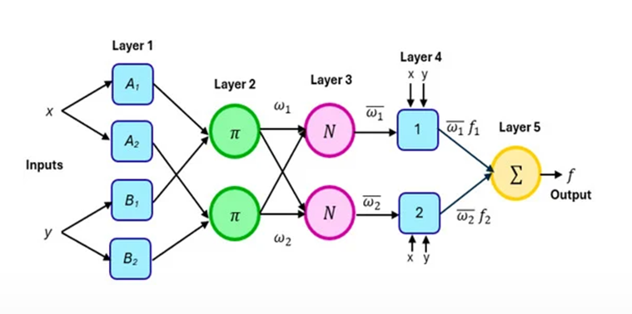
Figure ‎2.2 Adaptive neuro-fuzzy inference system (Jang, 1993)
Layer 1: Fuzzification Layer (Premise Parameters)
This first layer consists of adaptive nodes that perform the fuzzification process. Its main function is to convert crisp input values into fuzzy membership degrees, which show how much each input belongs to a certain linguistic set. (Karaboga and Kaya, 2019) explained that the nodes in this layer are represented by membership functions, and the parameters of these functions are called premise parameters because they are adjusted during the training stage. Assuming two inputs (x and y), the output of node i in this layer is calculated according to the chosen membership function ($μ$), expressed as:
$C_{1,i}=μA_{i}\left(x\right) \text{for }i=1,2$
$C_{1,i}=μ_{Bi-2}\left(y\right),i=3,4,$ (2.1)
Layer 2: Rule Base Layer (Premise Parameters)
Following the fuzzification process, signals are transmitted to the Rule Layer. This layer consists of fixed nodes labeled (∏), which represent the rule base. These nodes multiply the incoming membership degrees to calculate and represent the Firing Strength (or weight) of each specific rule:
$C_{2,i}=w_{i}=μA_{i}\left(x\right)×μB_{i}\left(y\right), i=1,2$ (2.2)
Layer 3: Normalization Layer
This layer contains fixed nodes, usually written as N. Its role is to calculate the normalized firing strength of each rule by dividing its firing strength by the total firing strength of all rules. (Rajab, 2019) explained that this step helps balance the contribution of all rules before producing the final output.
$C_{3,i}=\overline{w_{i}}=\frac{w_{i}}{w_{1}+w_{2}}$ (2.3)

Layer 4: Defuzzification Layer (Consequent Parameters)
This layer is an adaptive layer that performs the first step of defuzzification. It combines the normalized firing strength of each rule with the consequent parameters (pi, qi, ri). (Rajab, 2019) explained that these parameters are adjusted during the training process to improve the prediction accuracy of the ANFIS model.
$C_{4,i}=\overline{w_{i}}f_{i}=\overline{w_{i}}\left(p_{i}x+q_{i}y+r_{i}\right)$ (2.4)
Layer 5: Summation and Output Layer Finally, the Summation Layer consists of a single fixed node (∑) that aggregates all incoming signals from Layer 4 to produce the final, precise Crisp Output, thereby completing the fuzzy inference cycle:

$C_{ 5,i}=\sum_{i}{\overline{w_{i}}}f_{i}=\frac{\sum_{i}{w_{i}f_{i}}}{\sum_{i}{w_{i}}}$ (2.5)

Hybrid Learning Mechanism of ANFIS
The hybrid learning mechanism is directly related to the performance of ANFIS. For complex problems, ANFIS can be trained using more than one learning method to improve prediction accuracy (Tabbussum and Dar, 2021). In this approach, least squares estimation (LSE) is used to calculate the linear consequent parameters during the forward pass and backpropagation is used to adjust the nonlinear premise parameters during the backward pass. This combination allows the training process to be more efficient and enables the model to represent more complex relationships between the inputs and outputs.
ANFIS has also been found to be more interpretable than many traditional neural network models, in addition to its learning ability. According to Liu et al. (2022), ANFIS keeps a clear structure as it is based on fuzzy rules and layered processing. Additionally, neuro-fuzzy systems were mentioned as tools that can be used in engineering applications, as they combine data-based learning with human-like reasoning (Tiruneh et al., 2020). That is why ANFIS can provide a useful balance between prediction accuracy and interpretability, particularly in situations where both reliable results and clear explanation are needed.

Performance Evaluation Metrics
Four statistical measures, namely RMSE, MAE, MAPE and R², were used to evaluate the performance of the developed ANFIS models. These metrics are commonly used in statistical analysis and machine learning regression models to assess prediction accuracy by measuring the difference between the predicted and actual values. Multiple evaluation metrics provide a more accurate and reliable assessment than a single one because each metric measures a different aspect of prediction error (Chicco et al., 2021). The evaluation was performed on the testing dataset, which was not used in the training phase, to ensure an unbiased evaluation of the model generalization ability.

Root Mean Square Error (RMSE)
RMSE was used to measure the overall magnitude of prediction error between the predicted and actual values.

$RMSE=\sqrt{\frac{1}{n}\sum_{i=1}^{n}{{\left(y_{i}-\hat{y_{i}}\right)}^{2}}}$ (2.6)

Mean Absolute Error (MAE)
MAE was used to measure the average absolute difference between the predicted and actual values.

$MAE=\frac{1}{n}\sum_{i=1}^{n}{\left|y_{i}-\hat{y_{i}}\right|}$ (2.7)

Mean Absolute Percentage Error (MAPE)
MAPE was used to express prediction error as a percentage of the actual values.
$MAPE=\frac{100}{n}\sum_{i=1}^{n}{\left|\frac{y_{i}-\hat{y_{i}}}{y_{i}}\right|}$ (2.8)

Coefficient of Determination ($R^{2}$)
$R^{2}$is a statistical measure that indicates the proportion of variance in the dependent variable that is explained by the independent variable(s) in a regression or prediction model.
$R^{2}=1-\frac{\sum_{i=1}^{n}{{\left(y_{i}-\hat{y_{i}}\right)}^{2}}}{\sum_{i=1}^{n}{{\left(y_{i}-\overline{y}\right)}^{2}}}$ (2.9)

Chapter Summary
This chapter reviewed the main topics related to road maintenance cost estimation. It showed that factors such as pavement condition, traffic loads, environmental conditions and maintenance requirements affect maintenance cost.
The chapter also showed that traditional methods are useful, but they may not be enough when the cost is affected by many related and nonlinear factors. Based on the reviewed literature, ANFIS was selected as a suitable method for developing the prediction model used in this study.

Methodology and Data Analysis

Introduction
The chapter explains the research methodology used to develop the road maintenance cost prediction model in Karbala Governorate. It outlines the general procedures of the study, including the identification of the factors affecting maintenance cost, collecting the required project data, and preparing them for analysis. The chapter also introduces expert questionnaires and statistical analysis to support the selection of the model input variables.
Furthermore, this chapter describes the main procedures used for model development, such as data preprocessing, data splitting and model training. It also introduces the development of ANFIS models using SC and FCM methods and comparison with ANN and MLR models. The performance measures used to evaluate the prediction models are also presented.

Case Study
The study area was chosen as the road network in Karbala Governorate is constantly subjected to the pressures of urban traffic, pilgrimages, and services. According to (Khudhair et al., 2024), many urban streets in Karbala are congested during peak hours with some parts of the road operating at LOS (E) or LOS (F), which indicates unstable traffic conditions and low network efficiency. The same study by Ewadh et al. (2018), also revealed that pavement age, traffic volume and structural features are the main factors that affect road deterioration in the governorate. This pressure is increased by construction activities, heavy transport from cement, sand and gravel plants and the growth of residential development. According to Al-(Theyab, 2021), the network is highly loaded, as major intersections experience high delays, particularly in the vicinity of the old city. The conditions of Karbala are appropriate for creating a data-driven model to predict the cost of road maintenance.

Open Survey
The open survey was the initial stage of data collection and aimed to check the relevance of the preliminary factors affecting the cost of road maintenance in the local conditions of Karbala Governorate.

Open Survey Stage
The open survey stage aimed to analyze the relevance of the preliminary factors that affect the cost of road maintenance in the local context of Karbala Governorate. In this phase, after reviewing the related literature, 10 initial factors were identified and the questionnaire (Appendix A) was prepared. The questionnaire comprised three broad categories; background information about the respondents, assessment of the factors identified on a five-point Likert scale, and a section for additional practical factors and comments from the experts. The results of this stage were used to confirm the initial list of factors and to identify locally relevant variables to be taken forward for analysis in the next stage.

Sample Selection Criteria
The respondents of the open questionnaire were selected from the professionals who work in the field of road maintenance, planning and supervision in Karbala Governorate. It comprised engineers, project managers, consultants and academic specialists with a direct link to the research topic. The criteria were chosen to make sure that the factors identified were based on local technical and practical experience.

Sample Characteristics
The specialists were selected using purposive sampling based on the criteria from the University of Karbala, Roads and Bridges Directorate, and Karbala Municipalities, and 21 specialists were selected. The sample consisted of project managers, execution engineers, and consultants who had relevant experience in road maintenance, as detailed in Table (3.1).
Table ‎3.1 Professional Profile of the Surveyed Experts (Researcher)
ID | Position | Education Level | Years of Experience | Work Sector
R1 | Project Manager | PhD | Between 11-25 years | Roads and Bridges
R2 | Execution Engineer | Master's degree | More than 25 years | Roads and Bridges
R3 | Project Manager | PhD | More than 25 years | University
R4 | Consultant | Master's degree | More than 25 years | Municipality
R5 | Execution Engineer | Master's degree | Between 5-10 years | Municipality
R6 | Consultant | PhD | Between 11-25 years | University
R7 | Project Manager | PhD | Between 11-25 years | University
R8 | Consultant | PhD | Between 11-25 years | University
R9 | Execution Engineer | Bachelor's degree | Between 5-10 years | Municipality
R10 | Consultant | Master's degree | Between 5-10 years | Roads and Bridges
R11 | Project Manager | Master's degree | Between 5-10 years | Roads and Bridges
R12 | Consultant | Bachelor's degree | Between 5-10 years | University
R13 | Project Manager | PhD | Between 5-10 years | University
R14 | Consultant | Master's degree | Between 11-25 years | Roads and Bridges
R15 | Execution Engineer | Bachelor's degree | Less than 5 years | Roads and Bridges
R16 | Execution Engineer | Bachelor's degree | Between 5-10 years | Municipality
R17 | Consultant | Master's degree | Between 11-25 years | University
R18 | Project Manager | Master's degree | Between 11-25 years | Roads and Bridges
R19 | Execution Engineer | PhD | Between 5-10 years | University
R20 | Project Manager | Master's degree | Between 11-25 years | Roads and Bridges
R21 | Consultant | Master's degree | Between 11-25 years | Roads and Bridges

Personal Information
The data collected on the educational qualifications, years of experience and job roles of the participants were processed using the Statistical Package for the Social Sciences (SPSS) to analyze the demographic profile of the participants. This software allowed for the systematic organization and description of the experts' backgrounds, and the appropriateness and reliability of the selected sample for the study was confirmed.
First: Academic Achievement
Figure (3.1) shows that master’s degree holders represent the largest group at 48%. This indicates that most experts had an advanced academic background relevant to the study. It also supports the reliability of the opinions used in this stage.

Figure ‎3.1 Academic Achievement of Open Survey Respondents (Researcher)
Second: Profession
Figure (3.2) shows that consultants represent the largest group at 38%. This indicates that a considerable part of the sample had relevant practical experience. It also supports the practical value of the responses provided by the experts.

Figure ‎3.2 Respondents Profession (Researcher)
Third: Years of Experience
Figure (3.3) shows that the 11–25 years category represents the largest group at 48%. This indicates that most experts had substantial field experience. It also strengthens the value of their judgments in identifying the factors affecting road maintenance cost.

Figure ‎3.3 Respondents' Years of Experience (Researcher)
The statistical analysis results confirm that the selected experts hold appropriate qualifications, professional backgrounds, and experience levels. They can provide reliable opinions on the topics studied.

Results of Open Questionnaire
The ten initial factors were generally agreed upon by the experts for their relevance using the open questionnaire. The answers also indicated practical issues related to the roads in Karbala Governorate. Three additional factors were added to the final list based on these observations: soil layers beneath the road, the storm-water drainage network, and trees in the central medians. This made the number of variables 13. These 13 factors were then used to formulate the closed questionnaire stage.

Closed Survey
A structured closed questionnaire was developed based on the results of the open survey. This questionnaire contained the finalized 13 factors and was sent to a larger number of specialized experts for review. Each factor's effect on the road maintenance cost was measured on a scale of 1 (No Effect) to 5 (Very High Effect) using a five-point Likert scale. The responses gathered were then converted into numerical data, and analyzed with the RII to rank the factors and determine the main input variables for the proposed prediction model.

Sample Size of Closed Survey
The study population was determined to be 64 engineers and specialists from the University of Karbala, Roads and Bridges Directorate, and the Directorate of Karbala Municipality distributed throughout the governorate center, districts and sub-districts, to ensure the results were representative. The required sample size was determined by using a formula suggested by (Mukti, 2025) for finite populations as follows:
$n=\frac{N}{1+N{(e)}^{2}}$ (3.1)
Where:
- n: The required sample size.
- N: The total population size (64).
- e: The margin of error (set at 0.05).
Therefore, the calculated minimum sample size was 55 respondents. To ensure this target was met, a total of 59 questionnaires were distributed. Out of these, 55 valid responses were successfully retrieved, achieving the required sample size for the analysis.

Reliability of the Questionnaire
To assess the internal consistency of the closed questionnaire items, Cronbach's Alpha coefficient was used to examine the reliability of the closed questionnaire. In this study, SPSS was used for reliability analysis. The Cronbach's Alpha value obtained was 0.81 which is above the recommended minimum value of 0.70 by (Kotian et al., 2022). This result shows that the consistency of the questionnaire items was acceptable and the answers received were appropriate for subsequent statistical analysis and model development. Cronbach's Alpha can be written mathematically as shown in Equation:
$α=\frac{k }{k-1}\left(1-\frac{\sum{{Si}^{2}}}{{St}^{2}}\right)$ (3.2)
Where,
K: denotes the number of questions in the collection.
Si: represents the variation in scores for each particular question.
St: reflects the overall variation in scores across all questions

Relative Importance Index (RII)
Ranking of the factors influencing road maintenance costs was carried out using the RII based on the experts' feedback. This statistical technique converts responses from the five-point Likert scale into a standardized value ranging from 0 to 1, allowing evaluation of the relative importance of each factor. The RII for each identified factor was calculated using Equation (3.3) (Azman et al., 2019):
$RII=\frac{\sum{w}}{AN}=\frac{{5n}_{5}+{4n}_{4}+{3n}_{3}+{2n}_{2}+{1n}_{1}}{5N}$ (3.3)

$\left(0≤RII ≤1\right)$
W: Represents the rating assigned to each factor by the participants, ranging from 1 to 5.
A: Denotes the maximum possible value on the scale used in this study (which is 5).
RII values are categorized into five levels as shown in Table (3.2). (Rooshdi et al., 2018):
Table ‎3.2 Classification of RII Values and Importance Levels
RII | Importance level
0.8 ≤ RII≤ 1 | High | H
0.6 ≤ RII < 0.8 | High-medium | H-M
0.4 ≤ RII < 0.6 | Medium | M
0.2 ≤ RII < 0.4 | Medium-low | M-L
0 ≤ RII < 0.2 | Low | L

Analysis of Closed Survey Results
The responses of the closed questionnaire were coded and analyzed using SPSS. The analysis produced the mean, standard deviation, and RII value for each factor. These results were used to rank the factors according to their relative importance and to support the selection of the variables adopted in the prediction model.

Closed Survey Form
The closed questionnaire was in two main sections as shown in Appendix (B). The first part provided information on the personal details of the participants, such as their academic qualifications, specialization, number of years of experience and their job title. This information was used to give an overview of the background of the respondents. The second part was about evaluating the effect of the 13 factors affecting the cost of road maintenance. These factors were the 10 factors identified from the literature and the 3 local factors identified after the open survey stage: soil layers beneath the road (F11), trees in the central medians (F12) and the storm-water drainage network (F13). The effect of each factor was measured on a five-point Likert scale (No effect = 1 to High effect = 5).

Analysis of Personal Information
The questionnaire sample's characteristics is as follows:
First: Academic Achievement
Figure (3.4) shows that respondents with postgraduate degrees (master’s and PhD) account for 62% of the sample. This indicates that a large proportion of the sample had an advanced academic background relevant to the study. It also supports the reliability of the sample in evaluating the factors affecting road maintenance cost.

Figure ‎3.4 Academic Achievement of Closed Survey Respondents (Researcher)

Second: Scientific Specialization
Figure (3.5) shows that respondents specialized in civil engineering and project management account for 86% of the sample combined. This indicates that most respondents had an academic background directly related to the technical and managerial aspects of the study.

Figure ‎3.5 Scientific Specialization of the Respondents (Researcher)
Third: Years of Experience
Figure (3.6) shows that respondents with more than 11 years of experience account for 51% of the sample. This indicates that more than half of the respondents had substantial practical experience relevant to the study. It also supports the reliability of their judgments in evaluating the factors affecting road maintenance cost.

Figure ‎3.6 Responders Years of Experience (Researcher)

Analysis of Respondent Consensus
A Kruskal–Wallis test was conducted to check if the experts' experience had an impact on their judgment of the factors affecting road maintenance cost. The Kruskal–Wallis test was used because it is a suitable nonparametric test to compare three or more independent groups when the data do not meet the assumptions of parametric tests, as explained by (Arifin, 2026). The respondents were classified into four groups based on the number of years they had of experience in their work, namely less than 5 years, 5-10 years, 11-25 years and more than 25 years. All the significance values of the factors were above 0.05 as reported in Table (3.3). This means that the experts' responses did not differ significantly between the experience groups.
Table ‎3.3 Kruskal-Wallis Test Results
Factor Code | Kruskal-Wallis H | p-value (Sig.)
F1 | 3.658 | 0.301
F6 | 0.679 | 0.878
F2 | 3.593 | 0.309
F3 | 7.134 | 0.068
F9 | 3.269 | 0.352
F5 | 2.149 | 0.857
F4 | 2.592 | 0.933
F13 | 5.226 | 0.156
F11 | 2.592 | 0.459
F8 | 2.600 | 0.457
F7 | 4.414 | 0.220
F12 | 0.793 | 0.851
F10 | 0.767 | 0.857

These results indicate sufficient agreement among the respondents and support proceeding with the ranking of factors using the RII.

Factor Ranking Based on RII Analysis
After confirming the consistency of the respondents’ opinions, the researcher ranked the identified factors using the Relative Importance Index (RII) method. This step was carried out to determine the importance of each factor affecting road maintenance cost in Karbala. The RII values were then used to arrange the factors from the highest to the lowest, as presented in Table 3.4. Based on the accepted importance level, the researcher retained the relevant factors for the next stage of analysis and model development.
Table ‎3.4 RII Results for Factors Affecting Road Maintenance Cost
Factor Code | Mean | Std. Deviation | RII | Rank | Level
F1 | 4.04 | 0.84 | 0.815 | 1 | H
F6 | 4.02 | 0.85 | 0.802 | 2 | H
F2 | 4.00 | 0.82 | 0.795 | 3 | H-M
F3 | 3.96 | 0.77 | 0.794 | 4 | H-M
F9 | 3.93 | 0.81 | 0.792 | 5 | H-M
F5 | 3.89 | 0.81 | 0.781 | 6 | H-M
F4 | 3.69 | 0.74 | 0.742 | 7 | H-M
F13 | 3.67 | 0.82 | 0.733 | 8 | H-M
F11 | 3.65 | 0.91 | 0.731 | 9 | H-M
F8 | 3.62 | 0.80 | 0.720 | 10 | H-M
F7 | 3.51 | 0.81 | 0.705 | 11 | H-M
F12 | 3.44 | 0.98 | 0.692 | 12 | H-M
F10 | 3.40 | 0.81 | 0.684 | 13 | H-M

The results show that all factors achieved RII values above 0.60 and were therefore retained for the next stage of model development.

Historical Data Collection
The data used in this study were obtained from official records from Roads and Bridges Directorate and Karbala Municipalities to support the proposed prediction model. All the data collected were based on the final measurements of completed maintenance projects, as indicated in Appendix (C), i.e. as-built quantities and actual executed costs rather than preliminary estimates. The records in the database were for complete maintenance projects. These records were used to prepare a database covering the period from 2010 to 2025 for the development of the ANFIS model.

Dataset Description
248 road maintenance projects were identified and documented to create the final dataset. These projects included various maintenance activities carried out in Karbala Governorate in the study period 2010–2025. The main types of maintenance work were included in the dataset, such as asphalt overlay, road rehabilitation, and patching. This dataset was used as a practical basis for the analysis of the factors related to maintenance cost and development of the ANFIS prediction model.

Model Variables Definition and Fuzzification Strategy
The input variables were divided into three categories: fuzzy variables based on linguistic categories, numerical variables and binary variables as follows:

Fuzzy Variables
  - Traffic Volume (AADT): This variable was categorized into three categories: Low, Medium and High, following the principles of traffic classification from AASHTO (2018) guidelines. The classification was used to represent the variation in traffic demand and its effect on pavement deterioration and pavement maintenance cost. Roads with higher traffic volumes will be expected to need a greater maintenance effort than roads with lower traffic volumes.
  - Heavy Vehicle Percentage: This variable was fuzzified as Low, Medium and High. The significance of its importance is that the damage to the pavement is more related to the axle loads of the vehicles than the number of vehicles. The Equivalent Single Axle Load (ESAL) factor rises rapidly when the percentage of heavy trucks is more than 8-10% based on AASHTO (1993) standards. Thus, pavement condition in the High category is indicative of a rapid deterioration rate, requiring higher financial allocations for major pavement rehabilitation projects.
  - Pavement Age: This was categorized into New (0-6 years), Medium (6-12 years) and Old (12-18 years). This classification takes into account the amount of deterioration over time as a result of the age of the pavement. It was based on the design life of pavement according to SCRB specifications. The new category is the best pavement condition while the medium and old categories have a higher likelihood of defects and maintenance requirements.
  - Subgrade Soil Condition: The California Bearing Ratio (CBR) value was used to fuzzify this variable into three categories: Weak (CBR < 3%), Fair (CBR = 3%–8%), and Strong (CBR > 8%). This classification is based on AASHTO guidelines for assessment of subgrade strength. Differential settlement and early alligator cracking in the surface layers are caused by weak subgrade soils. These situations require design engineers to use costly treatments such as soil replacement or increasing base thickness, which inevitably adds to the overall cost of maintenance.
  - Type of Maintenance: This was broken down into three levels: Preventive, Routine and Emergency. This classification is based on the overall trend of increasing maintenance costs from early treatment to more extensive repairs. In most cases, preventive maintenance is less expensive and delayed maintenance may be more expensive as the size of the repair/rehabilitation may increase.
  - Pavement Condition Index (PCI): This variable was defined based on the PCI framework provided in ASTM D6433, which is a pavement condition rating from 0 to 100. The lower PCI levels were broken down into three practical categories for this study: Fair (56-70), Poor (41-55), and Very Poor (0-40). This classification was adopted in order to simplify the ANFIS rule base, but still retain the practical and engineering meaning of pavement condition. It also agrees with recent studies supporting the more simplified categories of PCI for maintenance decision-making, e.g., (Ashqar et al., 2025). Considering this, PCI is used in the present study as an important indicator for determining the required maintenance strategy and estimating the related cost.

Numerical Variables
  - Area of Affected Pavement: This variable has been added as a continuous numerical variable measured in square meters (m²). It was added because the maintenance cost for the affected pavement area is directly related to the size of the area. This is a variable that may be different for larger work areas than for smaller maintenance areas and is important for model development.
  - Asphalt Layer Thickness: is a crisp numerical variable in centimeters (cm) that indicates the thickness of the asphalt layer used in the maintenance work. It was added because the thickness of the asphalt has a direct impact on the amount of materials used, as well as the overall cost of maintenance. Also, variations in thickness indicate variations in the type and extent of necessary treatment.
  - High Temperature Severity (HTS): This variable was added as a numerical variable to account for the combined effects of high temperature on pavement deterioration. It was estimated based on the meteorological data from 2000 to 2025 by adding all the hours during which the air temperature exceeded 45°C, and then converting them to equivalent days. The threshold of 45°C was selected based on the severe high temperature conditions of the hot central and southern governorates of Iraq, which were reported in recent studies by (Al-Nawasir and Al-Humeidawi, 2023) where PG76-10 was used. Also, recent testing of the thermal performance of asphalt mixes under Iraqi summer conditions revealed that the mixes designed for PG76-10 are specifically tested at high temperatures up to 75°C, and that the use of a high-air-temperature threshold as a measure of severe thermal exposure was supported, as reported by (Jaleel et al., 2025). The HTS variable was therefore linked with pavement age to account for both temperature severity and the length of time that the pavement has been exposed to the temperature.
  - Road Classification: This variable was coded numerically. The main roads were given a value of (1) and the secondary roads a value of (2).
  - Type of Road Layers: This variable was coded as a numerical variable. Roads were given a value of (1) for asphalt roads and (2) for concrete roads.

Binary Variables
  - Rainwater Drainage System Efficiency: This variable was coded as a binary variable. (1) means that there is an effective drainage system; (0) means that there is no effective drainage system. This variable was included as it relates to water that accumulates on the pavement surface due to the drainage condition, which in turn affects pavement deterioration and maintenance cost.
  - Central Medians Irrigation Impact: This variable was coded as a binary variable. A value of (1) was given if a central median was present with continuous irrigation, and a value of (0) was given if it was absent.

Selection of Model Input Variables
The last step in this stage was to determine the input variables for the proposed ANFIS model. All 13 factors scored within the range of 0.68 to 0.81, based on the calculated RII values. The classification adopted by Akadiri (2011) for the RII values from 0.60 to less than 0.80 considers them as high-medium level of importance, and values from 0.80 to 1.00 as high level of importance. However, as all the factors were within these acceptable importance ranges, the researcher kept them as input variables to develop the prediction model. The selection of the variables used in the model was based on the results of the questionnaire analysis and the expert evaluation process, which gave a clear basis for selecting the variables. The variables chosen for the study, their description, and coding are shown in Table 3.5.
Table ‎3.5 Input Variables for ANFIS Cost Estimation Model
Variable | Description | Unit/Coding
V1 | Pavement Area | Square Meter
V2 | Pavement Age | 1= New, 2= Medium, 3= Old
V3 | Median Islands | 1= Exist, 0= None
V4 | Asphalt Thickness | Centimetres
V5 | High Temperature Severity )HTS) | number of days exceeding 45°C
V6 | Road Classification | 1= Main, 2= Secondary
V7 | Road Condition (PCI) | 1= Fair, 2= Poor, 3= Very Poor
V8 | Heavy Vehicle )AADT( | 1= Low, 2= Medium, 3= High
V9 | Drainage System | 1= Exist, 0= None
V10 | Type of Maintenance | 1= Preventive, 2= Routine 3= Emergency
V11 | Soil Strength | 1= Weak, 2= Medium, 3= Strong
V12 | Pavement Type | 1= Asphalt, 2= Composite (Asphalt + Concrete)
V13 | Traffic Volume (AADT) | 1= Low, 2= Medium, 3= High

The variables in Table (3.5) are geometric, structural, traffic, environmental and maintenance variables that have an impact on road maintenance cost estimation. Continuous variables like pavement area, asphalt thickness and high temperature severity were entered as continuous values, while other variables were coded as categorical variables for their use in the ANFIS model. This combination provides a comprehensive representation of the main factors influencing pavement maintenance and rehabilitation costs. Thus, including all 13 variables improves the ability of the model to predict the relationship between project conditions and the expected cost.

Data Preprocessing
The data of 248 maintenance projects were systematically prepared before using them in the ANFIS model. In this stage, three major steps were taken: data cleaning, descriptive statistical analysis and data normalization. These steps were performed to organize the information and to make it suitable for model development. These are described in the next few subsections.

Data Cleaning
Before model development, the data obtained from the final measurement records of the 248 maintenance projects were examined. A few missing data were identified for some qualitative data including pavement age, pavement condition (PCI), traffic loading, and subgrade soil strength. These variables are typically determined by field observation and engineering judgment, and are not necessarily measured. Thus, they are considered as fuzzy data and cannot be filled with statistical techniques. No missing quantitative and financial data were identified because the data were fully recorded in the official documents. The missing data were completed by contacting the supervising engineers of the projects to determine the correct classification for the actual conditions on site during the project's execution.

Descriptive Statistics
The dataset of 248 projects was used for descriptive statistical analysis of the 13 input variables and the output variable (maintenance cost). This was done to determine the minimum, maximum, mean and standard deviation of each variable. The universe of discourse for the membership functions was determined by the minimum and maximum values in the ANFIS model. Table (3.6) shows the statistical results of all variables.
Table ‎3.6 Descriptive Statistics for Model Variables
Variable | N | Minimum | Maximum | Mean | Std_Deviation
V1 | 248 | 95 | 140764 | 35712 | 34433
V2 | 248 | 1 | 3 | 2.17 | 0.81
V3 | 248 | 0 | 1 | 0.51 | 0.50
V4 | 248 | 6 | 16 | 8.58 | 2.54
V5 | 248 | 161 | 585 | 407.09 | 142.68
V6 | 248 | 1 | 2 | 1.59 | 0.49
V7 | 248 | 1 | 3 | 1.98 | 0.90
V8 | 248 | 1 | 3 | 2.18 | 0.77
V9 | 248 | 0 | 1 | 0.84 | 0.37
V10 | 248 | 1 | 3 | 2.00 | 0.90
V11 | 248 | 1 | 3 | 1.90 | 0.72
V12 | 248 | 1 | 2 | 1.09 | 0.29
V13 | 248 | 1 | 3 | 1.95 | 0.89
C | 248 | 1.9 × 10⁶ | 3.59 × 10⁹ | 8.02 × 10⁸ | 8.24 × 10⁸

Data Normalization
Before model training, the data were preprocessed using a normalization step. The input variables and the output cost were scaled to the range [0,1] using the Min-Max method. This method is widely used in machine learning to place variables on a common scale and improve model efficiency. The normalization process was performed according to Equation (3.4):
$X_{norm}= \frac{X_{}-X_{min}}{X_{max}-X_{min}}$ (3.4)

Training, Checking, and Testing Sets
The processed dataset consisting of 248 maintenance projects was split into three subsets: training, checking, and testing, for model development and evaluation. To maintain a similar distribution of maintenance cost in the three subsets, a stratified data partitioning approach was used in this study. To reduce sampling bias and to ensure that the training, checking, and testing sets had a similar pattern of the output variable, this approach was adopted. The training set was used to train the ANFIS model and to adjust the parameters of the model, the checking set was used during the training process to monitor the behavior of the model and to reduce the overfitting problem, and the testing set was used to test the model with unseen data and to evaluate the performance of the model.

Different Data Split Ratios
A number of data split ratios were tested to find the most suitable distribution for the development of the ANFIS model as shown in Table (3.7). The evaluation was done by comparing the predictive performance of the models generated with different percentages of training, checking and testing data. From the comparative results, the ratio of 70:20:10 was chosen as the final split of data for training, checking and testing. This ratio had the highest overall predictive performance of the scenarios tested and was thus used in the further stages of model development.
Table ‎3.7 Data Splitting Scenarios and Performance Metrics
Data Division, % |  |  | Training error, % | Testing error, % | Determination Coeff. (R²)
Training, % | Checking, % | Testing, %
85 | 10 | 5 | 10.5 | 9.2 | 91.3
85 | 5 | 10 | 12.1 | 11.4 | 89.6
80 | 5 | 15 | 8.9 | 13.8 | 87.1
80 | 10 | 10 | 20.1 | 15.9 | 92.8
80 | 15 | 5 | 14.2 | 19.2 | 91.7
70 | 15 | 15 | 18.4 | 17.3 | 90.6
70 | 20 | 10 | 5.1 | 8.19 | 95.1
70 | 5 | 25 | 9.4 | 11.6 | 88.5
65 | 20 | 15 | 11.5 | 21.8 | 87.3
65 | 25 | 10 | 13.4 | 24.2 | 86.8

Statistical Homogeneity Test (ANOVA)
The training subset, checking subset and testing subset were subjected to a one-way ANOVA test to determine the consistency of the data partitioning. The calculated P value is 0.6738 (> 0.05) as presented in Table (3.8), which means that there is no significant difference among the means of the three subsets.
In addition, Levene's test was used to test for equality of variances. Odoi and Samita (2019) state that this test is an important step to support the ANOVA results. The calculated P-value in Levene's test was 0.7123 (> 0.05), indicating that the variances of the subsets are homogeneous. The similar standard deviations and minimum and maximum values of the datasets also support this result. Lastly, the spread of the data in the subsets is similar in the boxplot as seen in Figure (3.7). Thus, the chosen data split is statistically acceptable for modeling.

Table ‎3.8 One-Way ANOVA Results for the Data Subsets
Source | Sum of Squares (SS) | Degrees of Freedom (df) | Mean Square (MS) | F-value | p-value
Groups | 8.24 × 10¹⁶ | 2 | 4.12 × 10¹⁶ | 0.4 | 0.6738
Error | 2.68 × 10¹⁹ | 245 | 1.04 × 10¹⁷
Total | 2.68 × 10¹⁹ | 247
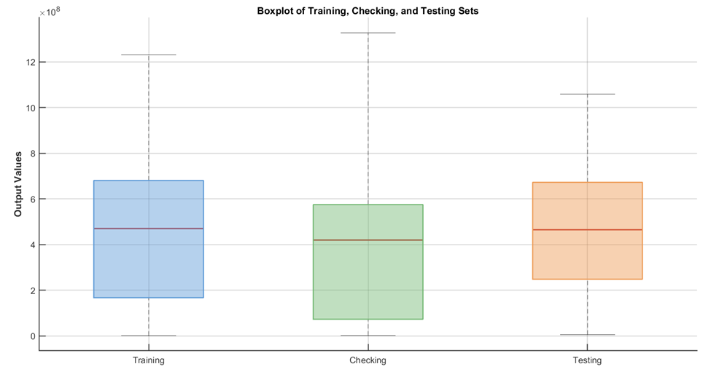
Figure ‎3.7 Boxplot of Data Subsets

Fuzzy Rule Generation Methods
The initial rule base and membership functions were determined automatically from the data using clustering methods. In this study, SC and FCM were used to identify data clusters, and these clusters were then used to generate the initial fuzzy rules and membership functions before ANFIS training.

Subtractive Clustering (SC) Approach
The SC approach was used to generate the initial FIS from the input data. In this method, the clustering process depends on the Influence Radius parameter, which affects the number of clusters and the size of the rule base. To examine its effect on model performance, five radius values were tested: 0.2, 0.4, 0.6, 0.8, and 1.0. For each value, an initial FIS was generated and then evaluated during model development.

Fuzzy C-Means (FCM) Approach
The FCM approach was used as an alternate method to create the original FIS. In this approach, the number of clusters needs to be determined prior to the clustering procedure. For this reason, five cluster sizes were tested: 8, 10, 12, 14, and 16. The fuzziness exponent (m) that determines the overlap between the clusters was also investigated for three values of 1.5, 2.0 and 2.5. A set of initial FISs were created for each combination and then assessed during the model development process.

Model Parameter Optimization
After generating the initial FIS structures, a grid search procedure was used to tune the main model parameters. This step was implemented to identify the best parameters to use in the model during development.

Membership Functions Evaluation
In this step, various membership function types were used to investigate their effect on the performance of the ANFIS model. The membership function is an important element for representing the input data in the fuzzy system, so the following membership functions were evaluated: Gaussian (gaussmf), Two-sided Gaussian (gauss2mf), Generalized Bell (gbellmf), Difference between two sigmoidal functions (dsigmf), and Pi-shaped (pimf). The models were tested with the selected clustering settings and the performance of the models was compared to determine which function is most suitable to represent the input variables.

Hybrid Training and Epoch Selection
The hybrid learning algorithm was used to train the ANFIS model. This algorithm has a training process that combines the least-squares method and gradient descent. The duration of training was investigated by varying the number of epochs: 50, 75, 100, 150, and 200. In this stage, the performance of the model was monitored using the checking set and the most appropriate training setting was selected.

Grid Search Procedure for Model Configuration
After the main model parameters were fixed, all the possible combinations of these parameters were created and tested using a grid search. This step was to demonstrate the effects of various parameter combinations on the performance of the ANFIS model. In the SC approach, the combinations consisted of 10 data partitioning ratios, 5 types of membership functions, 5 influence radius values and 5 epoch levels, resulting in 1,250 different models (10×5×5×5). Likewise, the FCM approach comprised 10 data partitioning ratios, 5 cluster sizes, 3 fuzziness exponent values and 5 epoch levels, which yielded 750 models (10×5×3×5).
A total of 2,000 ANFIS models were constructed and tested in this stage. The final comparison was based on the performance of each model on the testing dataset, to find the best one.

Comparison of SC and FCM Models
After evaluating the 2,000 generated models, a comparison was made between the SC and FCM approaches. First, the models within each approach were ranked according to their performance on the testing dataset. The model with the lowest error values and the highest $R^{2}$ in the SC group was selected as the best SC model. The same procedure was applied to the FCM group to identify the best FCM model. The two selected models were then compared directly using the evaluation metrics (RMSE, MAE, MAPE, $R^{2}$) and the final number of fuzzy rules. Based on this comparison, the model that achieved better predictive performance with a suitable rule structure was selected as the final ANFIS model.

Sensitivity Analysis Procedure
The final ANFIS model was subjected to a one-at-a-time (OAT) sensitivity analysis to find the relative influence of each input variable on the predicted maintenance cost. In this procedure, one input variable was varied at a time in its normalized range, with the other variables remaining at their mean normalized values. The change in the model output was then recorded for each variable. Then the sensitivity values were normalized to give the relative importance percentages of the input variables. These values were used to rank the model inputs, based on their effect on maintenance cost. The method is consistent with that reported by Tunkiel et al. (2020) in the OAT approach.

Comparative Models
The preprocessed dataset was used to test the developed ANFIS model with two benchmark models, ANN and MLR, with the same ratio of data partitioning (70% training, 20% checking, and 10% testing) to check the predictive performance of the developed ANFIS model. Such a setup was used to ensure consistency in model evaluation.

Artificial Neural Network (ANN) Model
A feedforward Artificial Neural Network (ANN) was developed with the MATLAB Deep Learning Toolbox. The ANN model was used with the same 13 input variables and the same output variable used in the ANFIS model, so that a direct comparison could be made. The network architecture consisted of an input layer, one hidden layer, and an output layer for the maintenance cost. The Levenberg–Marquardt algorithm was used for training. A trial-and-error method was used to determine the best architecture by changing the number of hidden neurons between 1 and 20. The best performance and lowest error during the testing phase were the criteria used for selecting the final model.

Multiple Linear Regression (MLR) Model
A Multiple Linear Regression (MLR) model was also developed as a conventional statistical benchmark. The model was established using the same preprocessed dataset and the same data partitioning adopted for ANFIS and ANN. This model was included to provide a reference for evaluating the performance of the AI-based models in maintenance cost prediction.
The predictive performance of ANFIS, ANN, and MLR was subsequently compared using RMSE, MAE, MAPE, and $R^{2}$, based on the unseen testing dataset.

Chapter Summary
The practical foundation for the construction of the prediction model was laid in this chapter. The affecting factors were validated using expert opinion and RII analysis and the historical data for 248 road maintenance projects were prepared for modeling. Data were cleaned, normalized and split into appropriate subsets for training, checking and testing.
The chapter also explained the modeling procedures employed in the study. ANFIS models were developed using SC and FCM methods, and the ANN and MLR models were prepared as comparison models. The evaluation process was established based on RMSE, MAE, MAPE and R² to support the selection of the best prediction model in the subsequent stage.

Results and Discussion

Introduction
This chapter presents the results of the prediction models developed in this study. It evaluates the ANFIS models developed using SC and FCM methods to select the best model.The selected ANFIS model is then examined through accuracy measures, rule analysis, and manual validation. Its performance is also compared with ANN and MLR models. Finally, sensitivity and interaction analyses are presented to identify the main factors affecting road maintenance cost in Karbala Governorate.

Cost Distribution
The distribution of maintenance cost across the collected projects is shown in Figure 4.1. The results indicate that most observations fall within the low to medium cost range, while a smaller number of cases extend to significantly higher values.
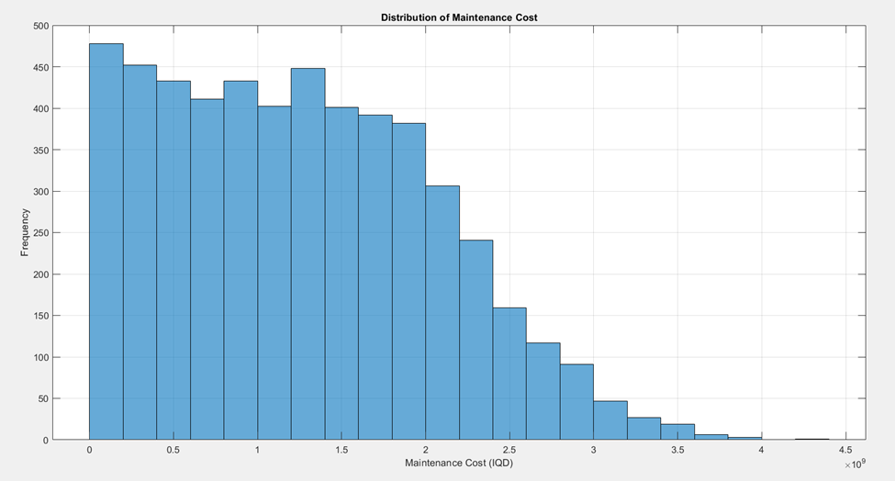
Figure ‎4.1 Distribution of Road Maintenance Costs in the Collected Dataset
The cost distribution shows that most maintenance projects fall within the low to medium cost range, while a smaller number of projects have higher costs. This indicates that maintenance cost does not follow the same pattern across all projects, but changes according to the conditions of each case. The presence of some high-cost cases suggests that certain factors may lead to a greater increase in maintenance cost than usual. Based on this, it can be understood that maintenance cost is not affected by one factor only, but by the combined effect of several variables. This explains the need for a model that can represent these relationships in a flexible way, such as the ANFIS model.

Performance Evaluation of ANFIS Models
This section presents the performance evaluation of the developed ANFIS models using two rule generation methods: SC and FCM. The models were compared based on the testing results to identify the best configuration for predicting road maintenance cost.

Model Performance Based on Subtractive Clustering (SC)
SC-based ANFIS models showed clear performance variation under different parameter settings. Several cluster radius and training epoch combinations were tested using grid search to identify the optimal configuration. The main results are summarized in Table 4.1 based on testing accuracy and stability.
Table ‎4.1 Performance Assessment of SC-ANFIS Models
Radius | MF_Type | Epochs | Rules | R² | MAPE | RMSE
0.4 | gaussmf | 70 | 10 | 0.94 | 8.98 | 73,967,493
0.4 | gaussmf | 200 | 10 | 0.94 | 9.0 | 78,967,493
0.2 | gbellmf | 50 | 17 | 0.93 | 10.3 | 69,431,937
0.3 | gbellmf | 70 | 17 | 0.95 | 10.9 | 62,652,736
0.2 | gbellmf | 100 | 17 | 0.95 | 11.3 | 65,467,345
0.4 | gauss2mf | 50 | 10 | 0.95 | 8.19 | 65,325,594
0.2 | gbellmf | 150 | 17 | 0.95 | 11.5 | 66,642,795
0.5 | dsigmf | 100 | 9 | 0.84 | 11.6 | 115,914,186
0.2 | gbellmf | 200 | 17 | 0.94 | 11.9 | 69,823,064
0.2 | dsigmf | 70 | 17 | 0.92 | 12.9 | 81,766,189
0.3 | dsigmf | 50 | 13 | 0.93 | 13.9 | 78,639,166
The results show that the model with a cluster radius of 0.4, gauss2mf, and 50 epochs achieved the best overall performance among the tested models, with R² = 0.95 and MAPE = 8.19%. This configuration showed a good ability to represent the relationship between the input variables and maintenance cost, and it provided the most accurate prediction among the examined cases. To present the prediction performance in a visual form, Figure 4.2 shows the relationship between the actual and predicted values for the testing dataset.
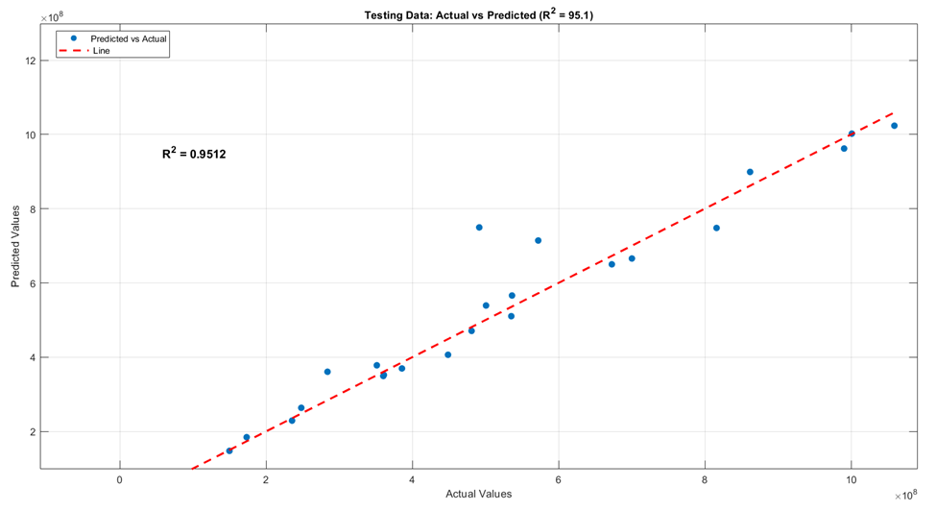
Figure ‎4.2 Actual vs Predicted Values for Testing Dataset
As shown in Figure 4.2, the predicted values are generally close to the actual values for most testing samples. The data points are distributed near the reference line, which indicates good agreement between the predicted and actual maintenance costs. Although some points show slight deviations, the overall distribution confirms that the selected SC-ANFIS model achieved good prediction accuracy during the testing stage.

Model Performance Based on Fuzzy C-Means (FCM)
The performance of FCM-based ANFIS models showed variation under different parameter settings. The main results are presented in Table 4.2, where the top configurations are arranged based on testing performance.
Table ‎4.2 Performance Assessment of FCM-ANFIS Models
Rules | Exponent | R_Squared | MAPE | RMSE
10 | 2.5 | 0.95 | 16.06 | 68,128,855
8 | 2.5 | 0.91 | 20.02 | 86,847,350
14 | 2.5 | 0.93 | 20.42 | 77,979,047
16 | 2 | 0.90 | 22.94 | 90,376,795
10 | 2 | 0.66 | 33.83 | 171,304,185
12 | 2 | 0.93 | 10.8 | 67,541,536
14 | 2 | 0.94 | 34.18 | 41,448,082
16 | 1.5 | 0.95 | 34.92 | 42,437,682
12 | 1.5 | 0.91 | 39.19 | 37,513,843
8 | 2 | 0.90 | 42.90 | 44,205,198

The model with 12 rules and an exponent value of 2 showed the best overall performance, with R² = 0.93 and MAPE = 10.8%. This indicates that the model was able to represent the relationship between the input variables and maintenance cost with good accuracy.
Clear differences between training and testing results were found in some model settings. This shows that the model is sensitive to parameter selection, especially the number of rules. Increasing the number of rules did not always improve prediction accuracy, and in some cases it reduced model stability.

Selection of the Optimal Model
The comparison between the best SC-based and FCM-based models is presented in Table 4.3. The results indicate a clear difference in prediction accuracy and model stability.
Table ‎4.3 Statistical comparison between the optimal SC and FCM models
Model | Clustering Technique | Fuzzy Rules | $$R^{2}$$ | MAPE (%)
Model 1 | Subtractive Clustering (SC) | 10 | 0.95 | 8.19
Model 2 | Fuzzy C-Means (FCM) | 12 | 0.93 | 10.8
The SC-based model achieved higher performance, with R² = 0.95 and MAPE = 8.19%, compared to R² = 0.93 and MAPE = 10.8% for the FCM-based model. This indicates better prediction accuracy and improved generalization for unseen data.
The reduced error and increased correlation of the SC model show its strong ability to capture the relationship between the input variables and maintenance cost. The results also show stable performance with low sensitivity to parameter changes. Based on these findings, the researcher selected the SC-based ANFIS model as the best model because it provides consistent and reliable prediction results.

Analysis of ANFIS Model Structure and Parameters
The structure of the selected SC-based ANFIS model is defined by a set of parameters that control its prediction behavior. The overall architecture of the model is illustrated in Figure (4.3), which shows the flow of data from input variables through membership functions and fuzzy rules to the final output. This structure reflects how the model processes the relationships between inputs and maintenance cost.
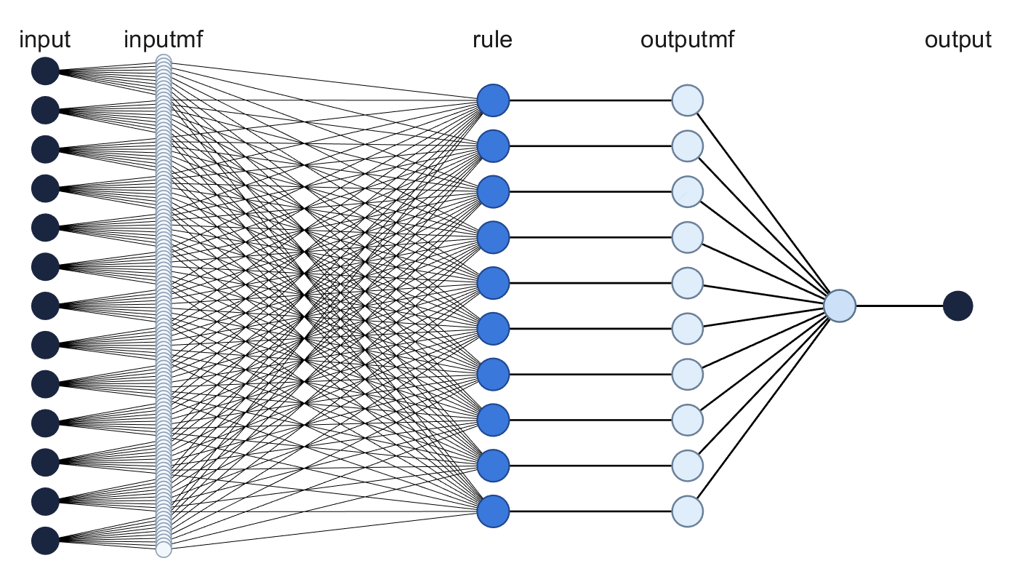
Figure ‎4.3 Architecture of the ANFIS Model Used for Cost Estimation
The model consists of 13 input variables and one output, based on a Sugeno-type system with gauss2mf membership functions and linear output functions. The connections between layers indicate the role of fuzzy rules in transforming input data into a predicted cost value. The main parameter settings adopted for this model are presented in Table (4.4), which summarizes the selected configuration used in the training and development process.
Table ‎4.4 Parameters of the Selected SC-ANFIS Model
Parameters | Settings
FIS Type | Sugeno
FIS Generation Method | Subtractive Clustering (SC)
Optimization Method | Hybrid
Input Nodes | 13
Output Node | 1
Membership Function Type | Gaussian Combination (gauss2mf)
Output Function Type | Linear
Cluster Radius | 0.4
Training Epochs | 50
Number of Fuzzy Rules | 10
Total Nodes | 164
Linear Params | 140
Nonlinear Params | 520
Total Parameters | 660
AND Method | Prod
OR Method | Probor
Defuzzification Method | Wtaver
The table shows the main parameters used in the model, such as the optimization method, number of rules, number of training epochs, and type of membership function. These parameters were selected to provide a good balance between model accuracy and simplicity. The selected number of rules and training epochs helped the model learn the main patterns in the data without adding unnecessary complexity. In general, this model setting gave stable results and showed a clear relationship between the input variables and maintenance cost.

Sugeno Linear Coefficients
The selected ANFIS model is given in table 4.5 in mathematical form representing the Sugeno linear coefficients of each fuzzy rule.
Table ‎4.5 Sugeno Linear Coefficients of the Optimal ANFIS Model
Rule | Rule1 | Rule2 | Rule3 | Rule4 | Rule5 | Rule6 | Rule7 | Rule8 | Rule9 | Rule10
V1 | 0.8711 | 0.9342 | 0.0101 | 0.899 | 1.030 | 0.923 | 0.931 | 0.01112 | 1.102 | 0.960
V2 | 0.0702 | 0.1103 | 0.0000 | 0.114 | -0.090 | 0.031 | 0.075 | 0.00031 | -0.409 | 0.048
V3 | 1.1211 | 0.0002 | 0.0031 | 0.047 | 0.000 | 0.031 | 0.000 | -0.00008 | -0.139 | 0.048
V4 | -0.0414 | 0.0513 | -0.0001 | 0.076 | -0.001 | 0.015 | -0.008 | -0.00010 | 2.059 | 0.001
V5 | -0.0063 | -0.0497 | 0.0003 | -0.002 | 0.100 | -0.011 | -0.029 | -0.00045 | -0.032 | -0.017
V6 | -0.042 | 0.1782 | 0.0004 | -0.088 | 0.176 | 0.000 | 0.016 | 0.00022 | -0.068 | 0.073
V7 | -0.0781 | -0.0491 | 0.0009 | -0.071 | -0.068 | -0.101 | -0.051 | 0.00041 | -0.494 | 0.009
V8 | 0.0533 | 0.1065 | -0.0001 | 0.062 | 0.028 | 0.051 | 0.019 | 0.00135 | -0.409 | -0.010
V9 | -0.3955 | -0.4420 | -0.0001 | -0.019 | 0.000 | 0.031 | 0.015 | -0.00003 | -0.130 | 0.000
V10 | -0.0295 | 0.0000 | 0.0004 | -0.008 | 0.010 | 0.027 | 0.016 | 0.00022 | 0.035 | -0.060
V11 | 0.1271 | 0.1062 | -0.0003 | -0.148 | -0.079 | -0.029 | 0.018 | -0.00057 | -0.002 | -0.026
V12 | -0.0026 | -0.0014 | 0.0002 | -0.091 | -0.065 | 0.002 | 0.006 | -0.00029 | -0.190 | 0.011
V13 | -0.1294 | 0.0002 | -0.0009 | 0.005 | -0.006 | 0.007 | 0.000 | -0.00038 | -0.231 | 0.003
Constant | -0.5377 | 0.1821 | -0.0003 | -0.025 | 0.032 | 0.032 | 0.017 | 0.00026 | -0.336 | 0.047
This model is made up of 10 fuzzy rules, with each rule having 13 input coefficients and 1 constant term, making a total of 140 coefficients. Each of these coefficients is the contribution of the input variable in a particular rule. The difference in the values of the coefficients between the rules suggests that the influence of the input variables is different in each rule. This implies that the model is not based on a fixed relationship, but instead is flexible and changes its response based on the pattern of the input.
The coefficients are a direct mathematical representation of the model structure. They also facilitate the understanding of the model and enable the predictability process to be analysed during the model validation and application.

Rule Importance Analysis
The fuzzy rules are not equally contributing to the selected SC-based ANFIS model as shown in figure 4.4. Rule 1 has the highest importance (20.4%), followed by Rule 4 (12.6%) and Rule 2 (12.3%). In contrast, Rules 9 and 10 have the lowest contributions, with less than 5% each. This indicates that the model is mainly influenced by a few important rules, while the remaining rules provide additional support in representing different input conditions.
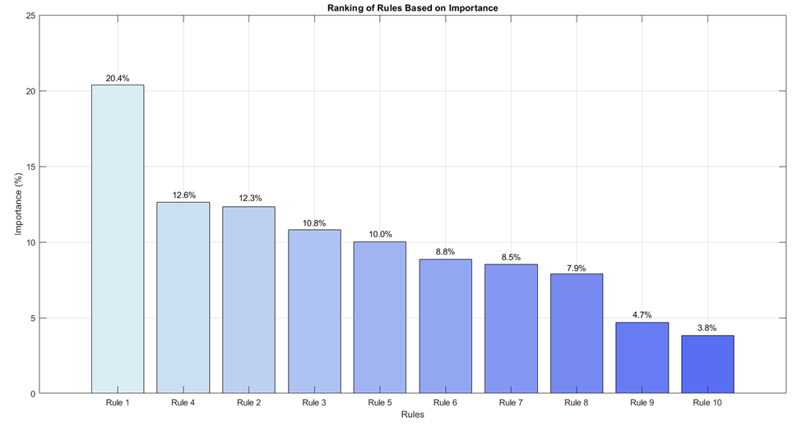
Figure ‎4.4 Fuzzy rule importance in the SC-ANFIS model
The result is that there are only a few dominant rules that control the model response, and the rest are less frequent rules. Multiple rules with moderate contribution means the model is able to represent a variety of input patterns and is not dominated by a single dominant rule.This distribution is a result of how well the model adapts its response in various situations. It also demonstrates that the chosen rule structure is adequate to capture the primary data patterns and has predictable performance.

Manual Validation of the Selected Model
The researcher selected a representative case from the testing dataset to manually validate the ANFIS model. The selected case corresponds to Case No. 36 within the testing data presented in Appendix (D). The calculation was performed step by step to compare the predicted output with the actual maintenance cost.
Step 1: Input Preprocessing
The input values were transformed into the same format used in the final model. This included normalization of the input values. The processed values are presented in Table 4.6.
Table ‎4.6 Input preprocessing values
Input Variable | Actual Value | Normalized Value
V1 | 1880 | 0.4506
V2 | 1 | 0.0069
V3 | 0 | 0.0000
V4 | 6 | 0.0000
V5 | 161 | 0.0000
V6 | 2 | 0.9817
V7 | 1 | 0.0096
V8 | 1 | 0.0022
V9 | 1 | 0.9819
V10 | 1 | 0.0008
V11 | 3 | 0.9950
V12 | 1 | 0.0000
V13 | 1 | 0.0000

The transformation reduced the scale of large input values, while smaller values remained within a lower range. This resulted in a more balanced input distribution and limited the dominance of variables with high numerical magnitude.
This preprocessing step improved the consistency of model input and allowed the prediction to reflect the combined effect of variables rather than being influenced by scale differences.
Step 2: Rule Firing Strengths
The rule activation strength indicates how strongly each fuzzy rule responds to the selected input case, while the normalized weight represents the relative contribution of each rule to the final output. The normalized weights range from 0 to 1, and their total should be approximately equal to 1.
Table ‎4.7 Rule firing strengths
Rule Number | Rule Activation Strength | Normalized Weight
Rule 1 | 9.31E-39 | 5.56E-38
Rule 2 | 3.14E-17 | 1.87E-16
Rule 3 | 0.074818478 | 0.446865158
Rule 4 | 5.52E-99 | 3.29E-98
Rule 5 | 8.80E-99 | 5.26E-98
Rule 6 | 1.85E-87 | 1.10E-86
Rule 7 | 4.08E-09 | 2.44E-08
Rule 8 | 0.09261117 | 0.553134818
Rule 9 | 4.58E-104 | 2.74E-103
Rule 10 | 1.83E-118 | 1.09E-117
As shown in Table 4.7, Rule 8 and Rule 3 have the main contributions, with normalized weights of 0.5531 and 0.4469, respectively. The remaining rules have values close to zero, which means that they have almost no effect on the final prediction. This indicates that the selected input pattern is mainly represented by Rule 8 and Rule 3.
Step 3: Consequent Outputs
Based on the results in Table 4.7, only Rule 3 and Rule 8 have significant normalized weights, while the remaining rules have negligible contributions. Therefore, the consequent outputs (Zi) are mainly influenced by these active rules.
Each consequent output is computed using a linear equation that combines the normalized input variables with their corresponding coefficients.
For Rule 3, based on Table 4.7, the output is calculated as:
Z3 = (0.0101 × V1) + (0.0000 × V2) + (0.0031 × V3) + (-0.0001 × V4)
+ (0.0003 × V5) + (0.0004 × V6) + (0.0009 × V7) + (-0.0001 × V8)
+ (-0.0001 × V9) + (0.0004 × V10) + (-0.0003 × V11) + (0.0002 × V12)
+ (-0.0009 × V13) + (-0.0003)
After substituting the normalized values from Table 4.6:
Z3 = (0.0101 × 0.4506) + (0.0000 × 0.0069) + (0.0031 × 0.0000)
+ (-0.0001 × 0.0000) + (0.0003 × 0.0000) + (0.0004 × 0.9817) + (0.0009 × 0.0096) + (-0.0001 × 0.0022) + (-0.0001 × 0.9819) + (0.0004 × 0.0008) + (-0.0003 × 0.9950) + (0.0002 × 0.0000) + (-0.0009 × 0.0000) + (-0.0003)
Z3 = 0.0045

For Rule 8, based on Table 4.7, the output is calculated as:
Z8 = (0.01112 × V1) + (0.00031 × V2) + (-0.00008 × V3) + (-0.00010 × V4) + (-0.00045 × V5) + (0.00022 × V6) + (0.00041 × V7) + (0.00135 × V8) + (-0.00003 × V9) + (0.00022 × V10) + (-0.00057 × V11) + (-0.00029 × V12)
+ (-0.00038 × V13) + (0.00026)
After substituting the normalized values from Table 4.6:
Z8 = (0.01112 × 0.4506) + (0.00031 × 0.0069) + (-0.00008 × 0.0000) + (-0.00010 × 0.0000) + (-0.00045 × 0.0000) + (0.00022 × 0.9817) + (0.00041 × 0.0096) + (0.00135 × 0.0022) + (-0.00003 × 0.9819) + (0.00022 × 0.0008) + (-0.00057 × 0.9950) + (-0.00029 × 0.0000) + (-0.00038 × 0.0000) + (0.00026)
Z 8 = 0.0049
Step 4: Final Output Calculation
The final normalized output was calculated using the normalized weights and consequent outputs
$$C=\sum_{i=1}^{n}{\left(\overline{w_{i}}Z_{i}\right)}$$
$$C_{norm}=\left(0.446865158×0.0045\right)+\left(0.553134818×0.0049\right)$$
$$C_{norm}=0.002011+0.002710$$
$$C_{norm}=0.004721$$

Step 5: Inverse Normalization
The value obtained from the ANFIS model was then normalized and the values were Reconverted to original cost scale, using the inverse Min-Max normalization equation. This step provides the estimated maintenance expense in Iraqi Dinar (IQD).
$$C=C_{norm}\left(C_{max}-C_{min}\right)+C_{min}$$
$$C=0.004721\left(3,590,000,000-1,900,000\right)+1,900,000$$
$$C≈18,840,000 IQD$$

For Case No. 36 in the testing data, the normalized output was inverted to get the original output. Using inverse normalization, to the original cost scale. The predicted maintenance cost was 18,840,000 IQD, compared with an actual cost of 17,891,000 IQD. The The absolute error of 949,000 IQD and the percentage error of 5.3%, show that the results achieved were satisfactory. A good prediction accuracy for the selected case. The result indicates that the prediction: was affected by the net result of Rule 3 and Rule 8, which is a net result of the two rules. The model's capability of representing the conditions of the input by means of active fuzzy rules. The good agreement between the predicted and actual values indicates the reliability of It is the model that is used in practice for estimating maintenance costs..

Comparison with ANN and MLR
The selected ANFIS model is evaluated through comparison with two benchmark models, namely ANN and MLR. The comparison is done with the same dataset and data split in order to have the same evaluation of prediction accuracy and generalization. The comparison is based on their ability to represent the relationship between the input variables and maintenance cost, as well as the differences in prediction error and stability. This offers a clear basis for comparing the models' performance.

Performance of ANN Model
The evaluation of the ANN model was carried out by testing the model with 1 to 20 hidden neurons. The architecture (13-2-1) was chosen because it was the most stable. The results indicated that the model was not successful in representing the high complexity of the 13 input variables. The more neurons that were added, the less accurate the predictions were, and the more they overfitted, or memorized the data noise instead of learning the patterns. This means that the traditional ANN is not suitable for modelling the complex and non-linear relationships in this particular dataset.
Figure ‎4.5 Comparison Between ANFIS and ANN Model Predictions
The results of the ANFIS model were found to be better than the ANN model as seen in Figure (4.5). The ANFIS model achieved a high coefficient of determination (R² = 95.1%), which shows that the model has a good ability to explain the variation in the actual cost data. It also had a low error value of 8.2% (MAPE), which indicates high prediction accuracy. It is also observed from the scatter plot that the predicted values of the ANFIS model are concentrated around the reference line, which indicates good agreement with the actual values.
The ANN model had a lower predictive performance, a lower coefficient of determination (R² = 78.8%) and higher prediction error (MAPE = 22.29%). Furthermore, the scatter points of the ANN model are more widely distributed from the reference line, suggesting weaker agreement with the actual values. In conclusion, it is found that the ANFIS model is more accurate and more stable than the ANN model in predicting the maintenance cost.

Performance of MLR Model
The prediction performance of the MLR model was found to be weaker on the testing dataset, with R² = 0.64 and MAPE = 27.29%. As seen in these results, the model is not very effective in representing the relationship between the input variables and maintenance cost. The lower performance is primarily because the model is linear, and therefore less flexible in handling the change in the relationship under different input conditions. Consequently, the model resulted in higher prediction error and lower stability than ANN and ANFIS. Overall, the MLR model showed the lowest performance in terms of prediction accuracy and consistency when compared to the other models tested.

Sensitivity and Interaction Analysis
This section looks at the effect of the input variables on the predicted maintenance cost, and focuses on their individual importance and combined influence. The sensitivity analysis is used to identify the variables which have the most significant influence on the model's output. Using interaction analysis, the interaction between pairs of variables on the predicted cost is then explored under various conditions. This approach can give an insight into the behavior of the model and enable identification of the factors that make maintenance costs variable.

Relative Importance of Input Variables
A relative importance analysis was performed for the variables in the model to understand how the input variables affect the maintenance cost. This analysis can help determine which variables are most significant for the model output and can give more insight into what is associated with changes in maintenance cost.
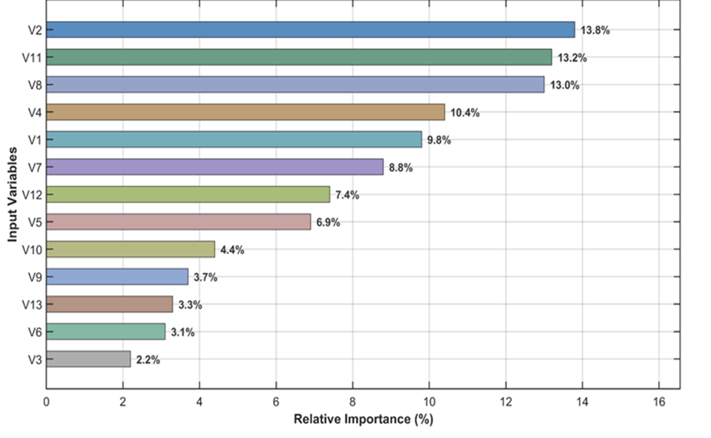
Figure ‎4.6 Relative Importance of Input Variables for Maintenance Cost
The results indicate that the input variables do not have the same impact on the maintenance cost. The variables related to pavement condition, traffic loading and soil properties were the most significant indicating their important role in cost prediction. This is because they are directly related to pavement damage and maintenance requirements. Other variables, however, had less importance and therefore had a smaller effect on the predicted cost. In general, these results indicate that a set of variables has varying levels of importance on the maintenance cost, thus the model has the ability to represent the problem in a clear and realistic way.

Influence of AADT and HTS on Maintenance Cost
To examine the combined effect of AADT for heavy-loaded vehicles and high temperature severity on maintenance cost, several interaction cases were analyzed. The case shown in Figure 4.7 was selected because it clearly represents the combined influence of traffic loading and temperature severity on the predicted maintenance cost. The remaining interaction cases are presented in Appendix (E).
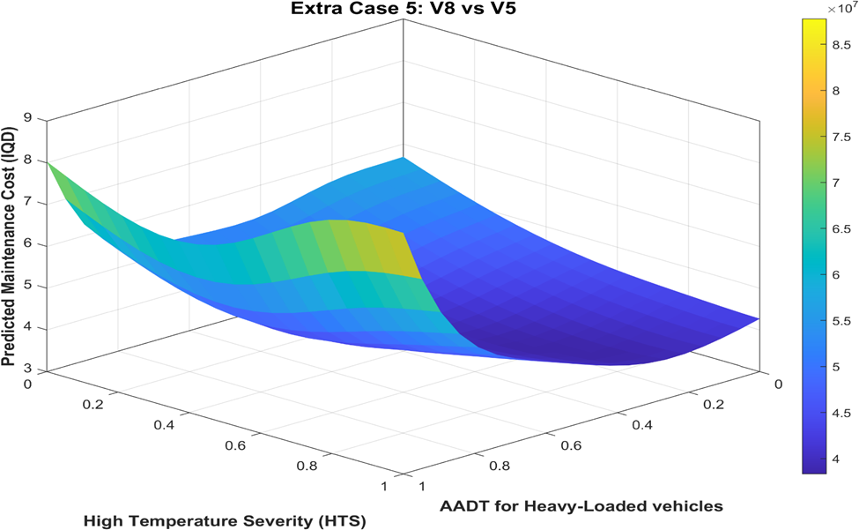
Figure ‎4.7 Interaction effect of AADT and HTS on maintenance cost
The figure shows that the effect of high temperature severity on maintenance cost becomes clearer as the level of AADT for heavy-loaded vehicles increases. At low traffic levels, the increase in cost is moderate, while at higher traffic levels the increase becomes more noticeable. This indicates that maintenance cost is affected by both variables together, not by each one separately. From an engineering point of view, high temperature can soften the asphalt layer and increase its susceptibility to rutting, while heavy-loaded vehicles increase pavement stress, which leads to higher maintenance cost.

Discussion of Results
The results show that road maintenance cost in Karbala Governorate is influenced by combined and nonlinear effects rather than isolated variables. The SC-based ANFIS model achieved the best performance compared with the FCM-based ANFIS, ANN, and MLR models. This agrees with Moghayedi and Windapo (2019), who found that ANFIS gives better prediction accuracy than classical statistical methods under uncertain cost conditions. It also agrees with Milad et al. (2022) and Ujong et al. (2025a), who showed that ANFIS is suitable for pavement-related prediction and maintenance decision support.
The lower performance of MLR supports the idea that linear models may not be sufficient for problems affected by nonlinear and interacting variables. The sensitivity analysis showed that pavement age, soil strength, and AADT for heavy-loaded vehicles were among the most influential variables, which agrees with Ewadh et al. (2018b) and Llopis-Castelló et al. (2020). In addition, the interaction analysis showed that heavy-loaded traffic and high temperature severity together increase maintenance cost. Therefore, the findings are generally consistent with the previous studies presented in Chapter One, while this study differs by applying ANFIS directly to road maintenance cost prediction using actual completed project data from Karbala Governorate.

Chapter Summary
This chapter showed that the SC-based ANFIS model achieved the best prediction performance among the tested models. The selected model gave high accuracy with R² = 0.95 and MAPE = 8.19%, which indicates good agreement between the predicted and actual maintenance costs.
The comparison results showed that ANFIS performed better than ANN and MLR. The sensitivity and interaction analyses also showed that pavement age, soil strength, heavy-loaded traffic, and temperature severity were among the main factors affecting maintenance cost. These results support the use of the developed model for road maintenance cost estimation and planning in Karbala Governorate.

Development of the Web-Based Application

Introduction
The web-based application developed in this study to assist the road maintenance cost estimation in this study, in the Governorate of Karbala, is presented in this chapter. This application allows for easy electronic entry of project information, calculation of cost estimates and presentation of the results in an organized format. The chapter also provides an explanation of the major interfaces of the application, the operational steps and assessment of the user..

Application Overview and Development Framework
The developed application was created to be a useful decision support tool for the use of the final prediction model. It organizes the variables required for the project, does the data processing and shows the maintenance cost prediction in an easy-to-understand form.

Application Objectives
The main objectives of developing the web-based application consist of:
  - Practical Application:To provide a practical platform for applying the final ANFIS model in estimating road maintenance cost.
  - Ease of Use: To enable the user to enter project data and obtain prediction results through a simple and clear interface.
  - Prediction Support: To support the estimation process by presenting the predicted cost in an organized and understandable form.
  - Result Presentation: To display the outputs of the prediction process through cost classification, graphical representation, and final reporting.
  - Decision Support: To assist engineers and decision-makers in maintenance planning and cost estimation under the local conditions of Karbala Governorate.

Development Phases
The development of the web-based application passed through the following phases:
i. Interface Preparation: The main pages and input fields of the application were prepared in a clear and organized form.
ii. Data Organization: The required project variables were arranged to ensure proper entry and use in the prediction process.
iii. Model Linking: The final ANFIS model was linked with the application to process the entered data and generate the predicted cost.
iv. Output Presentation: The prediction results were presented through numerical display, classification, graphical output, and final reporting.
v. Testing and Refinement: The application was tested to ensure proper operation and to improve the clarity of its outputs and interfaces.

Main Features and Functions of the Application
The developed application carries out a set of functions associated with road maintenance cost estimation. It enables the user to create a project record, input the necessary input variables and run the input data through the integrated prediction model. The application also shows the predicted maintenance cost and presents the supporting outputs, such as cost classification, graphical presentation, and final report. The functions are useful for practical use in organizing project information and clearly displaying prediction outcomes.

Practical Application
To demonstrate the practical use of the developed application, the following steps were adopted:
i. Real-World Scenario: A road maintenance project in Karbala Governorate was analyzed using the developed web-based application.
ii. Data Input: The required project variables were entered into the application to examine its performance on actual project cases.
iii. Output Evaluation: The application generated the predicted maintenance cost, which was reviewed in relation to the actual project cost.

Application Specifications
The developed application for estimating road maintenance cost includes the following features:
- Application Environment:
- The application was developed as a web-based system for estimating road maintenance cost.
- The application requirements are simple, and it can be accessed through a standard web browser without the need for special hardware specifications.
2. Ease of Use:
The application was designed to be simple and easy to use, so that users can interact with its interfaces in a clear and direct manner.
3. Principal Attributes:
    - Speed: The application provides a rapid prediction option for direct cost estimation.
    - Detailed Analysis: The application also provides a detailed prediction option that presents the importance of the input variables, their ranking, and the relative weight of each variable in the prediction process.
    - Accuracy: The application applies the final ANFIS model selected in this study to provide reliable prediction results.
    - Systematic Presentation: The application presents the entered data and the prediction outputs in an organized and understandable form.
4. Language:
The application was developed in both Arabic and English.
5. Additional Specifications:
The application provides the final prediction result in the form of a detailed report. It also includes graphical representation and explanatory outputs related to the most important input variables and their influence on the estimated maintenance cost.

Operating Method of the Application
The functionality, use, and execution of the application encompass the following phases:
- Opening the application: Upon opening the application, the home page appears on the screen and shows the main options of the system.
- Selection of the operating method: The application offers two operating methods for the user, including the following:
i. Quick Analysis
ii. Normal Method
- Quick analysis method: Upon selecting the quick analysis option, the user enters the required input variables directly, and the application displays the estimated maintenance cost in a rapid form.
- Normal operating method: Upon selecting the normal method, a new project is created first, then the basic project information and the required model input variables are entered.
- Prediction process: After completing the data entry stage, the application performs the prediction process using the integrated ANFIS model.
- Displaying outputs: In the normal method, the application displays the estimated maintenance cost together with the cost level indicator and the related detailed outputs.
- Additional pages: The normal method also allows the user to open the impact analysis page, review the explanatory outputs, and view the final report.

Running the Application
This section presents the practical steps of using the developed application, starting from the home page and ending with the display of results and the final report.

Home Page Interface
As shown in Figure 5.1, the home page is the starting interface of the application. It presents the title of the study and provides access to the main options of the system.

Figure ‎5.1 Home Page Interface of the Developed Web-Based Application

Project Creation Interface
This interface is used to create a new project by entering the basic project information required before starting the prediction process, as shown in Figure 5.2.

Figure ‎5.2 Project Creation Interface (Researcher)

Input Variables Interface
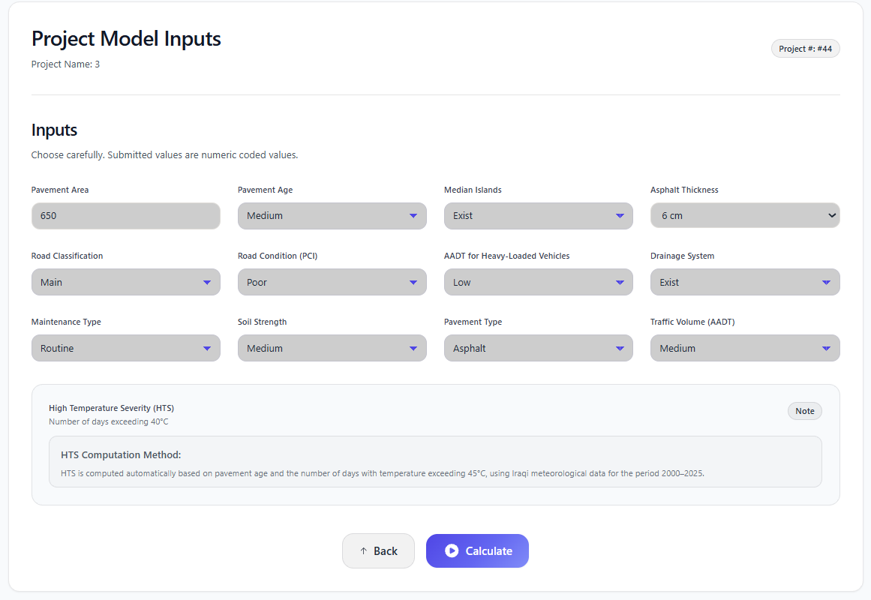
This interface is used to enter the required model variables before running the prediction process. It contains the project inputs in an organized form, which allows the user to complete the data entry clearly and directly, as shown in Figure 5.3.

Figure ‎5.3 Input Variables Interface of the Developed Application (Researcher)

Results Interface

This interface presents the prediction results in a clear and organized form. It displays the estimated maintenance cost, the cost indicator, a brief summary of the result, and the most influential factor affecting the prediction. It also provides access to the detailed report, as shown in Figure 5.4.
Figure ‎5.4 Results Interface of the Developed Application (Researcher)

Impact Analysis and Explanation Interface
This interface presents the detailed analytical outputs of the prediction process. It shows the relative influence of the input variables through a graphical representation and provides a short explanation of the most influential factors affecting the estimated maintenance cost, as shown in Figure 5.5.

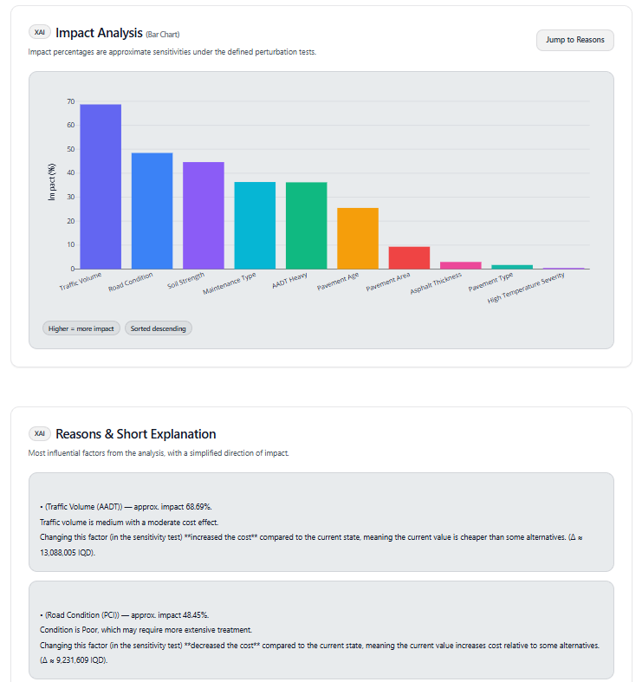
Figure ‎5.5 Impact Analysis and Explanation (Researcher)

Final Report Interface
This interface presents the final report of the prediction process in a clear and organized form. It includes the main project information, the entered input variables, and the related outputs of the prediction process, with the option to export the report in PDF format, as shown in Figure 5.6.
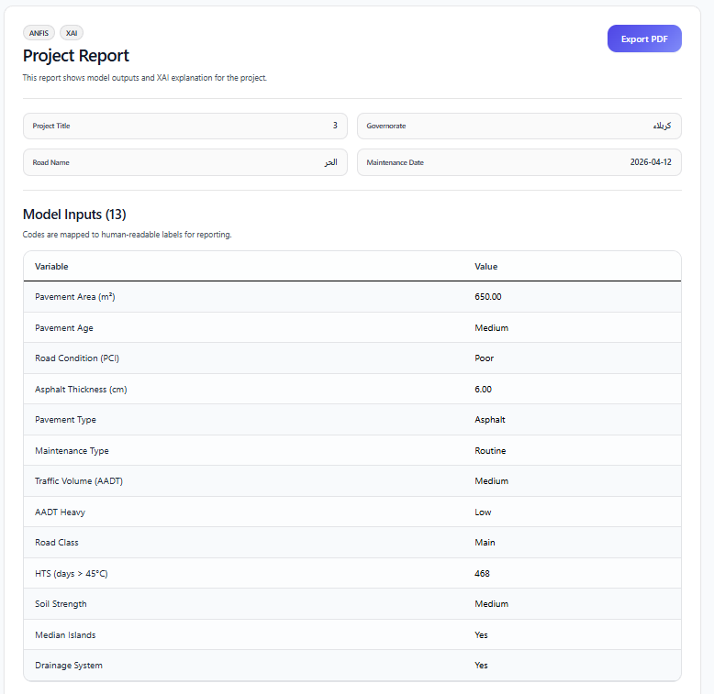
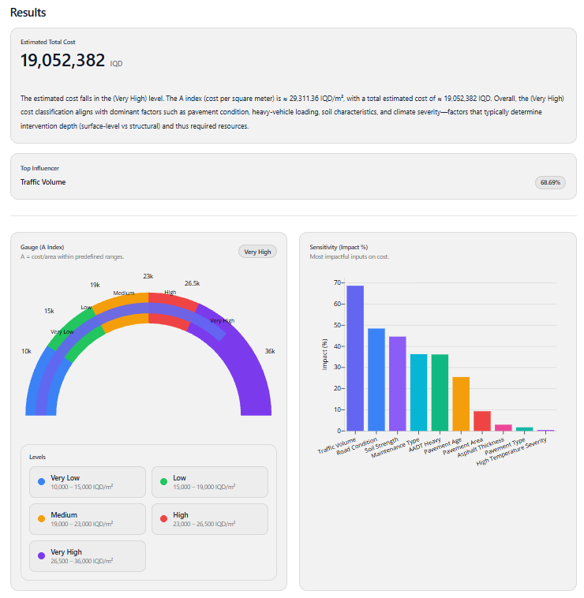
Figure ‎5.6 Project Report Interface (Researcher)
Figure ‎5.7 Results and Impact Analysis Interface (Researcher)

Evaluation of the Developed Application
The researcher used an evaluation questionnaire approach with the following steps to get the opinions of the users:

Sample Selection
The researcher chose 15 engineers and specialists who have experience in road maintenance and project work for the evaluation of the developed application. The participants were 6 engineers from Roads and Bridges Directorate and 9 engineers from Karbala Municipalities Directorates.

Presentation and Explanation
The evaluators were familiarized with the main interfaces of the application, the application's operating sequence and how the prediction results, analytical outputs and final report are presented. This allowed for a clear understanding of the application prior to evaluation.

Data Collection
After reviewing and using the application, the prepared questionnaires were distributed to the selected sample in order to collect their opinions regarding the clarity, usefulness, and performance of the application. The obtained responses are summarized in Table 5.1.
Table ‎5.1 Users’ Perspectives on the Developed Application (Researcher)
No. | Question | Percent | Answer
1 | Does the application achieve its main purpose of estimating road maintenance cost? | 80 | Very good
 |  | 20 | Good
 |  | 0 | Acceptable
Table 5.1 Continued….
No. | Question | Percent | Answer
2 | Does the application provide useful support for engineering work through cost estimation and result presentation? | 60 | Very good
 |  | 30 | Good
 |  | 10 | Acceptable
3 | Is there a practical need for a web-based application for road maintenance cost estimation? | 80 | Essential
 |  | 20 | Useful
4 | How easy is the application to use in general? | 70 | Easy
 |  | 20 | Moderate
 |  | 10 | Difficult
5 | How easy is it to enter project data and model input variables? | 70 | Easy
 |  | 20 | Moderate
 |  | 10 | Difficult
6 | How clear are the prediction results, cost indicator, and detailed outputs? | 60 | Very clear
 |  | 30 | Clear
 |  | 10 | Unclear
7 | How useful is the impact analysis and explanation page in helping users interpret the prediction results? | 70 | Very useful
 |  | 20 | Useful
 |  | 10 | Limited

Analysis of the Evaluation Results

Objective of the Application
    - Most respondents rated the application as Very good in achieving its main purpose, which is estimating road maintenance cost. This indicates that the evaluators considered the application effective in performing its intended function.
    - A smaller proportion rated it as Good, which suggests that the application was useful, although some improvement may still be possible.
    - Only a limited number of respondents rated it as Acceptable, which means that the general evaluation remained positive.

Support for Engineering Work:
- Most respondents considered that the application helps in estimating maintenance cost and presenting the results in a useful form for engineering work.
- Other respondents rated this aspect as Good or Acceptable, which indicates that the application provides practical support, although its usefulness may vary among users.

Need for the Application:
    - Most evaluators indicated that there is a clear need for a web-based application for road maintenance cost estimation.
    - The remaining respondents considered it Useful, which also reflects the practical importance of the application.

Ease of Use and Data Entry
    - Most respondents found the application easy to use, which reflects the clarity of its interfaces and the simplicity of its operating sequence.
    - In addition, most users found the data entry process to be easy or acceptable, indicating that the required project information and model inputs could be entered without major difficulty.

Clarity of Outputs and Analytical Pages
    - Most respondents considered the prediction results, cost indicator, and detailed outputs to be clear and understandable.
    - The evaluation also showed that the impact analysis and explanation page was useful in helping the user understand the estimated cost and the role of the most influential variables.

Chapter Summary
This chapter showed how the final ANFIS model was converted into a practical web-based application. The application allows users to enter project data, obtain the predicted maintenance cost, view the main outputs, and generate a final report.The evaluation results indicated that the application is clear, useful, and suitable as a supporting tool for road maintenance cost estimation.

Conclusions and Recommendations

Introduction
The chapter presents the final conclusions reached in this study on the basis of the results discussed in the preceding chapters. It also introduces the main recommendations and suggested directions for future research related to road maintenance cost estimation in Karbala Governorate.

Conclusions
The conclusions of this study are presented with regard to three main aspects, as follows.

Conclusions Related to Variables and Data
- The results showed that the engineering, traffic and environmental factors are interrelated, which is in accordance with the local conditions of road maintenance cost behavior.
- The adopted approach (literature review, expert questionnaires, RII analysis and historical records of the project) was successful in identifying and confirming the variables related to the maintenance environment in Karbala.
- The analysis identified 13 input variables as the primary variables that influence the maintenance cost of roads, which can be used to create a structured database for developing predictive models.
- This is because the use of 248 completed maintenance projects for the period 2010-2025 along with locally relevant variables such as soil condition, drainage system, median irrigation effect, strengthened the realism of the adopted data, and made the representation of the actual road maintenance conditions in Karbala Governorate more realistic.

Conclusions Related to Model Performance
- The researcher finds that the ANFIS model developed was able to capture the nonlinear relationship between the input variables and maintenance cost successfully and the developed ANFIS model is more accurate than ANN and MLR in predicting the maintenance cost.
- The fourth objective of the study was met by the adoption of the SC-based configuration as the final model, with R² = 0.95 and MAPE = 8.19%, thus confirming its reliability in the local context for preliminary cost estimates.
- Pavement age, soil condition, heavy-loaded traffic, and asphalt thickness were determined as the most influential factors and were found to have a greater cost increase when combined than if each factor was present alone..
- The researcher concludes that the fuzzy membership functions were useful in dealing with the variability of field data because they represented the inputs as gradual values, thus proving the suitability of the FNN framework for uncertain data.

Conclusions Related to Application Development
- The final ANFIS model was successfully converted into a usable web application, which can be used in the local context of Karbala Governorate to estimate the cost of road maintenance.
- The application allowed the user to input project information, calculate the predicted maintenance cost, view the key analytical results and create a final report in an easy and structured manner.
- The evaluation results revealed that the application was generally accepted and proved its usefulness in supporting preliminary maintenance planning, cost estimation and engineering decision-making in Karbala Governorate.

Recommendations
On the basis of the results of this study, the following recommendations are made:
- To obtain a longer pavement life and to minimize repeated maintenance, high quality paving materials and maintenance techniques that are capable of resisting high temperatures in the summer and heavy slow moving traffic, particularly during the million visitor periods, are recommended.
- The developed application is recommended to be adopted by local engineering departments in Karbala Governorate, which can help in preparing preliminary cost estimates and annual maintenance budgets, and reduce the time, effort and cost variation.
- The collected road maintenance data is recommended to be documented and kept, rather than on paper, as a digital database. This can help retrieve the data, future cost estimation models and maintenance planning in Karbala Governorate.
- It is recommended to offer training programs for young engineers to enhance their ability of using data-based estimation tools.

Suggestions for Future Research
- Future studies are recommended to develop hybrid models by combining ANFIS with optimization techniques such as GA or PSO in order to improve prediction accuracy.
- It is recommended to conduct comparative studies between the developed ANFIS model and other modern intelligent techniques, especially deep learning models, under different Iraqi conditions.
- Future research is encouraged to include economic and administrative variables that may affect maintenance cost, such as material prices, approval delays, and project management efficiency, in order to improve the practical value of the model.
- It is also recommended to integrate the developed model with GIS to support spatial analysis and improve maintenance planning and resource allocation in Karbala Governorate.

References
1. Abd, A., Kareem, Y. & Zehawi, R. 2024. Prediction and Estimation of Highway Construction Cost using Machine Learning. Engineering, Technology and Applied Science Research, 14, 17222-17231.https://doi.org/10.48084/etasr.8285
2. Abuhishmeh, K. & Hojat Jalali, H. 2024. Risk assessment of infrastructure using a modified adaptive neurofuzzy system: Theoretical application to sewer mains. Journal of Pipeline Systems Engineering and Practice, 15, 04024005.https://doi.org/10.1061/jpsea2.pseng-1560
3. Adounkpe, J. Y. P., Wendling, V., Dezetter, A., Arfib, B., Artigue, G., Pistre, S. & Johannet, A. 2025. A Comparison Between Adam and Levenberg–Marquardt Optimizers for the Prediction of Extremes: Case Study for Flood Prediction with Artificial Neural Networks. Engineering Proceedings, 101, 12.https://doi.org/10.3390/engproc2025101012
4. Ahmed, N. G., Kadhim, A. J. & Ferman, A. A. 2017. Prediction of Optimal Maintenance Alternative for Iraqi Pavement Management Based on Multi-Objective Optimization Technique and Constraint Genetic Algorithm.
5. Al-Mansoori, T., Abdalkadhum, A., Al-Husainy, A. S. & Abdalkadhum, A. 2020. A GIS-Enhanced pavement management system: a case study in Iraq. journal of Engineering Science and Technology, 15, 2639-2648
6. Al-Nawasir, R. I. & Al-Humeidawi, B. H. 2023. Qualitative evaluation for asphalt binder modified with SBS polymer. Tikrit Journal of Engineering Sciences, 30, 88-101.https://doi.org/10.25130/tjes.30.4.10
7. Al-Saady, A. M. & Rezouki, S. E. 2023. Artificial Neural Network Models to Predict the Cost and Time of Wastewater Projects. Journal of Engineering, 29, 93-109.https://doi.org/10.31026/j.eng.2023.01.06
8. Ali, A., Heneash, U., Hussein, A. & Eskebi, M. 2022. Predicting Pavement Condition Index Using Fuzzy Logic Technique. Infrastructures 2022; 7: 91. s Note: MDPI stays neutral with regard to jurisdictional claims in published…. Available at: https://www. academia. edu/download/94294360/pdf. pdf (Accessed: 23 July 2024).https://doi.org/10.3390/infrastructures7070091
9. Ali, A. M. & Lafta, A. M. 2023. World highways pavement management system: an overview. Muthanna Journal of Engineering and Technology, 11
10. Apiecionek, L. 2025. Fuzzy neural networks—A review with case study. Applied Sciences, 15, 6980.https://doi.org/10.3390/app15136980
11. Arifin, S. 2026. A Review of Kruskal-Wallis Test Applications in Scientific Research. Journal of Actuarial, Finance, and Risk Management, 4, 36-46.http://e-journal.president.ac.id/presunivojs/index.php/JAFRM/index
12. Ashqar, H. I., Issa, A. & Masri, S. 2025. A software for predicting Pavement Condition Index (PCI) using machine learning for practical decision‑making with an exclusion approach. SoftwareX, 31, 102304.https://doi.org/10.1016/j.softx.2025.102304
13. Azman, N. S., Ramli, M. Z., Razman, R., Zawawi, M. H., Ismail, I. N. & Isa, M. R. Relative importance index (RII) in ranking of quality factors on industrialised building system (IBS) projects in Malaysia. AIP Conference Proceedings, 2019. AIP Publishing LLC, 020029.
14. Basnet, K. S., Shrestha, J. K. & Shrestha, R. N. 2023. Pavement performance model for road maintenance and repair planning: a review of predictive techniques. Digital Transportation and Safety, 2, 253-267.https://doi.org/10.48130/dts-2023-0021
15. Cabrera, M. S. & Silva, D. L. 2023. Neural Network-Based Prediction of the Performance Budget for Road Defects and Highway Maintenance. 2023 IEEE 3rd International Conference on Software Engineering and Artificial Intelligence (SEAI).
16. Chicco, D., Warrens, M. J. & Jurman, G. 2021. The coefficient of determination R-squared is more informative than SMAPE, MAE, MAPE, MSE and RMSE in regression analysis evaluation. PeerJ Computer Science, 7.https://doi.org/10.7717/peerj-cs.623
17. Dastgheib, S. R., Feylizadeh, M. R., Bagherpour, M. & Mahmoudi, A. 2022. Improving estimate at completion (EAC) cost of construction projects using adaptive neuro-fuzzy inference system (ANFIS). Canadian Journal of Civil Engineering, 49, 222-232.https://doi.org/10.1139/CJCE-2020-0399
18. De Bortoli, A., Feraille, A. & Leurent, F. 2022. Towards Road Sustainability—Part I: Principles and Holistic Assessment Method for Pavement Maintenance Policies. Sustainability.https://doi.org/10.3390/su14031513
19. Elgamal, E., Fawzy, H., Mohamady, A. & Basha, A. 2025. Pavement management system: Condition assessment, challenges, and future directions. Journal of Contemporary Technology and Applied Engineering, 3, 93-102.https://doi.org/10.21608/jctae.2025.361183.1044
20. Ewadh, H. A., Almuhanna, R. & Alasadi, S. Developing optimized prioritizing road maintenance. MATEC Web of Conferences, 2018a. EDP Sciences, 01044.
21. Ewadh, H. A., Almuhanna, R. R. A. & Alasadi, S. 2018b. Validity Of Garber Model In Predicting Pavement Condition Index Of Flexible Pavement In Kerbala City. Kufa Journal Of Engineering, 09, 139-151.
Https://Doi.Org/10.30572/2018%2fkje%2f090211
22. Ferdinand, T., Sigit Pranowo, H., Jachrizal, S. & Riana Herlina, L. 2024. Road Repair Delay Costs in Improving the Road Rehabilitation Strategy through a Comprehensive Road User Cost Model. International Journal of Engineering and Technology Innovation, 14, 254-270.https://doi.org/10.1088/1757-899X%2F881%2F1%2F012171
23. Gaussmann, R., Coelho, D., Fernandes, A., Crocker, P. & Leithardt, V. R. 2020. Estimated maintenance costs of Brazilian highways using machine learning algorithms. Journal of Information Systems Engineering and Management, 5, em0119.https://doi.org/10.29333/jisem%2F8427
24. Gharieb, M., Nishikawa, T., Nakamura, S. & Thepvongsa, K. 2022. Application of Adaptive Neuro–Fuzzy Inference System for Forecasting Pavement Roughness in Laos. Coatings, 12, 380.https://doi.org/10.3390/coatings12030380
25. Haryati, A. E., Sugiyarto, S. & Putri, R. D. A. 2021. COMPARISON OF FUZZY SUBTRACTIVE CLUSTERING AND FUZZYC-MEANS. Jurnal Ilmiah Kursor, 11.https://doi.org/10.21107/KURSOR.V11I1.254
26. Hasan, M. A., Jrew, B., Abed, F. & Msallam, M. Developing a pavement maintenance management system of multi-lane highway in Iraq. IOP Conference Series: Materials Science and Engineering, 2020. IOP Publishing, 012171.
27. Hashemi Jokar, M. & Heidaripanah, A. 2024. ANFIS Models with Subtractive Clustering and Fuzzy C-Mean Clustering Techniques for Predicting Swelling Percentage of Expansive Soils. Journal of Soft Computing in Civil Engineering, 8, 141-159.https://doi.org/10.22115/scce.2024.408595.1691
28. Hewamalage, H., Bergmeir, C. & Bandara, K. 2019. Recurrent Neural Networks for Time Series Forecasting: Current Status and Future Directions. ArXiv, abs/1909.00590.https://doi.org/10.1016/J.IJFORECAST.2020.06.008
29. Iskandar, D., Hadiwardoyo, S. P., Sumabrata, R. J. & Fitriasari, I. N. Road maintenance strategy with characteristic of drainage condition based on pavement performance. AIP Conference Proceedings, 2018. AIP Publishing LLC, 040010.
30. Jaleel, M. M., Albdairi, M. & Almusawi, A. 2025. Marshall-Based thermal performance analysis of conventional and Polymer-Modified asphalt binders. Construction Materials, 5, 40.https://doi.org/10.3390/constrmater5020040
31. Jang, J.-S. 1993. ANFIS: adaptive-network-based fuzzy inference system. IEEE transactions on systems, man, and cybernetics, 23, 665-685.https://doi.org/10.3390/su16093771
32. Ji, A., Xue, X., Wang, Y., Luo, X. & Zhang, M. 2020. An integrated multi-objectives optimization approach on modelling pavement maintenance strategies for pavement sustainability. Journal of Civil Engineering and Management, 26, 717-732.https://doi.org/10.3846/jcem.2020.13751
33. Johnson, O. V., Xinying, C., Johnson, O. E., Khaw, K. W. & Lee, M. H. Learning rate schedules and optimizers, a game changer for deep neural networks. International Conference of Reliable Information and Communication Technology, 2023. Springer, 327-340.
34. Jung, H., Kim, Y., Kim, S., Park, C. & Nam, J. 2020. Life Extension of Aged Jointed Plain Concrete Pavement through Remodeling Index–Based Analysis. Materials, 13.https://doi.org/10.3390/ma13132982
35. Kaloop, M. R., El-Badawy, S. M., Hu, J. W. & Abd El-Hakim, R. T. 2023. International Roughness Index prediction for flexible pavements using novel machine learning techniques. Engineering Applications of Artificial Intelligence, 122, 106007.https://doi.org/10.1016/j.engappai.2023.106007
36. Karaboga, D. & Kaya, E. 2019. Adaptive network based fuzzy inference system (ANFIS) training approaches: a comprehensive survey. Artificial intelligence review, 52, 2263-2293.https://doi.org/10.1007/s10462-017-9610-2
37. Khudhair, H. S., Al-Jameel, H. A. & Konoplev, V. N. 2024. Investigation of Traffic Efficiency on Karbala Roads. Transportation and Information Technologies in Russia/Транспорт и информационные технологии, 14, 51-68.https://doi.org/10.12731/2227-930x-2024-14-1-251
38. Kiani Mavi, N., Brown, K., Fulford, R. & Goh, M. 2023. Forecasting project success in the construction industry using adaptive neuro-fuzzy inference system. International Journal of Construction Management, 24, 1550-1568.https://doi.org/10.1080/15623599.2023.2266676
39. Kırbaş, U. & Karaşahin, M. 2016. Performance models for hot mix asphalt pavements in urban roads. Construction and Building Materials, 116, 281-288.https://doi.org/10.1016/J.CONBUILDMAT.2016.04.118
40. Kotian, H., Varghese, A. L. & Motappa, R. 2022. An R function for Cronbach’s alpha analysis: A case-based approach. National journal of community medicine, 13, 571-575.https://doi.org/10.55489/njcm.130820221149
41. Kumar, R. & Tung, S. 2025. Automated detection and severity assessment of asphalt pavement distress using YOLOv8: A deep learning approach. International Journal of Pavement Research and Technology, 1-16.https://doi.org/10.1007/s42947-025-00584-7
42. Kuruvachalil, L., Karim, F., Masoud, A. R., Hasan, U., Ali, L., Sulaiman, F. B., Alosaimi, F. & Aljassmi, H. 2025. Advancing pavement Management: A comprehensive review of smart models for better decisions. Transportation Research Interdisciplinary Perspectives, 34, 101711.https://doi.org/10.1016/j.trip.2025.101711
43. Leonori, S., Martino, A., Luzi, M., Mascioli, F. M. F. & Rizzi, A. 2020. A generalized framework for ANFIS synthesis procedures by clustering techniques. Applied Soft Computing, 96, 106622.https://doi.org/10.1016/j.asoc.2020.106622
44. Liu, J., Yinchai, W., Siong, T. C., Li, X., Zhao, L. & Wei, F. 2022. A hybrid interpretable deep structure based on adaptive neuro-fuzzy inference system, decision tree, and K-means for intrusion detection. Scientific Reports, 12, 20770.https://doi.org/10.1038/s41598-022-23765-x
45. Liu, Q. H. & Cao, Q. 2024. Dynamic control method of construction cost based on fuzzy neural network. Automatika, 65, 1339-1349.https://doi.org/10.1080/00051144.2024.2372747
46. Llopis-Castelló, D., García-Segura, T., Montalbán-Domingo, L., Sanz-Benlloch, A. & Pellicer, E. 2020. Influence of pavement structure, traffic, and weather on urban flexible pavement deterioration. Sustainability, 12, 9717.https://doi.org/10.3390/su12229717
47. Mahdi, A. M. & Erzaij, K. R. 2024. Developing ANFIS-FMEA model for assessment and prioritization of potential trouble factors in Iraqi building projects. Open Engineering, 14, 20220513.https://doi.org/10.1515/eng-2022-0513
48. Majstorović, A. & Jajac, N. 2022. Maintenance Management Model for Nonurban Road Network. Infrastructures, 7.https://doi.org/10.3390/infrastructures7060080
49. Marović, I., Androjić, I., Jajac, N. & Hanák, T. 2018. Urban road infrastructure maintenance planning with application of neural networks. Complexity, 2018, 5160417.https://doi.org/10.1155/2018%2F5160417
50. Mehmood, M. I. & Zhang, B. 2021. AHP-DEMATEL Based Research on the Influencing Factors of the Daily Maintenance Costs of China's National and Provincial Trunk Highways. SSRN Electronic Journal.https://doi.org/10.2139/ssrn.3945569
51. Mhady, A. A., Budayan, C. & Gurgun, A. P. 2024. Estimate-at-completion (EAC) prediction using Archimedes optimization with adaptive fuzzy and neural networks. Automation in Construction, 166, 105653.https://doi.org/10.1016/j.autcon.2024.105653
52. Milad, A., Majeed, S. A., Adwan, I., Khalifa, N. A. & Yusoff, N. 2022. Adaptive neuro fuzzy inference system for predicting flexible pavement distress in tropical regions. Journal of Engineering Science and Technology, 17, 1-14
53. Moghayedi, A. & Windapo, A. Predicting the impact of size of uncertainty events on the construction cost of highway projects using ANFIS. EC3 Conference 2019, 2019. European Council on Computing in Construction, 146-153.
54. Mukti, B. H. 2025. Sample size determination: Principles and applications for health research. Health Sciences International Journal, 3, 127-143.https://doi.org/10.71357/hsij.v3i1.63
55. Naji, K. K., Gunduz, M. & Naser, A. F. 2022. An Adaptive Neurofuzzy Inference System for the Assessment of Change Order Management Performance in Construction. Journal of Management in Engineering, 38.https://doi.org/10.1061/%28asce%29me.1943-5479.0001017
56. Nautiyal, A. & Sharma, S. 2022. Methods and factors of prioritizing roads for maintenance: a review for sustainable flexible pavement maintenance program. Innovative Infrastructure Solutions, 7.https://doi.org/10.1007/s41062-022-00771-6
57. Nicosia, N. C. 2022. Short-Term Aging Performance and Simulation of Modified Binders Using Adaptive Neuro-Fuzzy Inference System. Jurnal Kejuruteraan, 34, 719-727.https://doi.org/10.17576/jkukm-2022-34(4)-19
58. Obeti, A. M., Muhwezi, L., Kakitahi, J. M. & Byaruhanga, C. B. 2024. Investigating the cost of mechanized unpaved road maintenance operations in Uganda. Transportation Research Interdisciplinary Perspectives, 25.https://doi.org/10.1016/j.trip.2024.101135
59. Radwan, M. M., Zahran, E. M., Dawoud, O., Abunada, Z. & Mousa, A. 2025. Comparative analysis of asphalt pavement condition prediction models. Sustainability, 17, 109.https://doi.org/10.3390/su17010109
60. Rajab, S. 2019. Handling interpretability issues in ANFIS using rule base simplification and constrained learning. Fuzzy Sets and Systems, 368, 36-58.https://doi.org/10.1016/j.fss.2018.11.010
61. Rooshdi, R. R. R. M., Majid, M. Z. A., Sahamir, S. R. & Ismail, N. a. A. 2018. Relative Importance Index of Sustainable Design and Construction Activities Criteria for Green Highway. Chemical engineering transactions, 63, 151-156.https://doi.org/10.3303/CET1863026
62. Rulian, B., Hakan, Y., Salma, S. & Yacoub, N. Pavement Performance Modeling Considering Maintenance and Rehabilitation for Composite Pavements in the LTPP Wet Non-Freeze Region Using Neural Networks. International Conference on Transportation and Development 2022, 2022. 36-48.
63. Saatchi, R. 2024. Fuzzy logic concepts, developments and implementation. Information, 15, 656.https://doi.org/10.3390/info15100656
64. Shihabudheen, K. & Pillai, G. N. 2018. Recent advances in neuro-fuzzy system: A survey. Knowledge-Based Systems, 152, 136-162.https://doi.org/10.1016/j.knosys.2018.04.014
65. Sirin, O., Gunduz, M. & Al Nawaiseh, H. M. 2024. Developing an Adaptive Neuro-Fuzzy Inference System for Performance Evaluation of Pavement Construction Projects. Sustainability, 16.https://doi.org/10.3390/su16093771
66. Smrudu, T. K., Sanjay Kumar, V. S. & Akkara, J. 2023. Pavement Condition Assessment Using Fuzzy Analytic Hierarchy Process. International Journal of Pavement Research and Technology, 18, 187 - 198.https://doi.org/10.1007/s42947-023-00335-6
67. Tabbussum, R. & Dar, A. Q. 2021. Modelling hybrid and backpropagation adaptive neuro-fuzzy inference systems for flood forecasting. Natural Hazards, 108, 519-566.https://doi.org/10.1007/s11069-021-04694-w
68. Taherdoost, H. 2016. Sampling methods in research methodology; how to choose a sampling technique for research. How to choose a sampling technique for research (April 10, 2016).https://doi.org/10.2139/SSRN.3205035
69. Tamagusko, T., Gomes Correia, M. & Ferreira, A. 2024. Machine learning applications in road pavement management: A review, challenges and future directions. Infrastructures, 9, 213.https://doi.org/10.3390/infrastructures9120213
70. Teng, H., Hagood, M., Yatheepan, Y. V., Fu, Y. & Li, H. 2016. The Development of Regression Models to Estimate Routine Maintenance Costs for State Highway Infrastructure. Journal of Transportation Technologies, 06, 339-359.https://doi.org/10.4236/JTTS.2016.65030
71. Theyab, N. B. 2021. Traffic and pollution evaluation for a selected road network in Karbala City.
72. Thompson, A., Desai, J. & Bullock, D. M. 2026. A Comparison of Connected-Vehicle Roughness and Traditional Pavement Condition Index. Future Transportation, 6, 47.https://doi.org/10.3390/futuretransp6010047
73. Tiruneh, G. G., Fayek, A. R. & Sumati, V. 2020. Neuro-fuzzy systems in construction engineering and management research. Automation in construction, 119, 103348.https://doi.org/10.1016/j.autcon.2020.103348
74. Ujong, J. A., Onyelowe, F. K., Emmanuel, E., Vishnupriyan, M., Ibe, K. C., Ugorji, B., Nwa-David, C., Ihenna, L. & Obimba-Wogu, J. 2025a. Development of an Adaptive Neuro-fuzzy Inference System (ANFIS) for Predicting Pavement Deterioration. Sustainable Intelligent Infrastructure, 1, 39-51.https://doi.org/10.62762/sii.2025.494563
75. Ujong, J. A., Onyelowe, F. K. C., Emmanuel, E., Vishnupriyan, M., Ibe, K. C., Ugorji, B., Nwa-David, C., Ihenna, L. & Obimba-Wogu, J. 2025b. Development of an Adaptive Neuro-fuzzy Inference System (ANFIS) for Predicting Pavement Deterioration. Sustainable Intelligent Infrastructure, 1, 39-51.https://doi.org/10.62762/sii.2025.494563
76. Wan, X., Yu, X., Chen, M., Ye, H., Liu, Z. & Yu, Q. 2025. Prediction of Skid Resistance of Asphalt Pavements on Highways Based on Machine Learning: The Impact of Activation Functions and Optimizer Selection. Symmetry, 17, 1708.https://doi.org/10.3390/sym17101708
77. Wang, Z. & Wang, H. 2017. Life-cycle cost analysis of optimal timing of pavement preservation. Frontiers of Structural and Civil Engineering, 11, 17-26.https://doi.org/10.1007/s11709-016-0369-3
78. Xiaoli, S., Ming, Z., Feng, W.-C. & Ping, Z. Quick Cost Estimation of Expressway Routine Maintenance Based on Historical Data. 2018. Science Publishing Group, 66–73.
79. Yao, H., Han, K., Liu, Y., Wang, D. & You, Z. 2024. Research and comparison of pavement performance prediction based on neural networks and fusion transformer architecture. AIMS Press, 32, 1239.https://doi.org/10.3934/era.2024059

Appendix A: Open Survey




Appendix B: Closed Survey



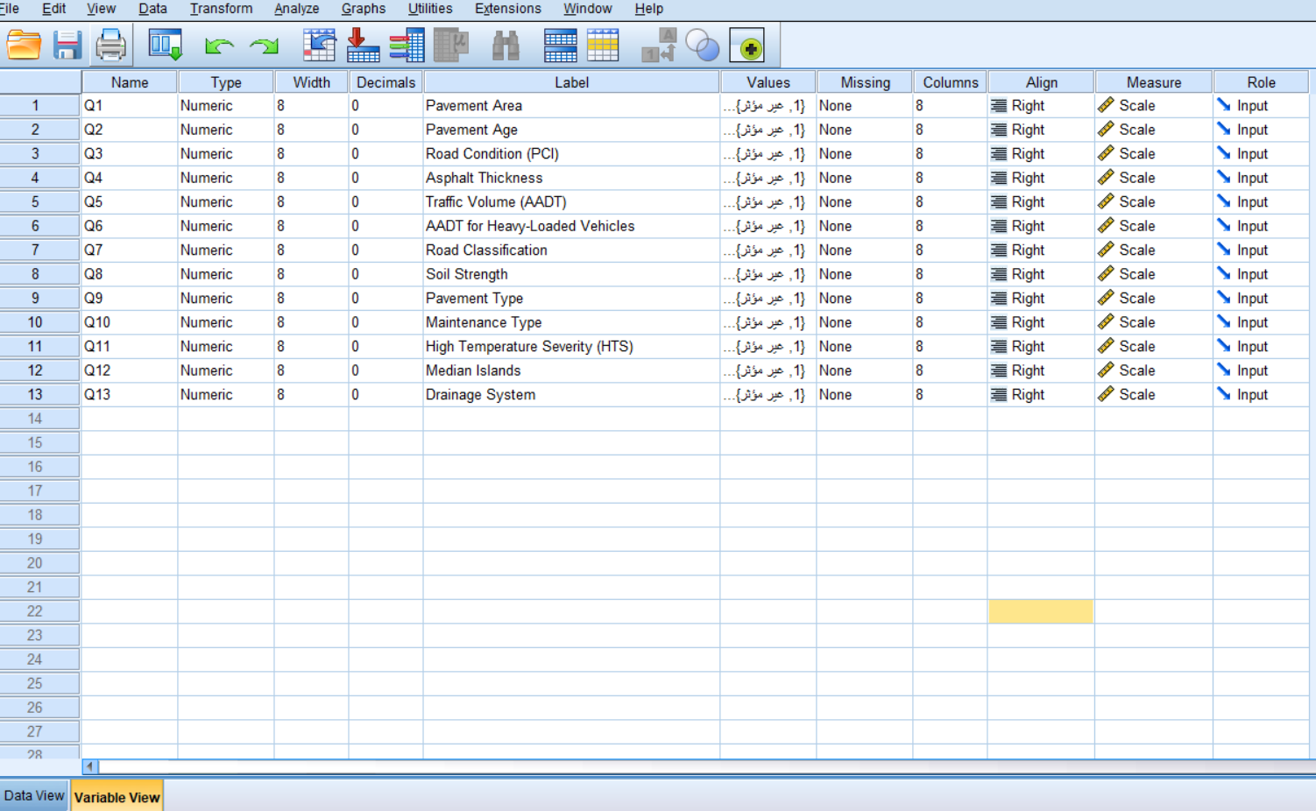

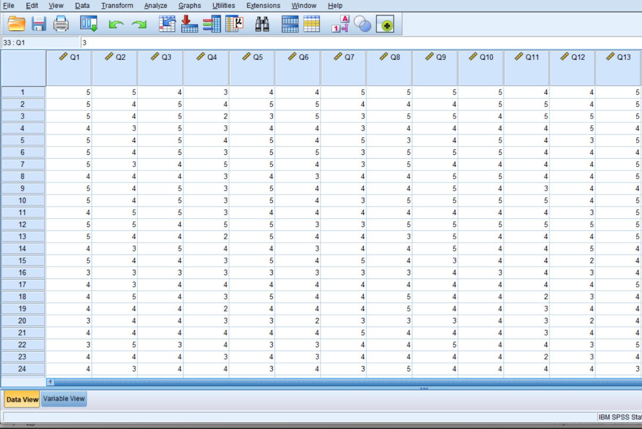
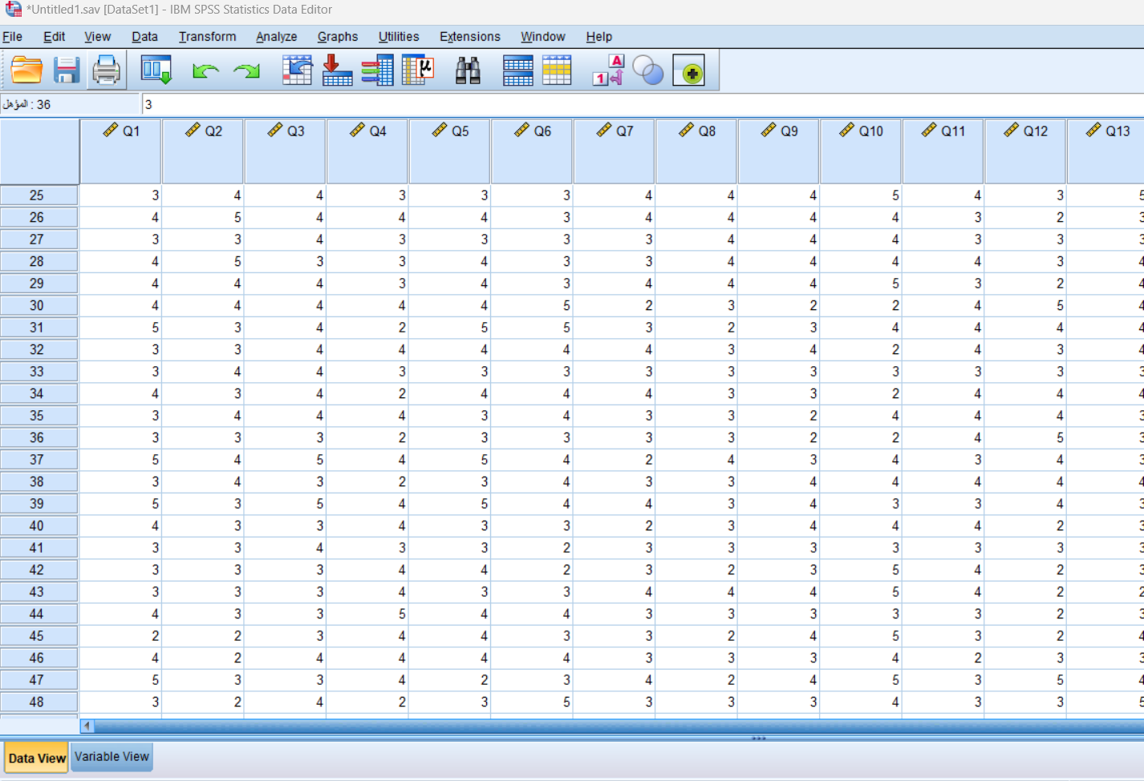

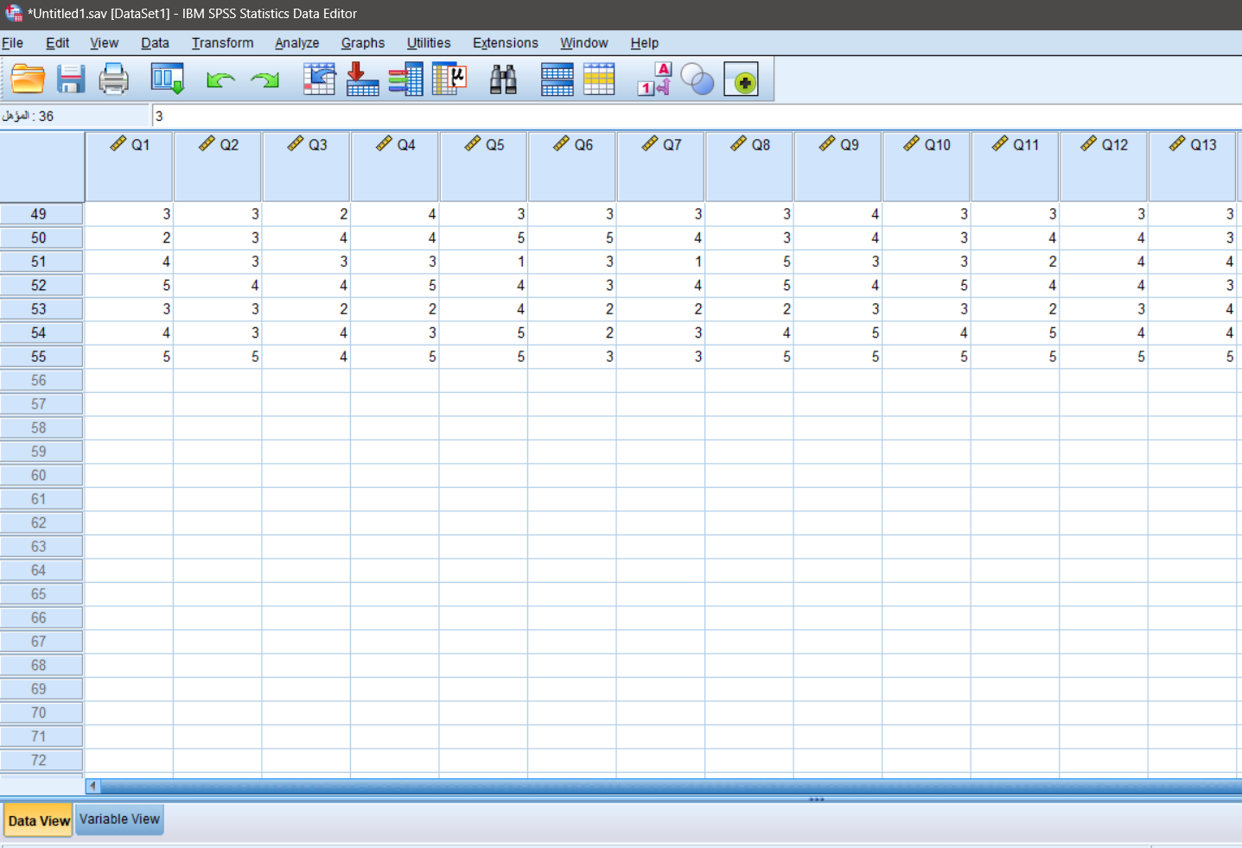
Appendix C: Historical Project Data

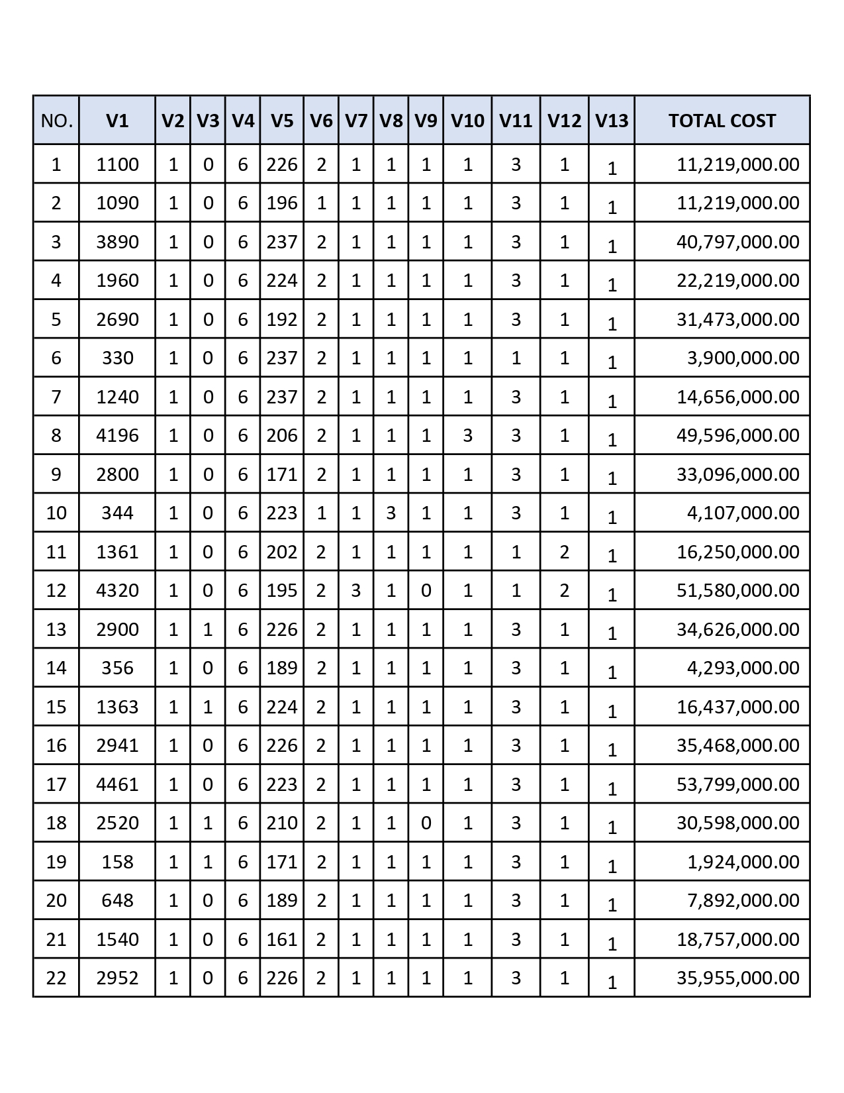
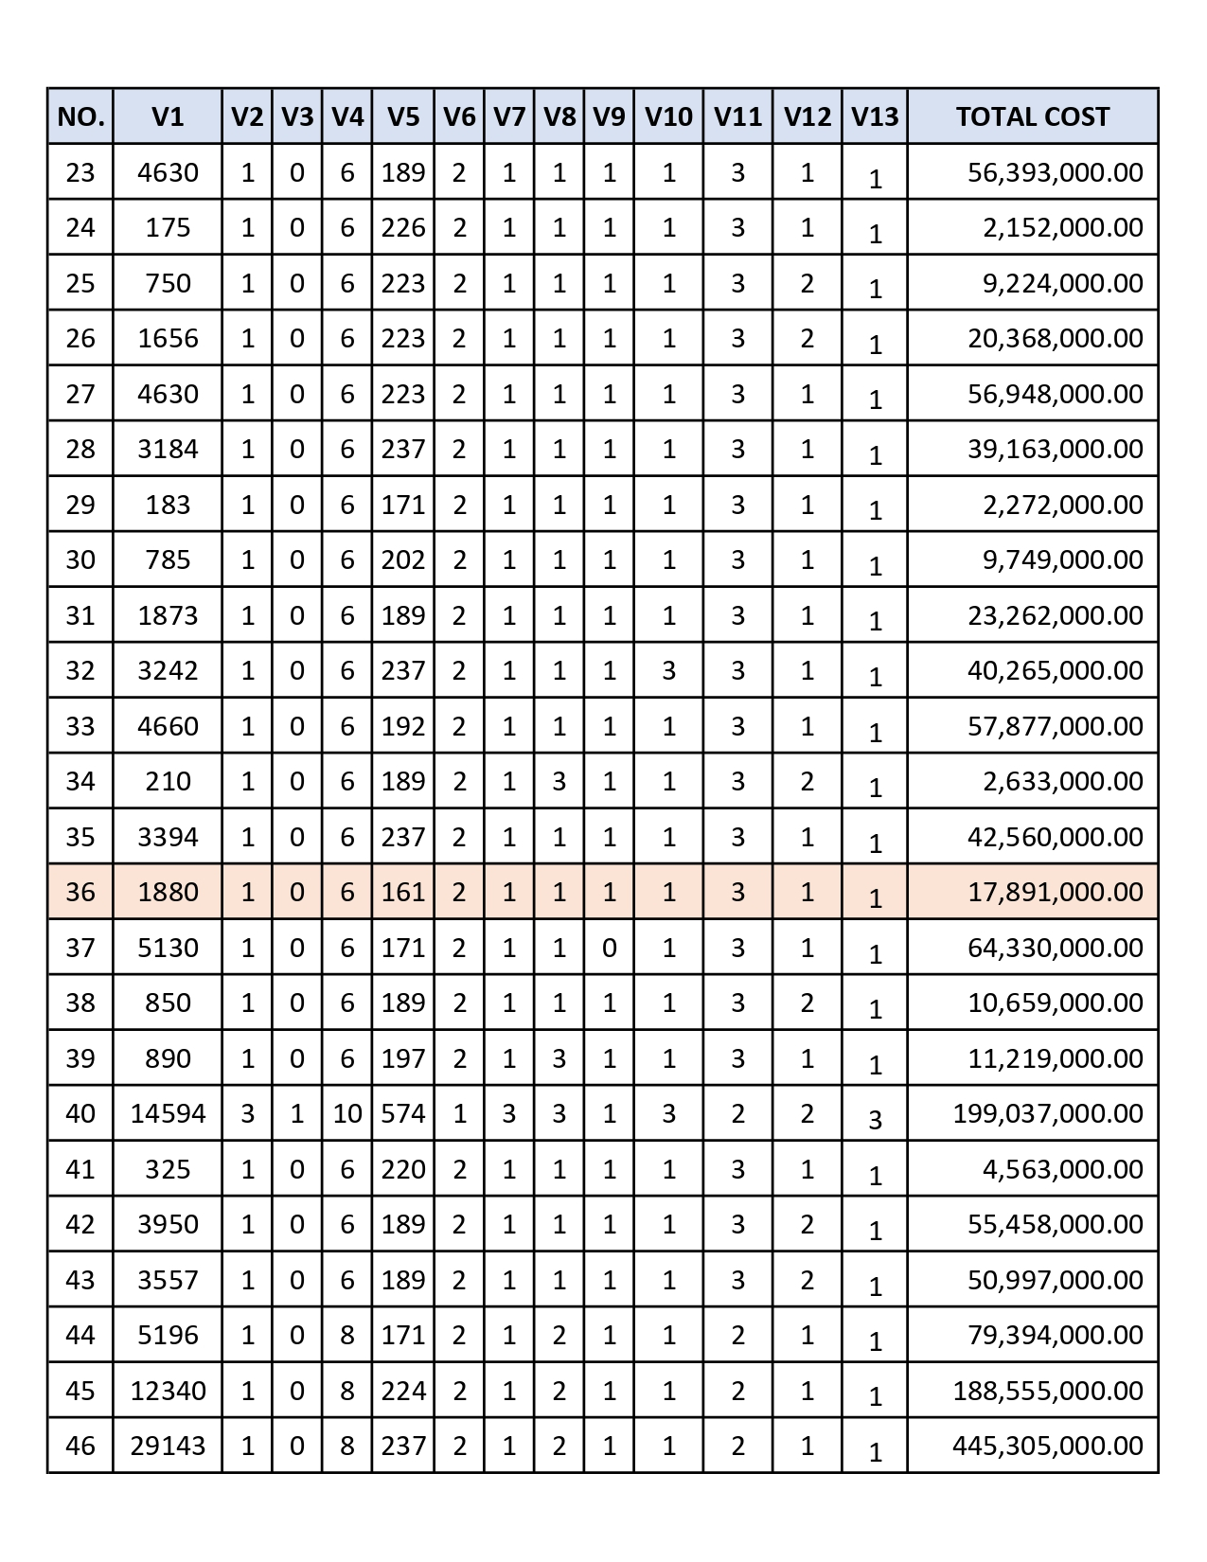

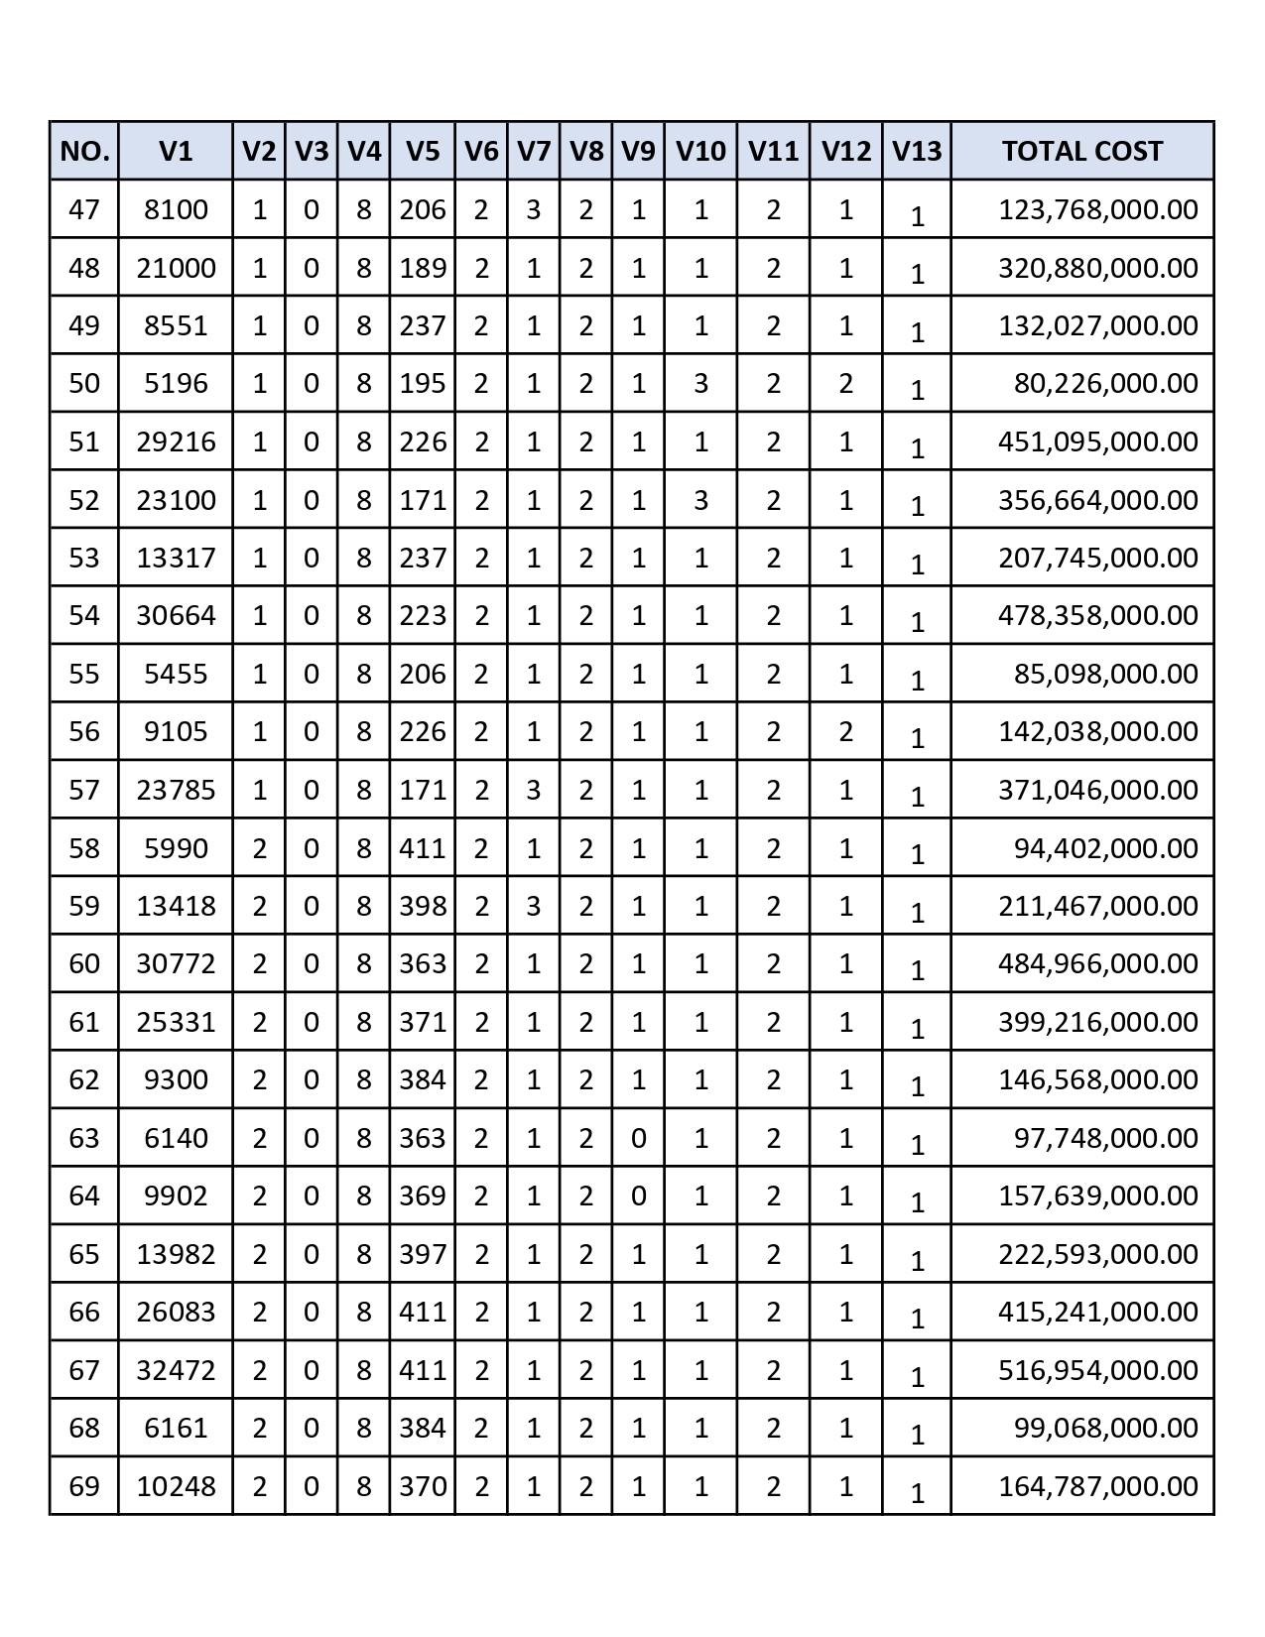

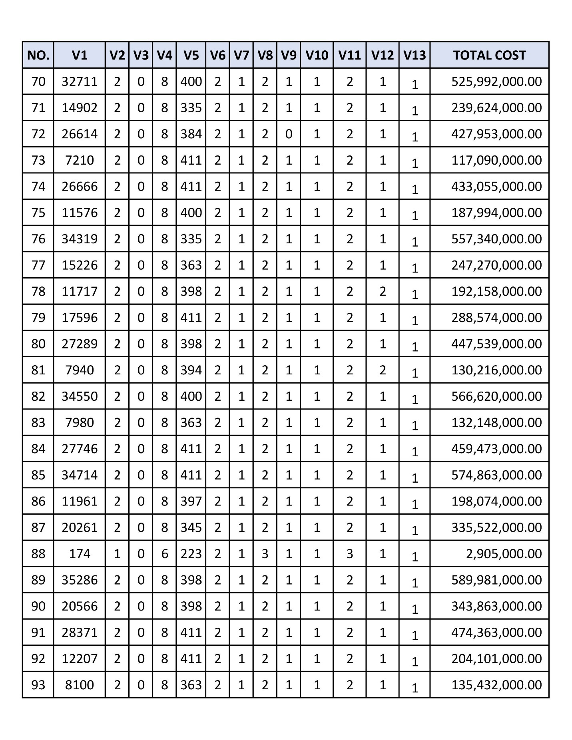

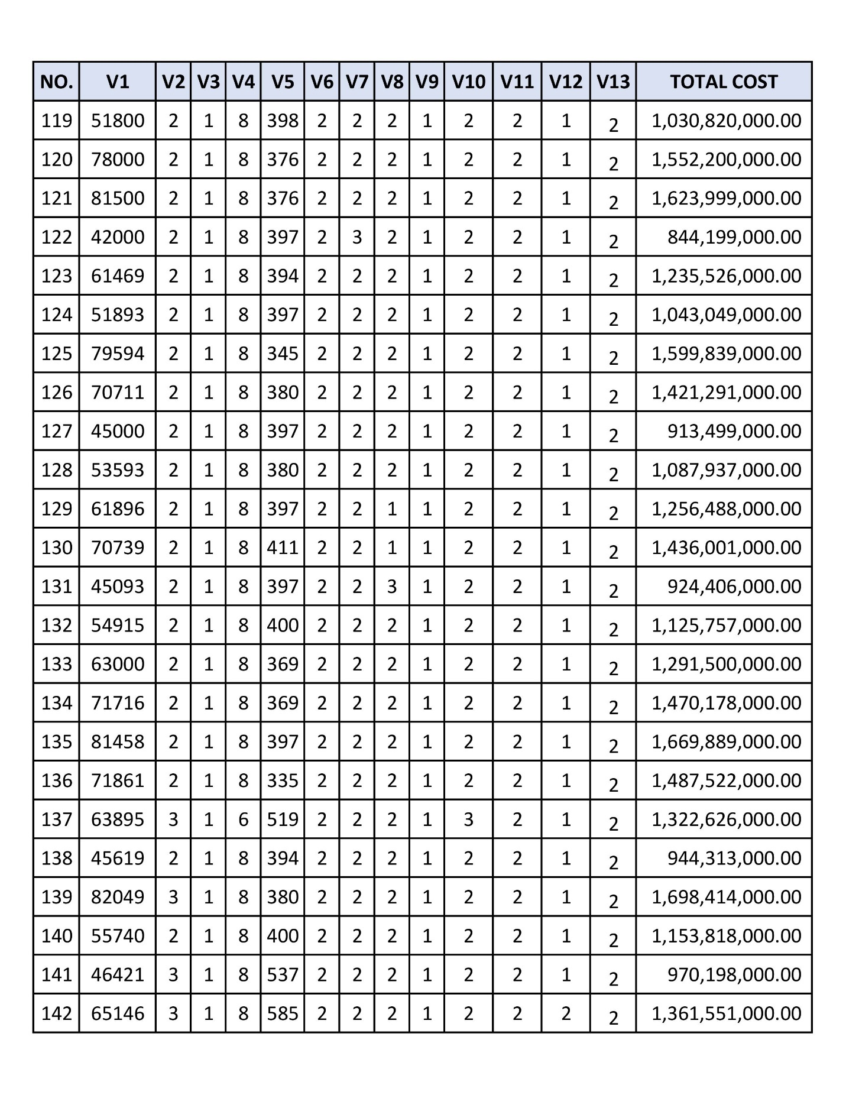

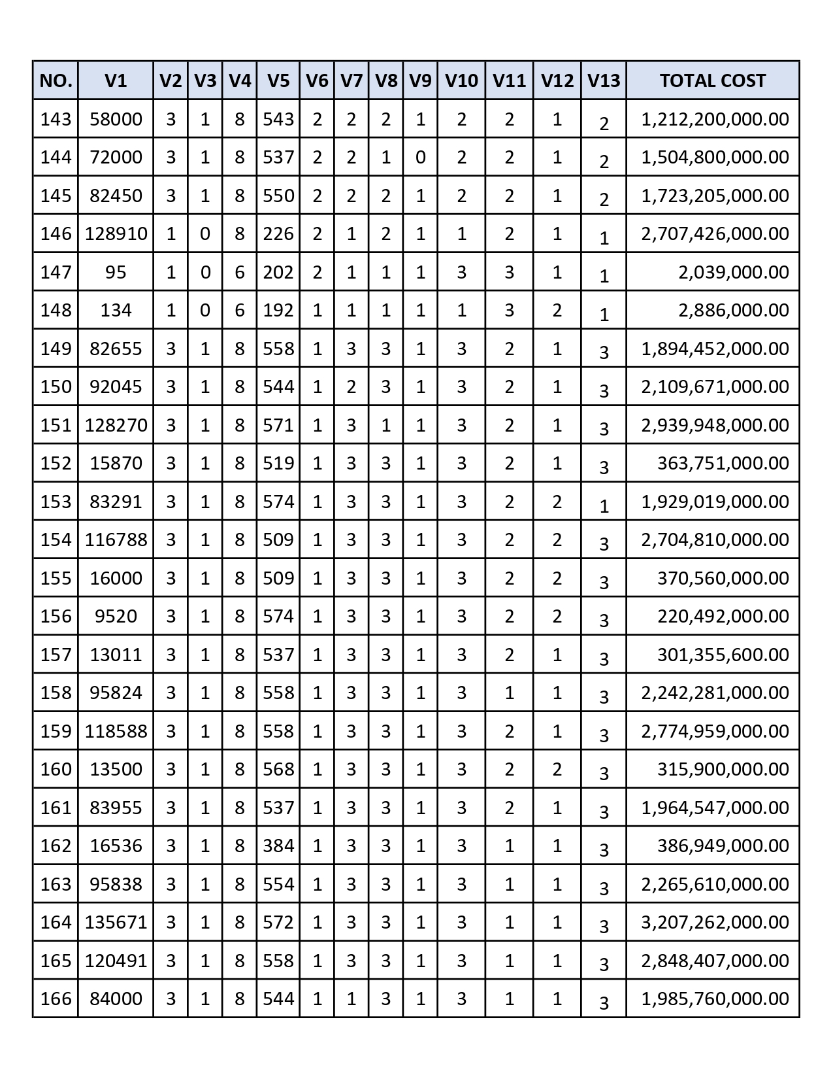

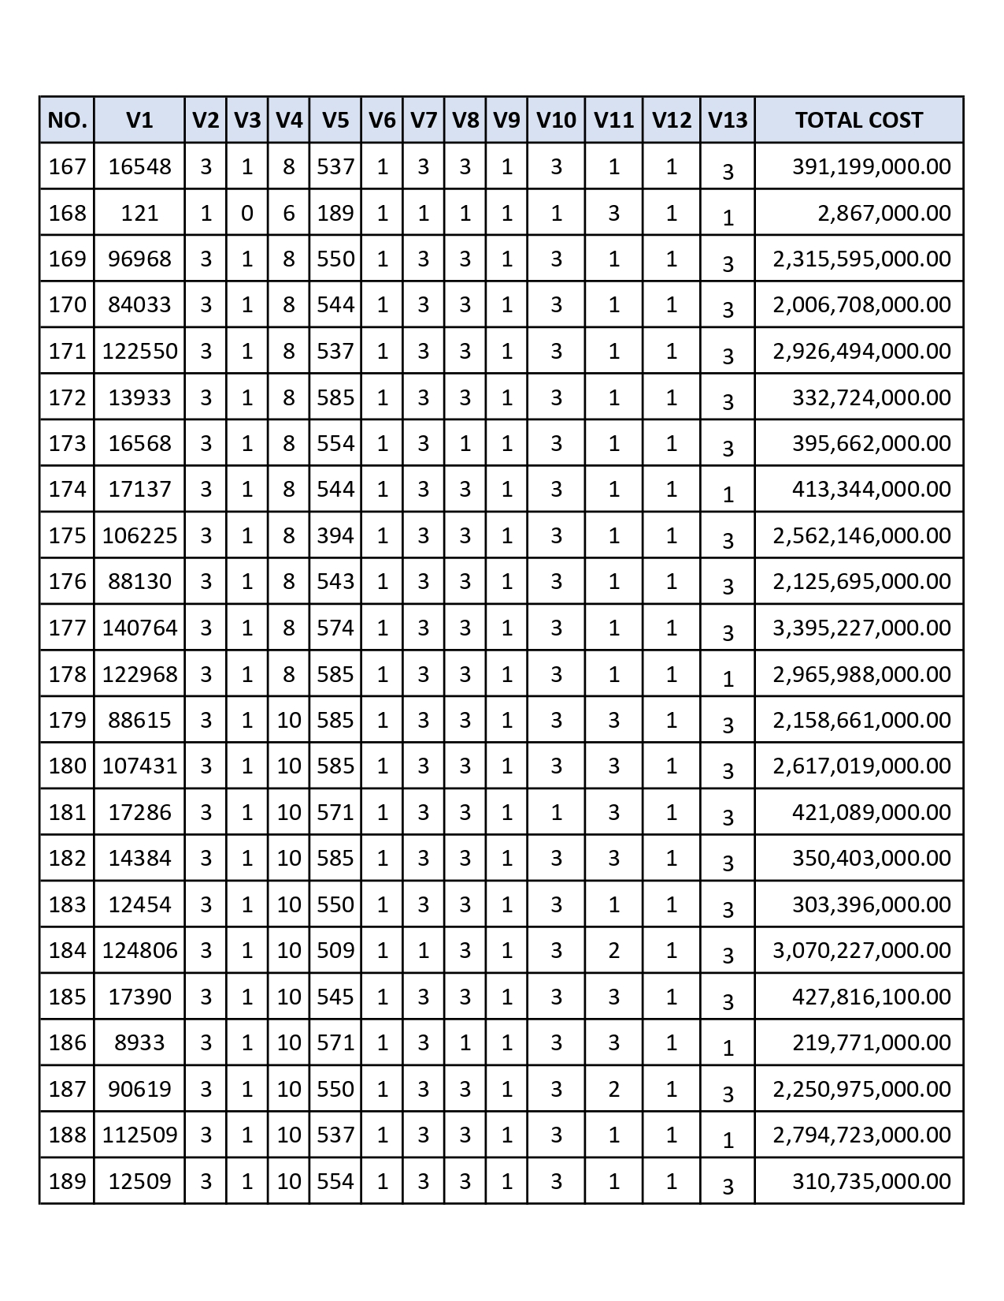

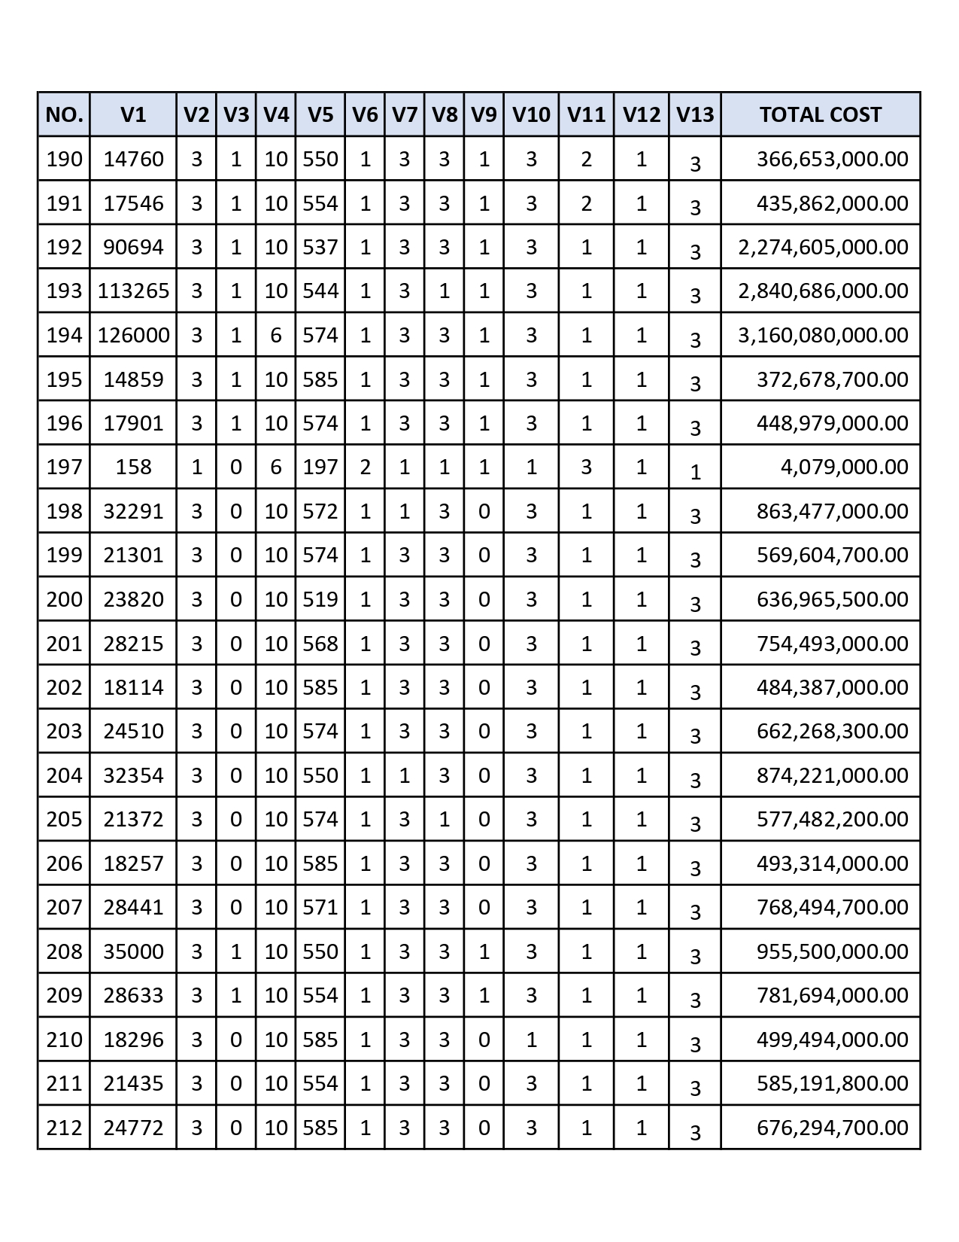

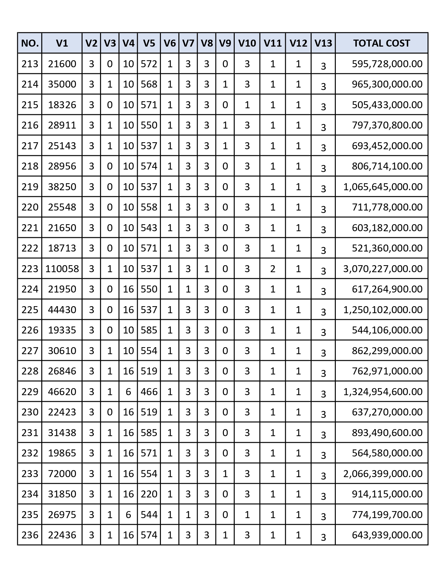

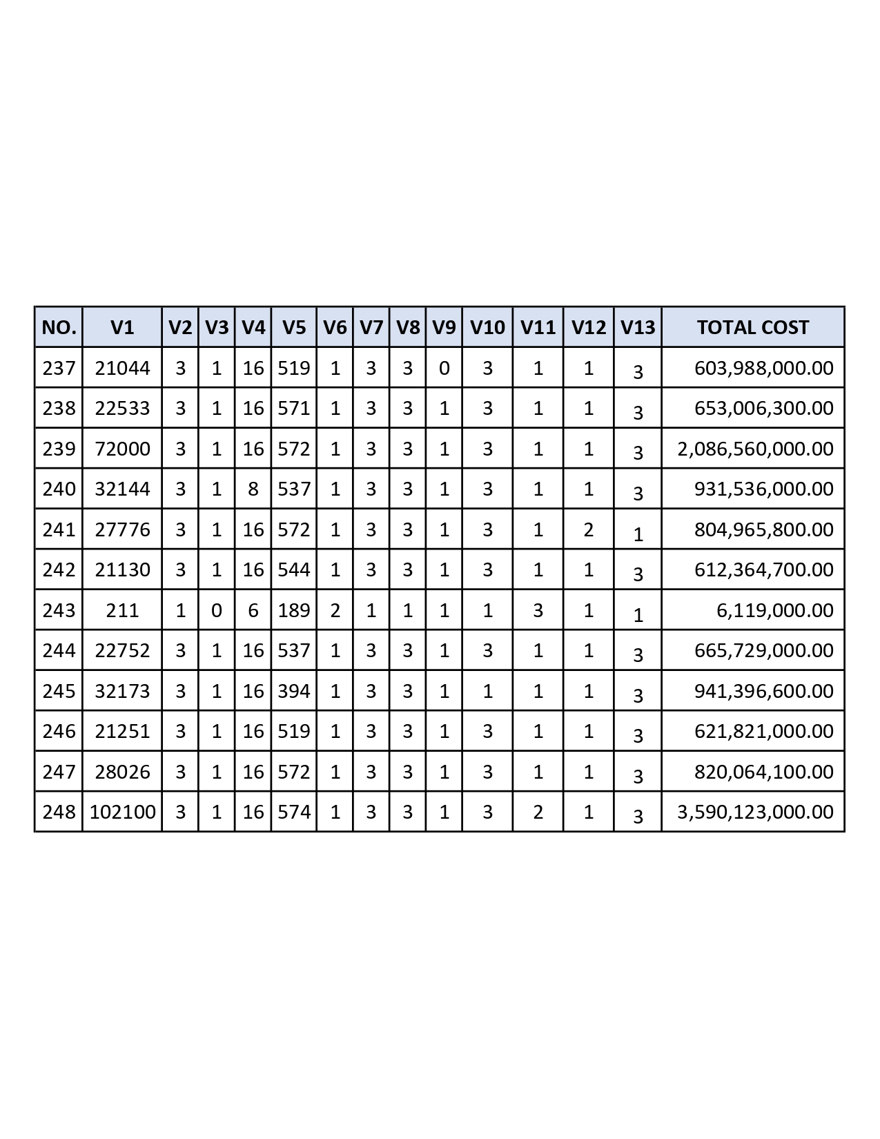

Appendix C: Historical Project Data
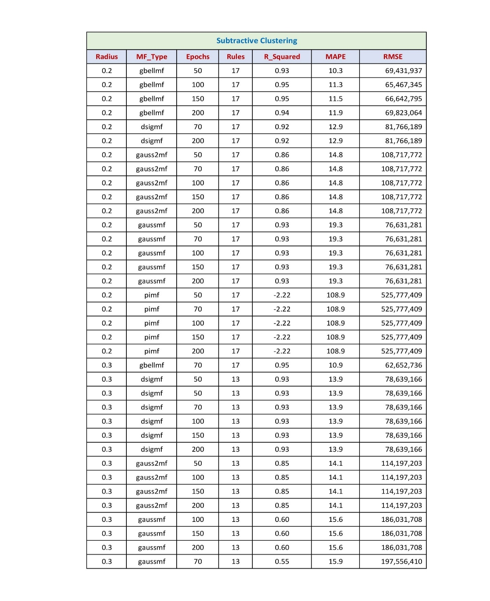

Appendix D:
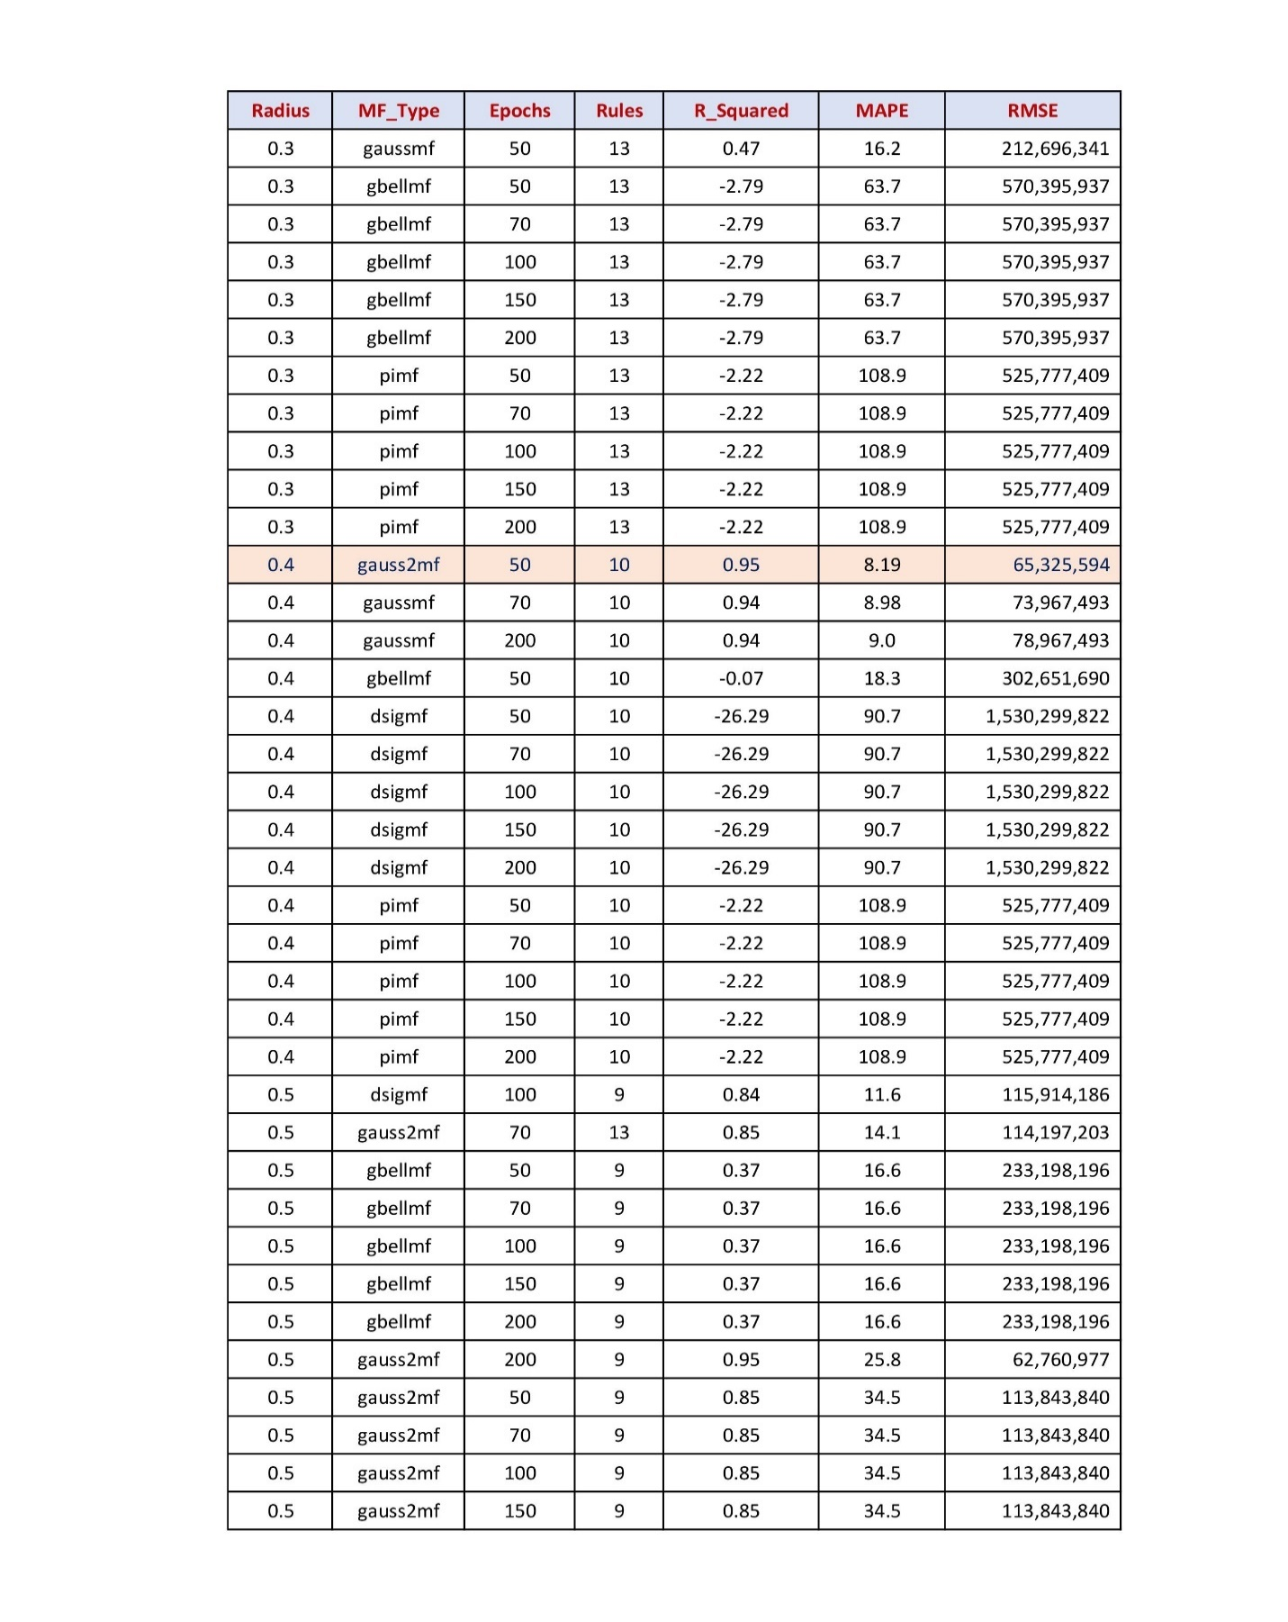

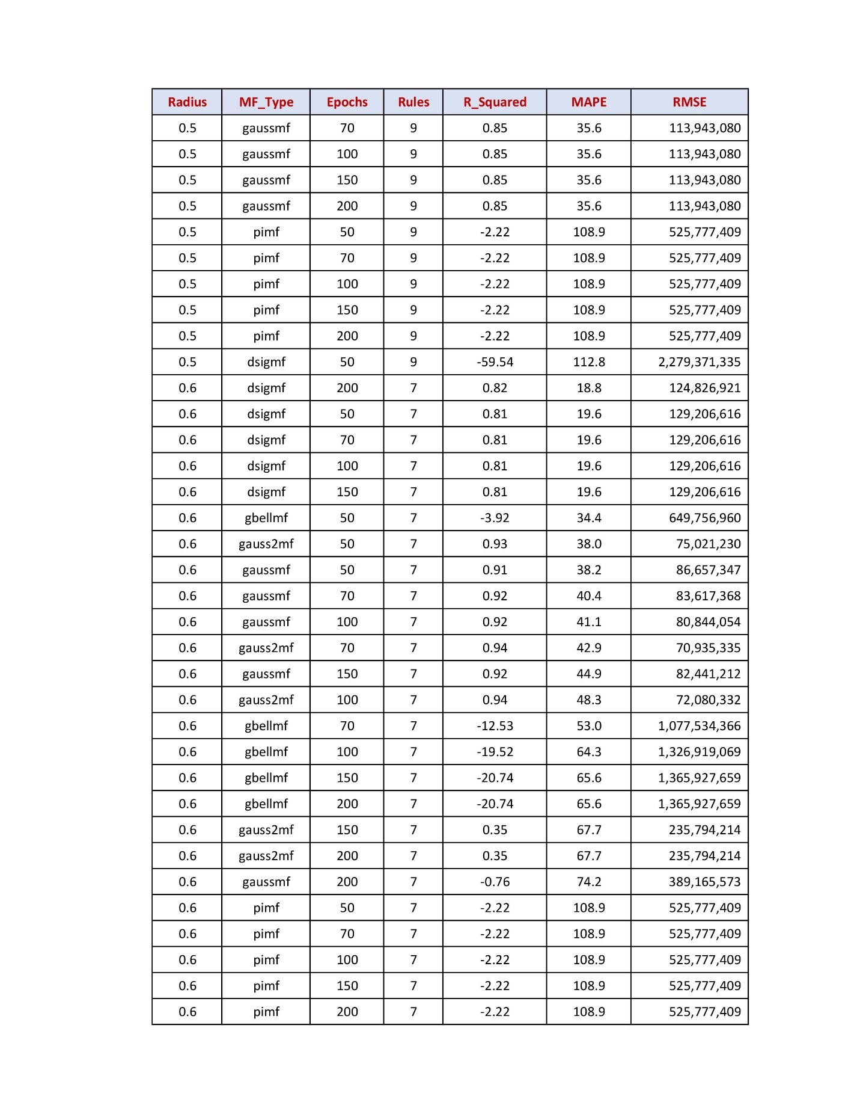

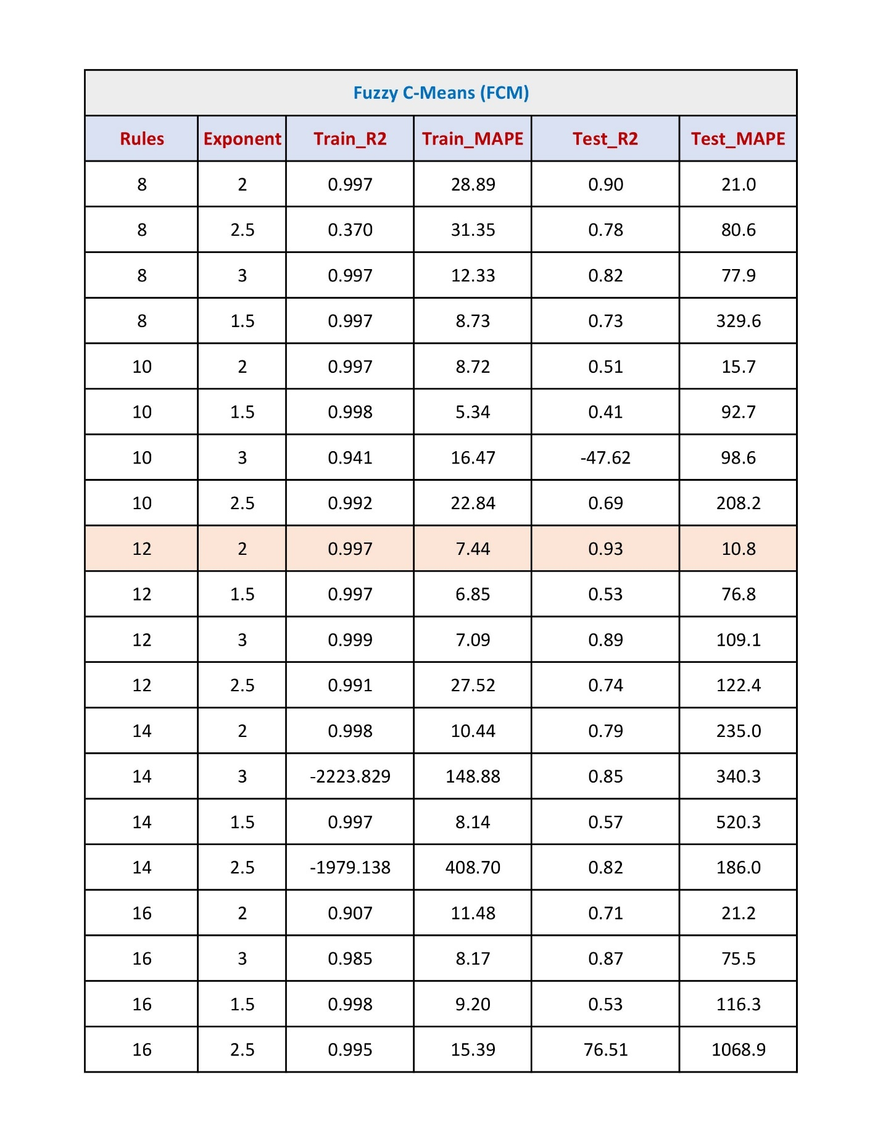

Appendix E:
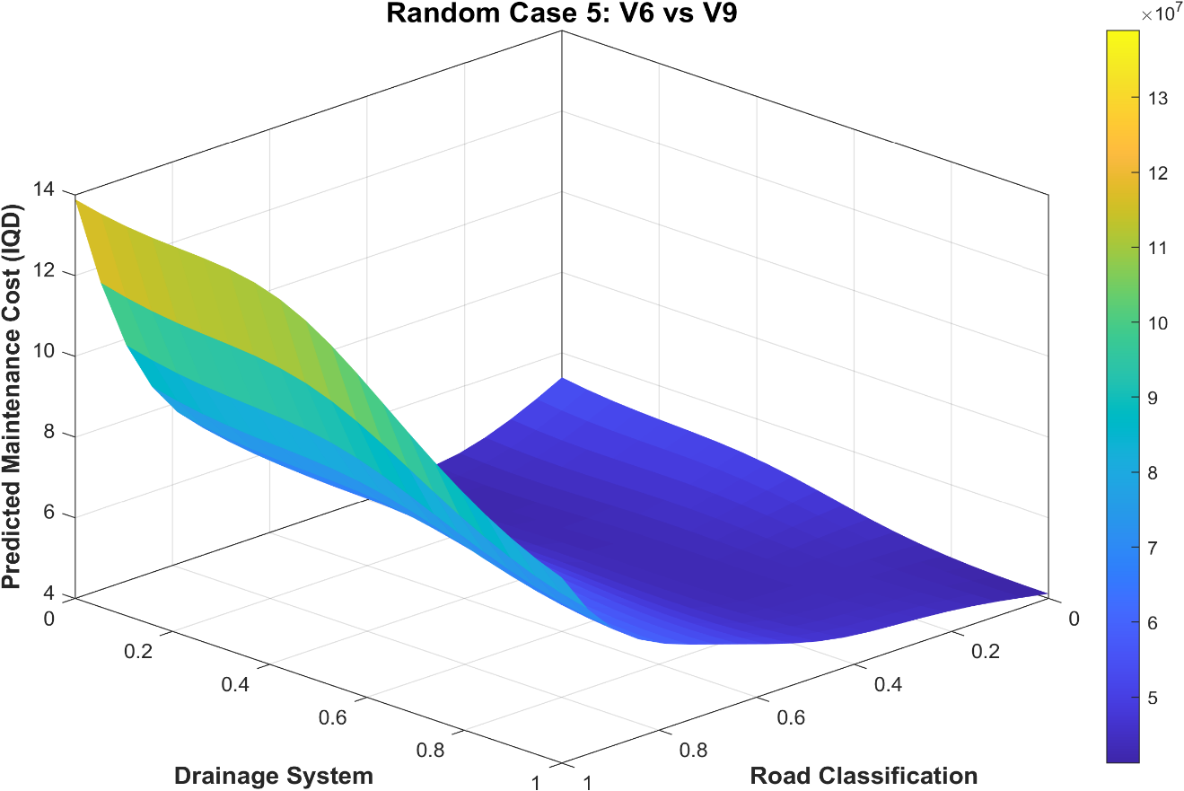
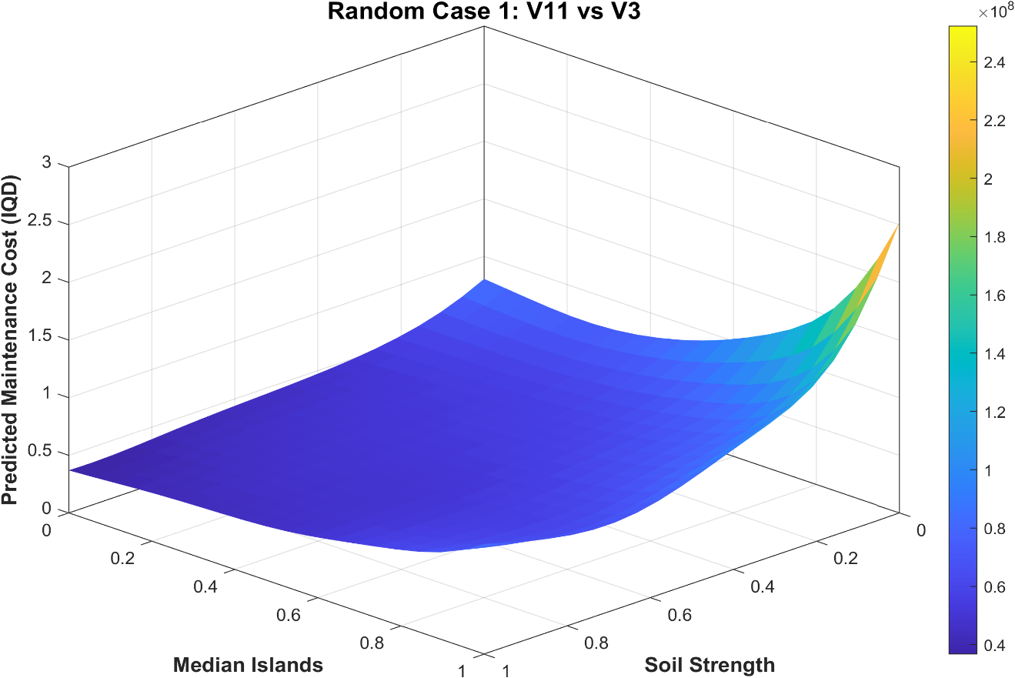
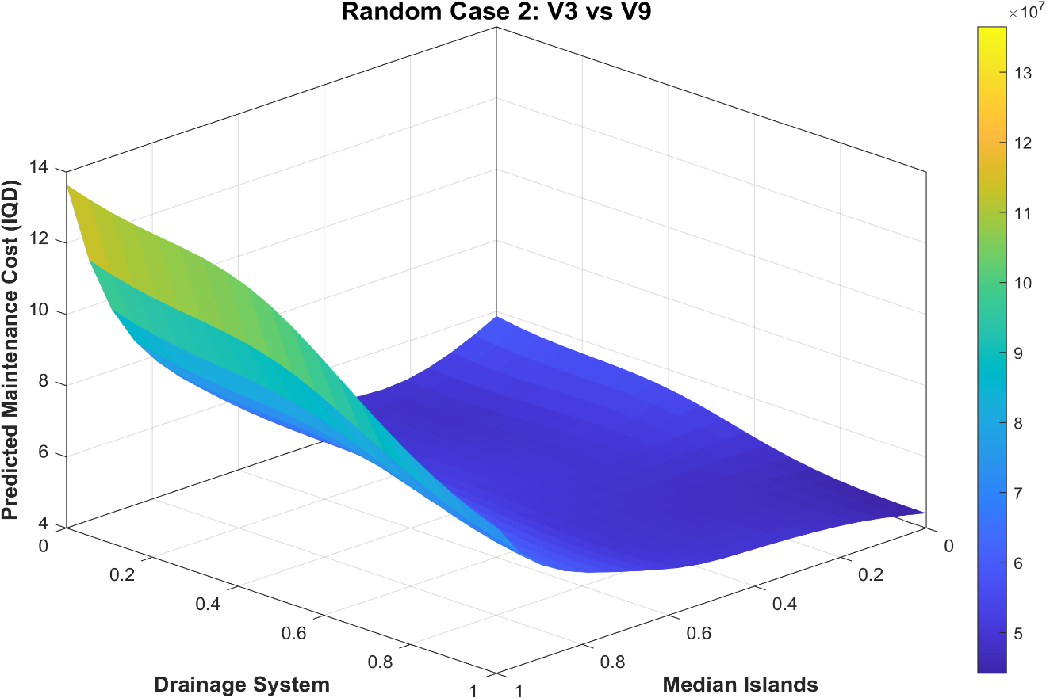
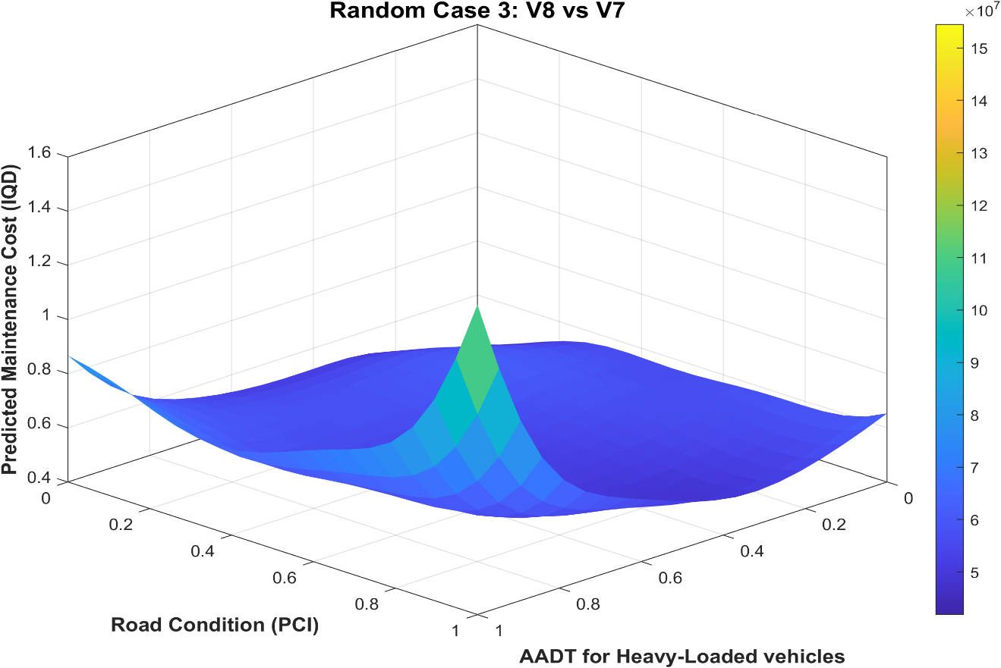

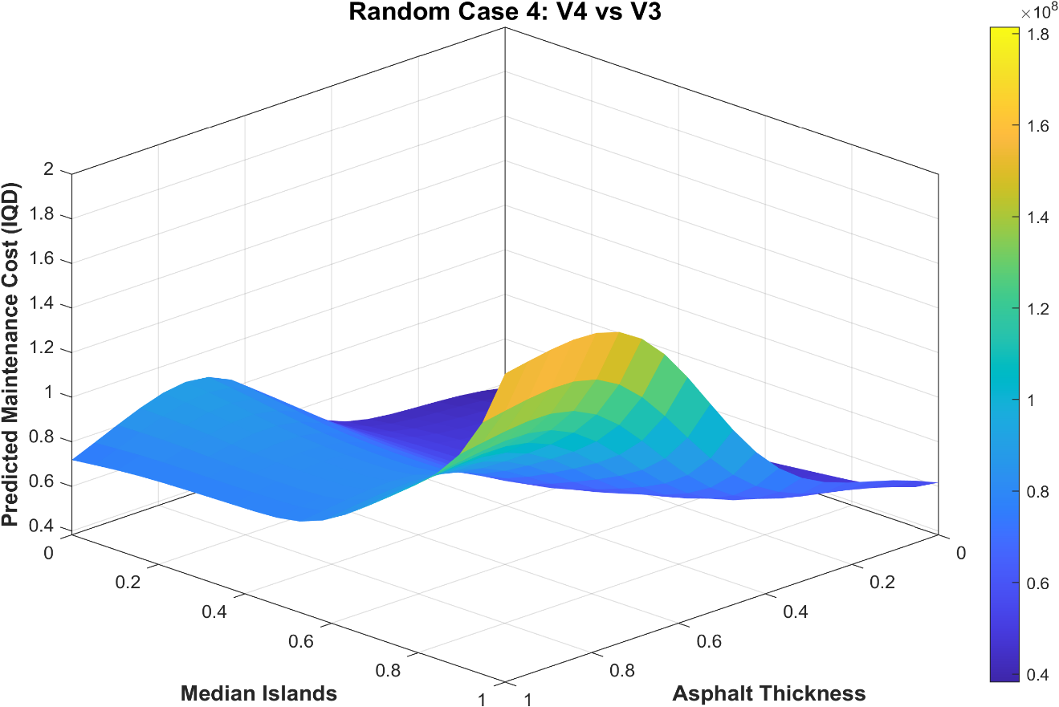
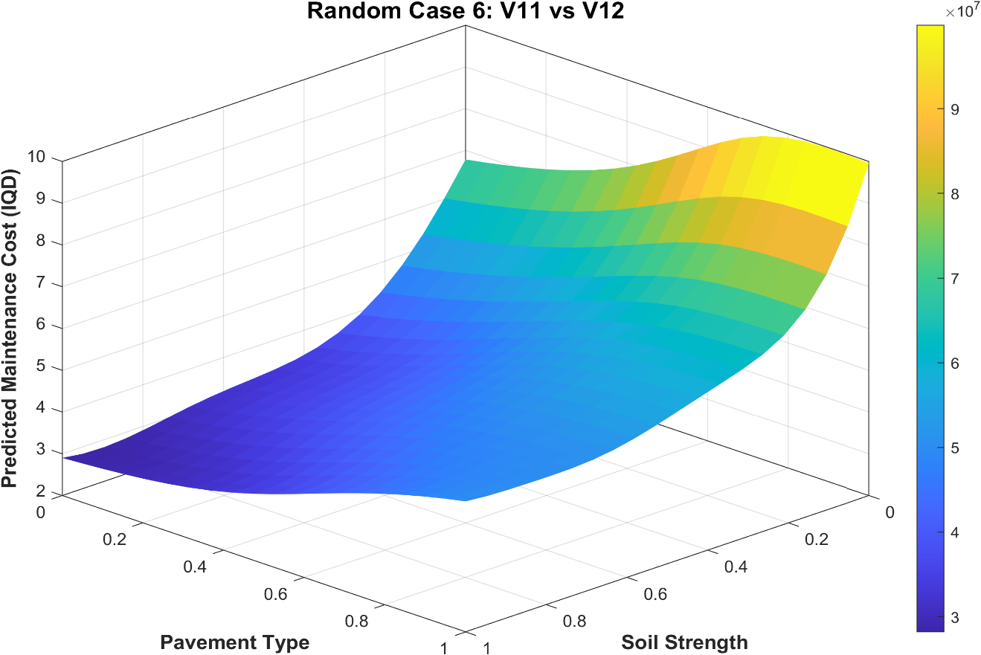

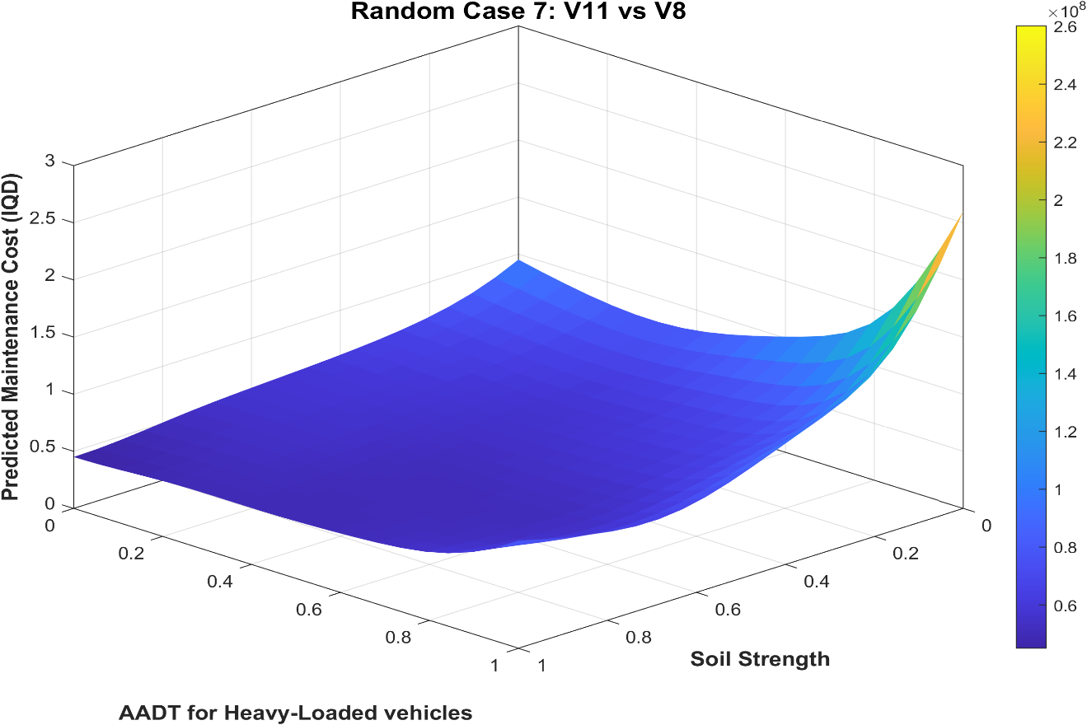
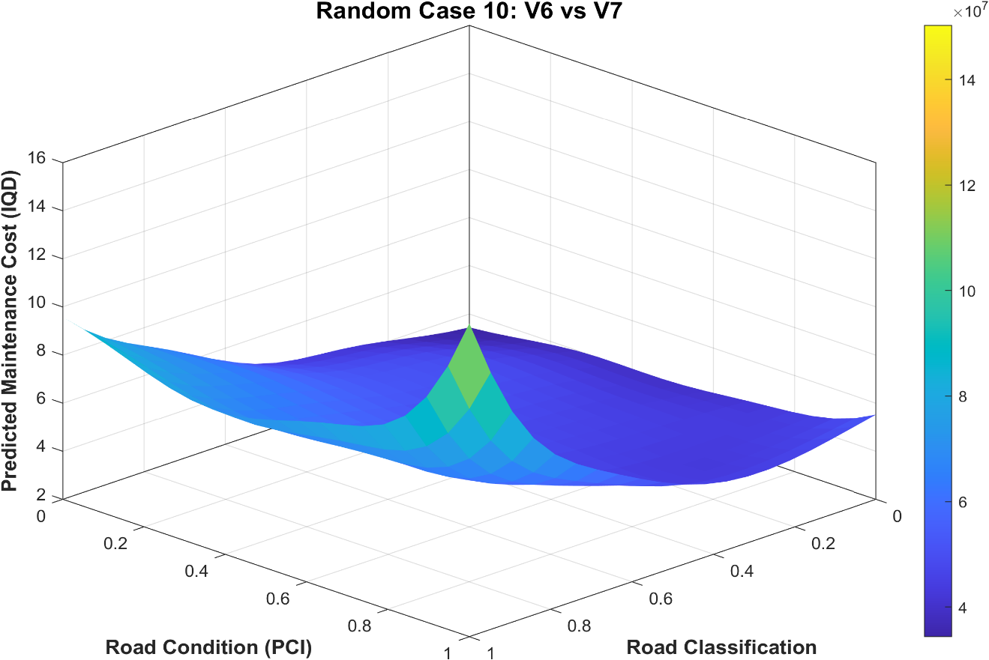

PUBLICATIONS



الخلاصة
تؤدي صيانة الطرق دورًا رئيسيًا في إدارة البنى التحتية، ولا يزال التقدير الدقيق لكلف الصيانة يمثل تحديًا بسبب تداخل العوامل المرورية والإنشائية والبيئية. تهدف هذه الدراسة إلى تطوير نموذج موثوق للتنبؤ بكلفة صيانة الطرق في محافظة كربلاء، مع الأخذ بنظر الاعتبار الظروف المحلية التي تؤثر في أداء التبليط ومتطلبات الصيانة.
تعتمد الدراسة على قاعدة بيانات مكونة من 248 مشروع صيانة منجز تغطي الفترة من 2010 إلى 2025. وتم تحديد ما مجموعه 13 متغيرًا مدخلًا من خلال مراجعة الأدبيات، واستشارة الخبراء، وتحليل مؤشر الأهمية النسبية. (RII) وتمثل هذه المتغيرات العوامل الرئيسة المؤثرة في كلفة الصيانة ضمن الظروف المحلية، بما في ذلك الخصائص المرورية، وحالة التبليط، والتأثيرات البيئية. في هذه الدراسة، تم التعامل مع مفهوم الشبكة العصبية الضبابية (FNN) بوصفه الإطار الذكي العام، بينما تم اعتماد نظام الاستدلال العصبي الضبابي التكيفي (ANFIS) بوصفه النموذج العملي المطبق للتنبؤ بكلفة الصيانة. وبعد تهيئة البيانات، تم تطوير نموذج ANFIS، وتمت مقارنة أدائه مع نموذجي الشبكة العصبية الاصطناعية (ANN) والانحدار الخطي المتعدد (MLR). تُظهر النتائج أن نموذج ANFIS المعتمد على التجميع الطرحي (Subtractive Clustering) حقق أفضل أداء تنبؤي، إذ بلغ معامل التحديد R² = 0.95 ومتوسط نسبة الخطأ المطلق MAPE = 8.19%، مما يشير إلى دقة جيدة. كما يُظهر النموذج قدرة واضحة على تمثيل العلاقات غير الخطية بين المتغيرات المدخلة وكلفة الصيانة.
تخلص الدراسة إلى أن نموذج ANFIS المطور يمكن أن يدعم تقدير كلفة الصيانة ويساعد في تحسين التخطيط واتخاذ القرار في محافظة كربلاء ضمن الظروف العملية.

جمهورية العراق
وزارة التعليم العالي و البحث العلمي
جامعة كربلاء
كلية الهندسة
قسم الهندسة المدنية

(نمذجة كلف صيانة مشاريع الطرق في محافظة كربلاء باستخدام الشبكة العصبية الضبابية)

رسالة مقدمة الى مجلس كلية الهندسة / جامعة كربلاء وهي جزء من متطلبات نيل درجة الماجستير في علوم الهندسة المدنية

من قبل :
علي سعد أحمد
باشراف :
أ.م غافل كريم اسود
تموز - 2026
محرم - 1448 هـ

